# Introduction

This document shows the correlation matrix, p-value matrix, and scatter plot matrix for different combinations of m and n based on 50,000 simulations, assuming the process is in control (IC), i.e., under the alternative hypothesis (Ha), with location ( 0 ) and scale ( 1 ) while IC location and scale parameters are (0,1). Here, m denotes the reference sample size, and n denotes the testing or monitoring sample size. The statistics calculated are:

1. WRS - Wilcoxon Rank Sum Test

2. MW - Mann-Whitney Test

3. VW - Vander Waerden Test

4. AB - Ansari-Bradley Test

5. Mood - Mood's Median Test

For simulation, I used the normal distribution due to the nonparametric setup. In Lepage (1971), it was proven that under the null hypothesis (H0), the WRS and AB statistics are uncorrelated for all m and n.

Reference: Lepage, Y. (1971). A combination of Wilcoxon's and Ansari-Bradley's statistics. Biometrika, 58(1), 213-217.

This document also provides correlation and scatter plot matrices to analyze the relationship between different statistical tests.

The following sections detail the results for each combination of m and n and the location and scale parameters.

# Index

This document contains results for the following combinations of m, n, location, and scale:

Combination of m = 50 , n = 5 , location = 0 , scale = 1

Combination of m = 50 , n = 10 , location = 0 , scale = 1

Combination of m = 50 , n = 15 , location = 0 , scale = 1

Combination of m = 50 , n = 20 , location = 0 , scale = 1

Combination of m = 50 , n = 25 , location = 0 , scale = 1

Combination of m = 50 , n = 30 , location = 0 , scale = 1

Combination of m = 50 , n = 50 , location = 0 , scale = 1

Combination of m = 75 , n = 5 , location = 0 , scale = 1

Combination of m = 75 , n = 10 , location = 0 , scale = 1

Combination of m = 75 , n = 15 , location = 0 , scale = 1

Combination of m = 75 , n = 20 , location = 0 , scale = 1

Combination of m = 75 , n = 25 , location = 0 , scale = 1

Combination of m = 75 , n = 30 , location = 0 , scale = 1

Combination of m = 75 , n = 50 , location = 0 , scale = 1

Combination of m = 100 , n = 5 , location = 0 , scale = 1

Combination of m = 100 , n = 10 , location = 0 , scale = 1

Combination of m = 100 , n = 15 , location = 0 , scale = 1

Combination of m = 100 , n = 20 , location = 0 , scale = 1

Combination of m = 100 , n = 25 , location = 0 , scale = 1

Combination of m = 100 , n = 30 , location = 0 , scale = 1

Combination of m = 100 , n = 50 , location = 0 , scale = 1

Combination of m = 125 , n = 5 , location = 0 , scale = 1

Combination of m = 125 , n = 10 , location = 0 , scale = 1

Combination of m = 125 , n = 15 , location = 0 , scale = 1

Combination of m = 125 , n = 20 , location = 0 , scale = 1

Combination of m = 125 , n = 25 , location = 0 , scale = 1

Combination of m = 125 , n = 30 , location = 0 , scale = 1

Combination of m = 125 , n = 50 , location = 0 , scale = 1

Combination of m = 150 , n = 5 , location = 0 , scale = 1

Combination of m = 150 , n = 10 , location = 0 , scale = 1

Combination of m = 150 , n = 15 , location = 0 , scale = 1

Combination of m = 150 , n = 20 , location = 0 , scale = 1

Combination of m = 150 , n = 25 , location = 0 , scale = 1

Combination of m = 150 , n = 30 , location = 0 , scale = 1

Combination of m = 150 , n = 50 , location = 0 , scale = 1

Combination of m = 175 , n = 5 , location = 0 , scale = 1

Combination of m = 175 , n = 10 , location = 0 , scale = 1

Combination of m = 175 , n = 15 , location = 0 , scale = 1

Combination of m = 175 , n = 20 , location = 0 , scale = 1

Combination of m = 175 , n = 25 , location = 0 , scale = 1

Combination of m = 175 , n = 30 , location = 0 , scale = 1

Combination of m = 175 , n = 50 , location = 0 , scale = 1

Combination of m = 200 , n = 5 , location = 0 , scale = 1

Combination of m = 200 , n = 10 , location = 0 , scale = 1

Combination of m = 200 , n = 15 , location = 0 , scale = 1

Combination of m = 200 , n = 20 , location = 0 , scale = 1

Combination of m = 200 , n = 25 , location = 0 , scale = 1

Combination of m = 200 , n = 30 , location = 0 , scale = 1

Combination of m = 200 , n = 50 , location = 0 , scale = 1

Combination of m = 300 , n = 5 , location = 0 , scale = 1

Combination of m = 300 , n = 10 , location = 0 , scale = 1

Combination of m = 300 , n = 15 , location = 0 , scale = 1

Combination of m = 300 , n = 20 , location = 0 , scale = 1

Combination of m = 300 , n = 25 , location = 0 , scale = 1

Combination of m = 300 , n = 30 , location = 0 , scale = 1

Combination of m = 300 , n = 50 , location = 0 , scale = 1

# Results

The following sections present the correlation, p-value, and scatter plot matrices for each combination of m, n, location, and scale.

## Results for m = 50 , n = 5 , location = 0 , scale = 1

### Correlation Matrix

| Statistic | WRS | MW | VW | AB | Mood |
| --- | --- | --- | --- | --- | --- |
| character | numeric | numeric | numeric | numeric | numeric |
| WRS | 1.0000 | -1.0000 | 0.9869 | -0.0002 | -0.0008 |
| MW | -1.0000 | 1.0000 | -0.9869 | 0.0002 | 0.0008 |
| VW | 0.9869 | -0.9869 | 1.0000 | -0.0015 | -0.0022 |
| AB | -0.0002 | 0.0002 | -0.0015 | 1.0000 | 0.9684 |
| Mood | -0.0008 | 0.0008 | -0.0022 | 0.9684 | 1.0000 |
| n: 5 | | | | | |

### P-Value Matrix

| Statistic | WRS | MW | VW | AB | Mood |
| --- | --- | --- | --- | --- | --- |
| character | numeric | numeric | numeric | numeric | numeric |
| WRS |  | 0.0000 | 0.0000 | 0.9686 | 0.8631 |
| MW | 0.0000 |  | 0.0000 | 0.9686 | 0.8631 |
| VW | 0.0000 | 0.0000 |  | 0.7341 | 0.6277 |
| AB | 0.9686 | 0.9686 | 0.7341 |  | 0.0000 |
| Mood | 0.8631 | 0.8631 | 0.6277 | 0.0000 |  |
| n: 5 | | | | | |

### Scatter Plot Matrix:

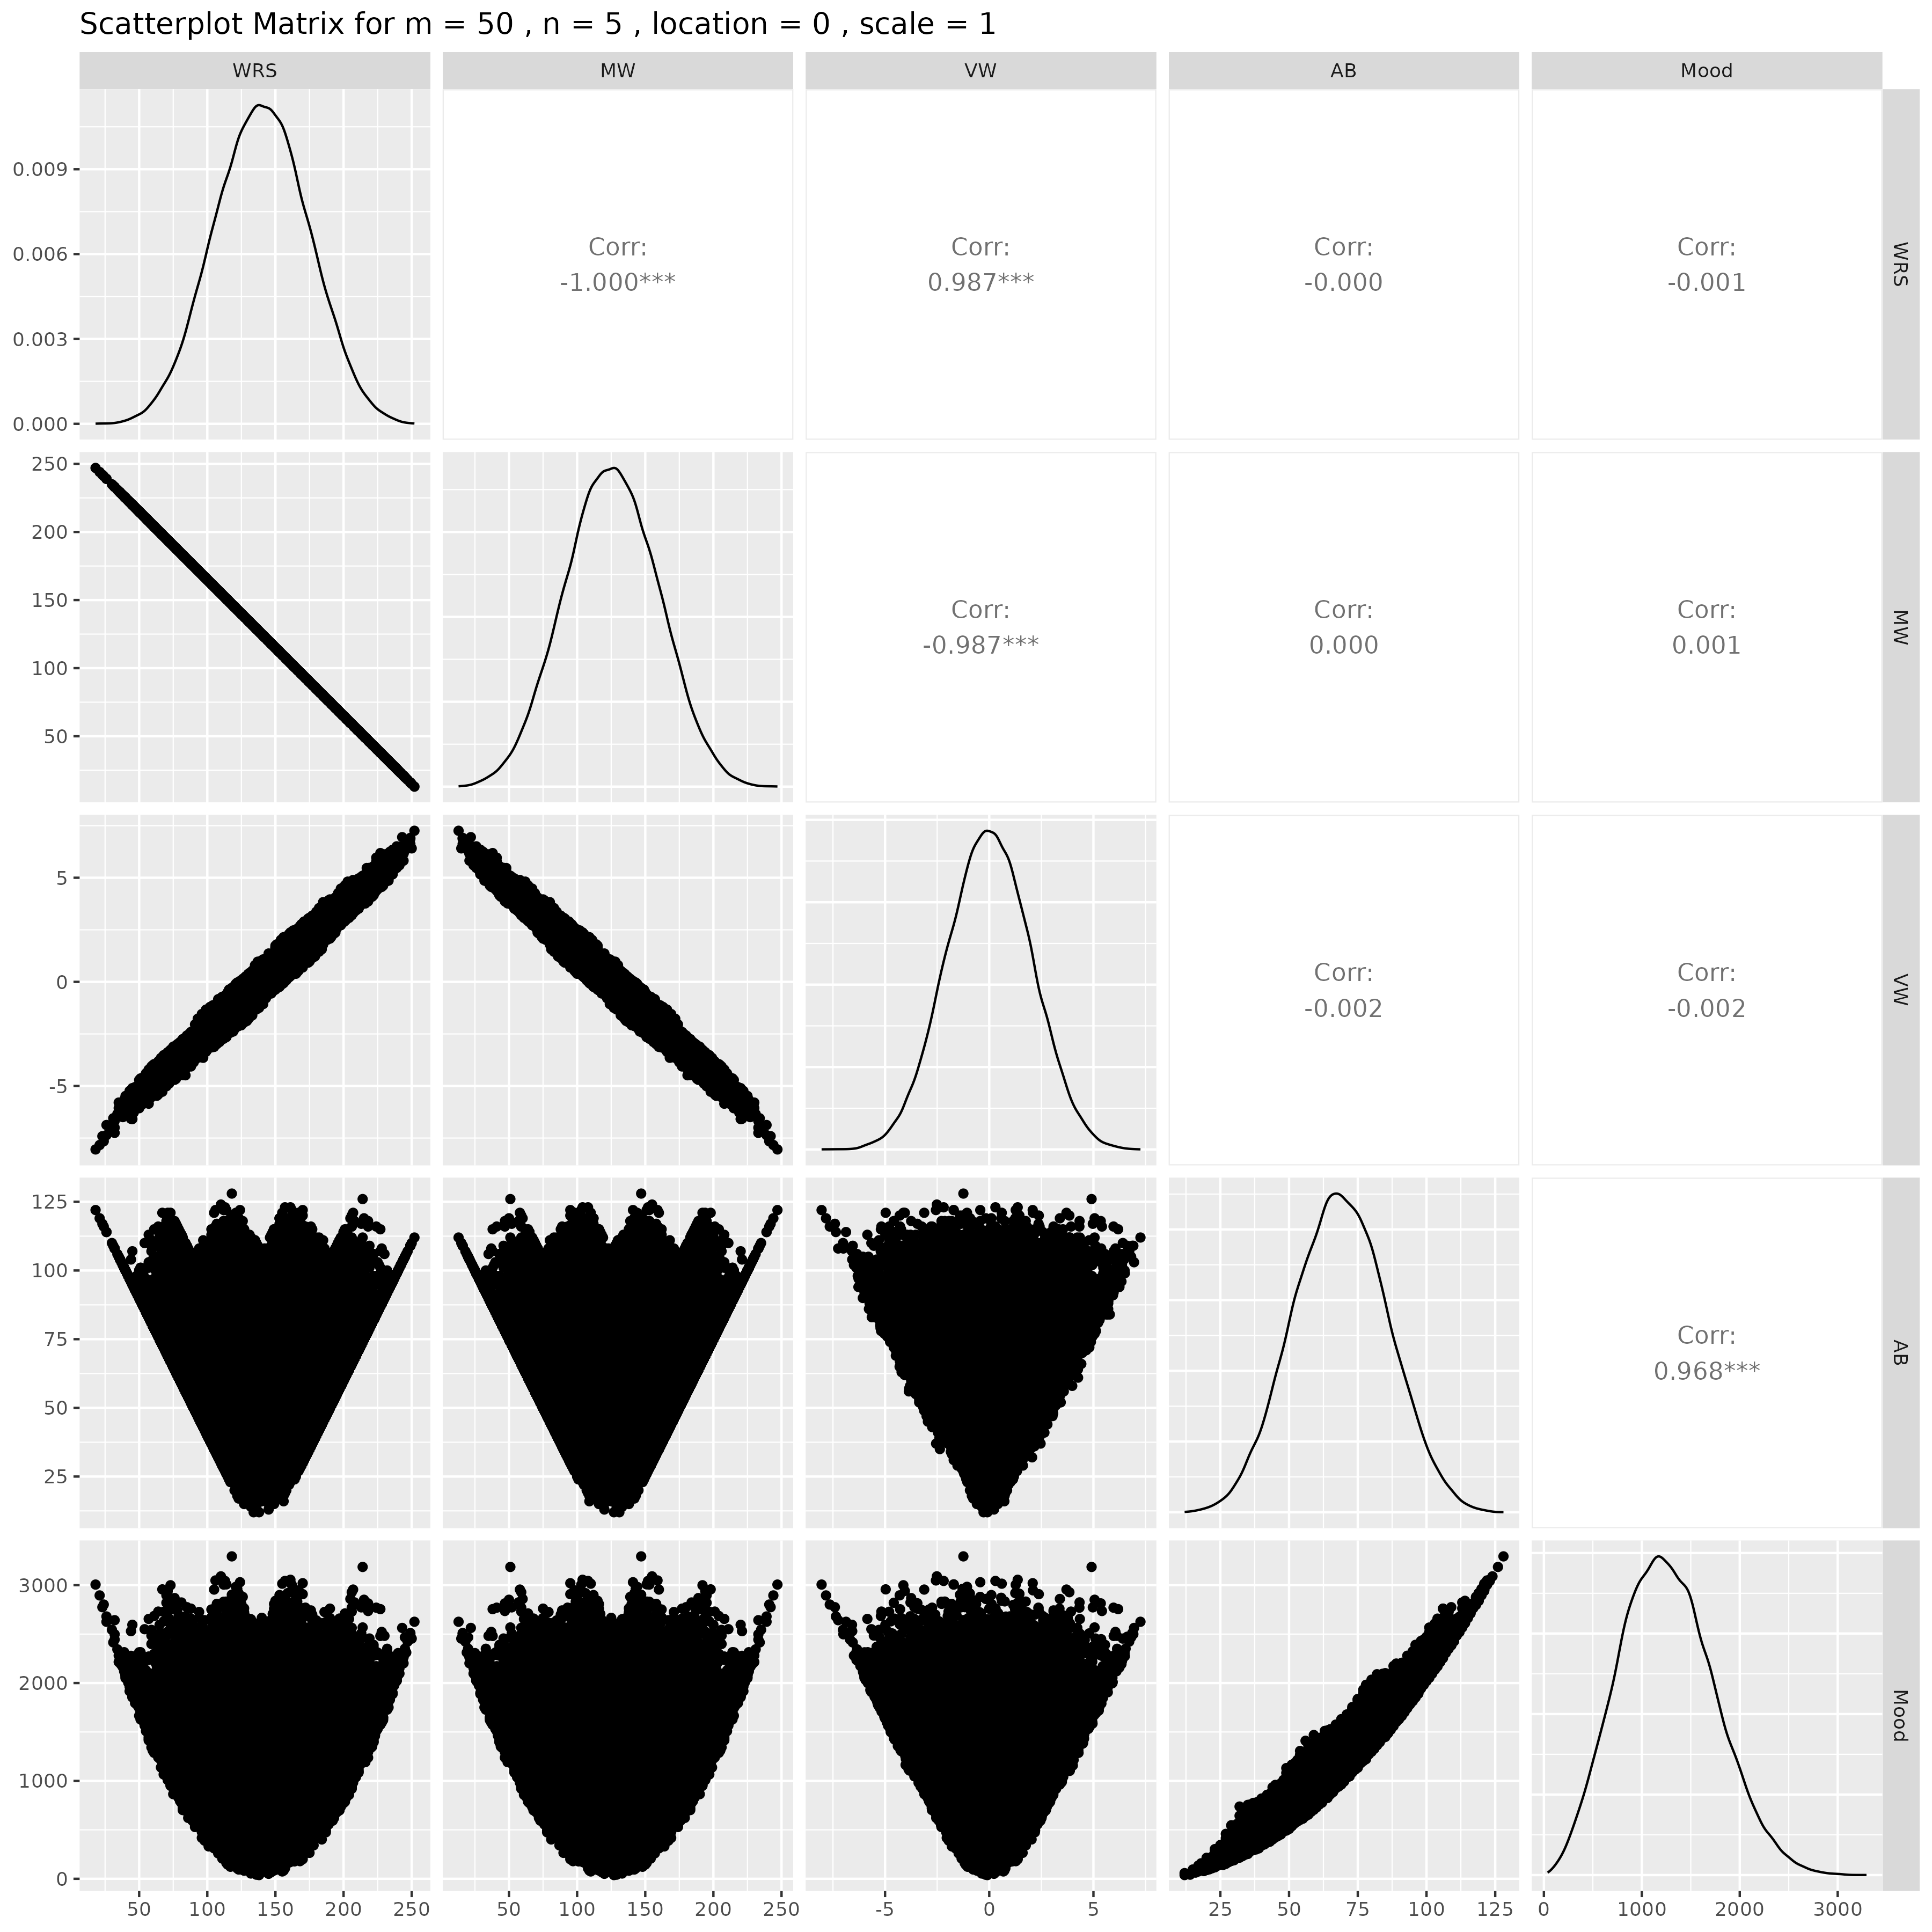

## Results for m = 50 , n = 10 , location = 0 , scale = 1

### Correlation Matrix

| Statistic | WRS | MW | VW | AB | Mood |
| --- | --- | --- | --- | --- | --- |
| character | Numeric | numeric | numeric | numeric | numeric |
| WRS | 1.0000 | -1.0000 | 0.9867 | 0.0080 | 0.0093 |
| MW | -1.0000 | 1.0000 | -0.9867 | -0.0080 | -0.0093 |
| VW | 0.9867 | -0.9867 | 1.0000 | 0.0079 | 0.0090 |
| AB | 0.0080 | -0.0080 | 0.0079 | 1.0000 | 0.9682 |
| Mood | 0.0093 | -0.0093 | 0.0090 | 0.9682 | 1.0000 |
| n: 5 | | | | | |

### P-Value Matrix

| Statistic | WRS | MW | VW | AB | Mood |
| --- | --- | --- | --- | --- | --- |
| character | Numeric | numeric | numeric | numeric | numeric |
| WRS |  | 0.0000 | 0.0000 | 0.0746 | 0.0382 |
| MW | 0.0000 |  | 0.0000 | 0.0746 | 0.0382 |
| VW | 0.0000 | 0.0000 |  | 0.0790 | 0.0453 |
| AB | 0.0746 | 0.0746 | 0.0790 |  | 0.0000 |
| Mood | 0.0382 | 0.0382 | 0.0453 | 0.0000 |  |
| n: 5 | | | | | |

### Scatter Plot Matrix:

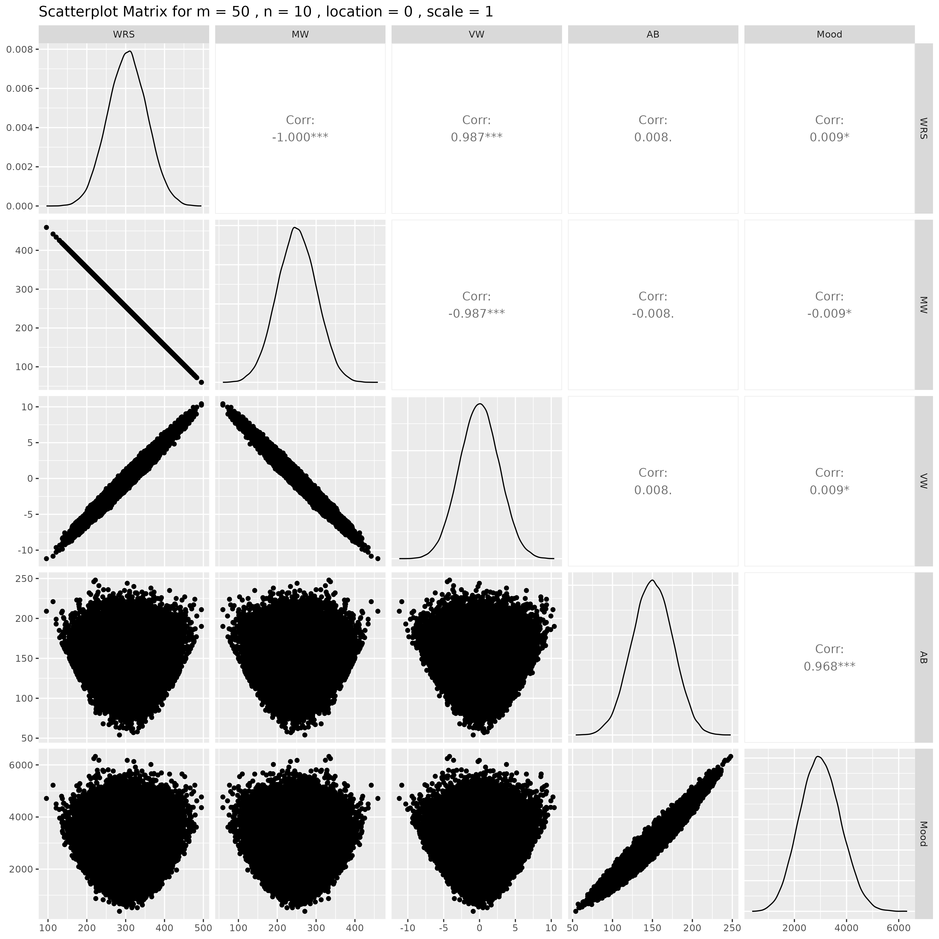

## Results for m = 50 , n = 15 , location = 0 , scale = 1

### Correlation Matrix

| Statistic | WRS | MW | VW | AB | Mood |
| --- | --- | --- | --- | --- | --- |
| character | Numeric | numeric | numeric | numeric | numeric |
| WRS | 1.0000 | -1.0000 | 0.9862 | -0.0010 | -0.0010 |
| MW | -1.0000 | 1.0000 | -0.9862 | 0.0010 | 0.0010 |
| VW | 0.9862 | -0.9862 | 1.0000 | 0.0005 | 0.0006 |
| AB | -0.0010 | 0.0010 | 0.0005 | 1.0000 | 0.9684 |
| Mood | -0.0010 | 0.0010 | 0.0006 | 0.9684 | 1.0000 |
| n: 5 | | | | | |

### P-Value Matrix

| Statistic | WRS | MW | VW | AB | Mood |
| --- | --- | --- | --- | --- | --- |
| character | Numeric | numeric | numeric | numeric | numeric |
| WRS |  | 0.0000 | 0.0000 | 0.8174 | 0.8226 |
| MW | 0.0000 |  | 0.0000 | 0.8174 | 0.8226 |
| VW | 0.0000 | 0.0000 |  | 0.9127 | 0.8926 |
| AB | 0.8174 | 0.8174 | 0.9127 |  | 0.0000 |
| Mood | 0.8226 | 0.8226 | 0.8926 | 0.0000 |  |
| n: 5 | | | | | |

### Scatter Plot Matrix:

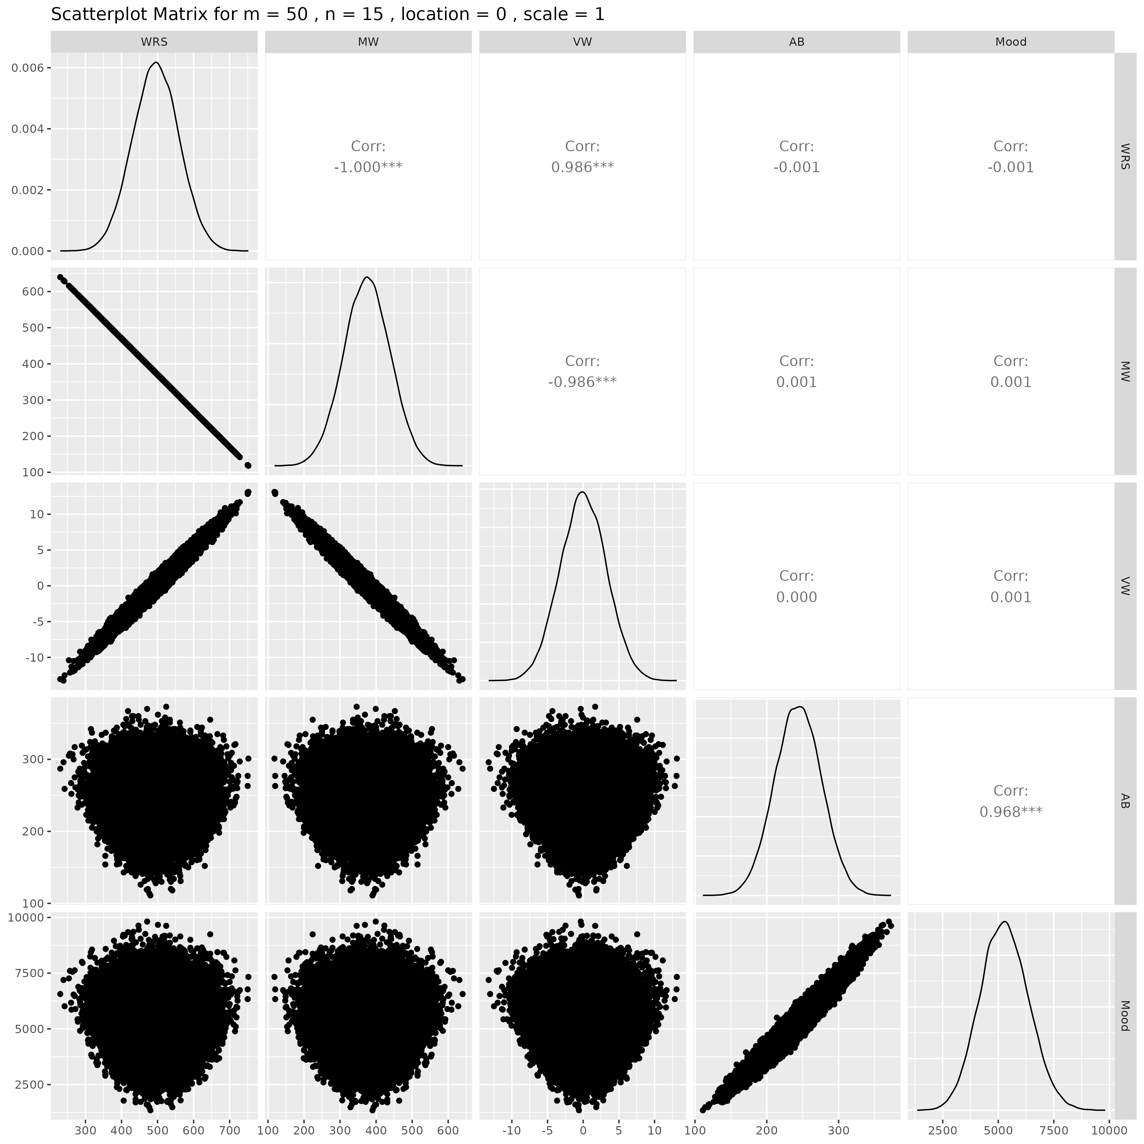

## Results for m = 50 , n = 20 , location = 0 , scale = 1

### Correlation Matrix

| Statistic | WRS | MW | VW | AB | Mood |
| --- | --- | --- | --- | --- | --- |
| character | Numeric | numeric | numeric | numeric | numeric |
| WRS | 1.0000 | -1.0000 | 0.9858 | 0.0076 | 0.0072 |
| MW | -1.0000 | 1.0000 | -0.9858 | -0.0076 | -0.0072 |
| VW | 0.9858 | -0.9858 | 1.0000 | 0.0073 | 0.0071 |
| AB | 0.0076 | -0.0076 | 0.0073 | 1.0000 | 0.9686 |
| Mood | 0.0072 | -0.0072 | 0.0071 | 0.9686 | 1.0000 |
| n: 5 | | | | | |

### P-Value Matrix

| Statistic | WRS | MW | VW | AB | Mood |
| --- | --- | --- | --- | --- | --- |
| character | Numeric | numeric | numeric | numeric | numeric |
| WRS |  | 0.0000 | 0.0000 | 0.0876 | 0.1067 |
| MW | 0.0000 |  | 0.0000 | 0.0876 | 0.1067 |
| VW | 0.0000 | 0.0000 |  | 0.1005 | 0.1143 |
| AB | 0.0876 | 0.0876 | 0.1005 |  | 0.0000 |
| Mood | 0.1067 | 0.1067 | 0.1143 | 0.0000 |  |
| n: 5 | | | | | |

### Scatter Plot Matrix:

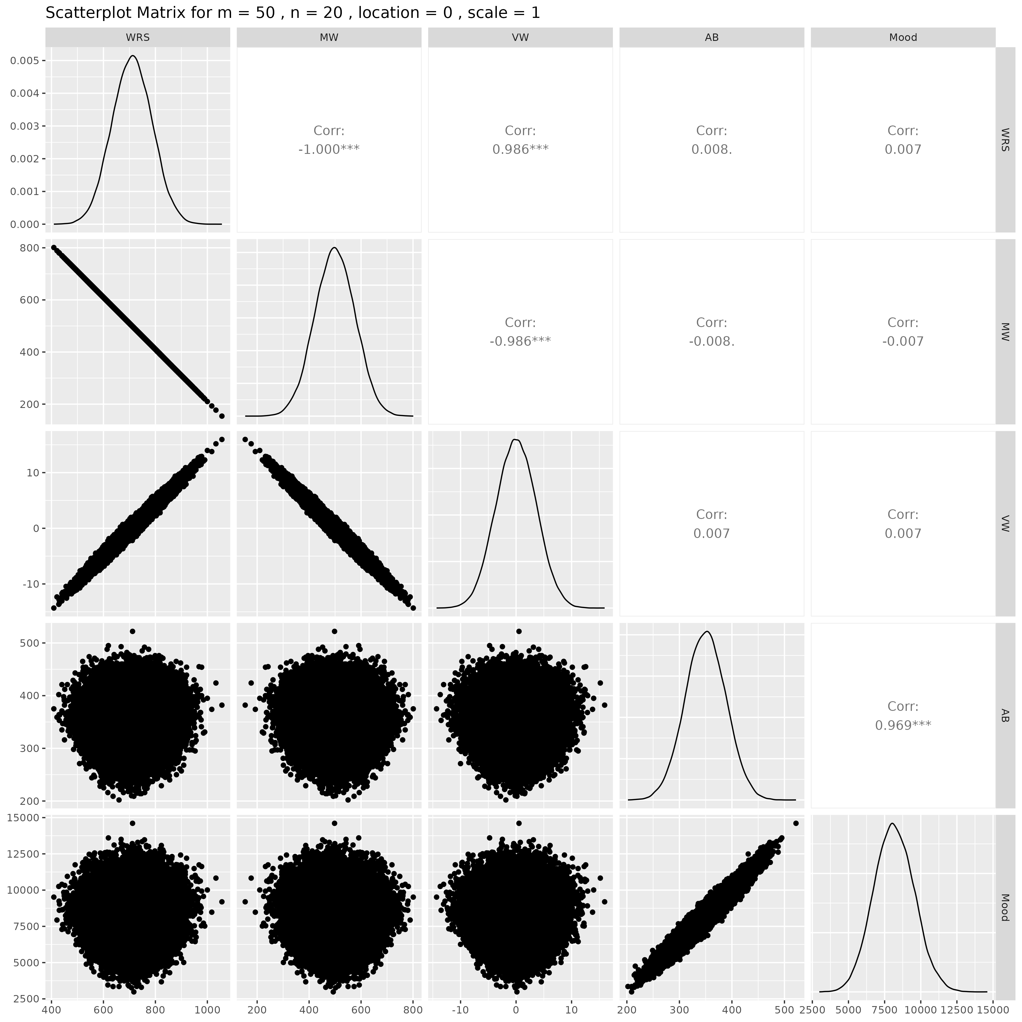

## Results for m = 50 , n = 25 , location = 0 , scale = 1

### Correlation Matrix

| Statistic | WRS | MW | VW | AB | Mood |
| --- | --- | --- | --- | --- | --- |
| character | Numeric | numeric | numeric | numeric | numeric |
| WRS | 1.0000 | -1.0000 | 0.9855 | -0.0040 | -0.0022 |
| MW | -1.0000 | 1.0000 | -0.9855 | 0.0040 | 0.0022 |
| VW | 0.9855 | -0.9855 | 1.0000 | -0.0049 | -0.0032 |
| AB | -0.0040 | 0.0040 | -0.0049 | 1.0000 | 0.9681 |
| Mood | -0.0022 | 0.0022 | -0.0032 | 0.9681 | 1.0000 |
| n: 5 | | | | | |

### P-Value Matrix

| Statistic | WRS | MW | VW | AB | Mood |
| --- | --- | --- | --- | --- | --- |
| character | Numeric | numeric | numeric | numeric | numeric |
| WRS |  | 0.0000 | 0.0000 | 0.3706 | 0.6294 |
| MW | 0.0000 |  | 0.0000 | 0.3706 | 0.6294 |
| VW | 0.0000 | 0.0000 |  | 0.2772 | 0.4736 |
| AB | 0.3706 | 0.3706 | 0.2772 |  | 0.0000 |
| Mood | 0.6294 | 0.6294 | 0.4736 | 0.0000 |  |
| n: 5 | | | | | |

### Scatter Plot Matrix:

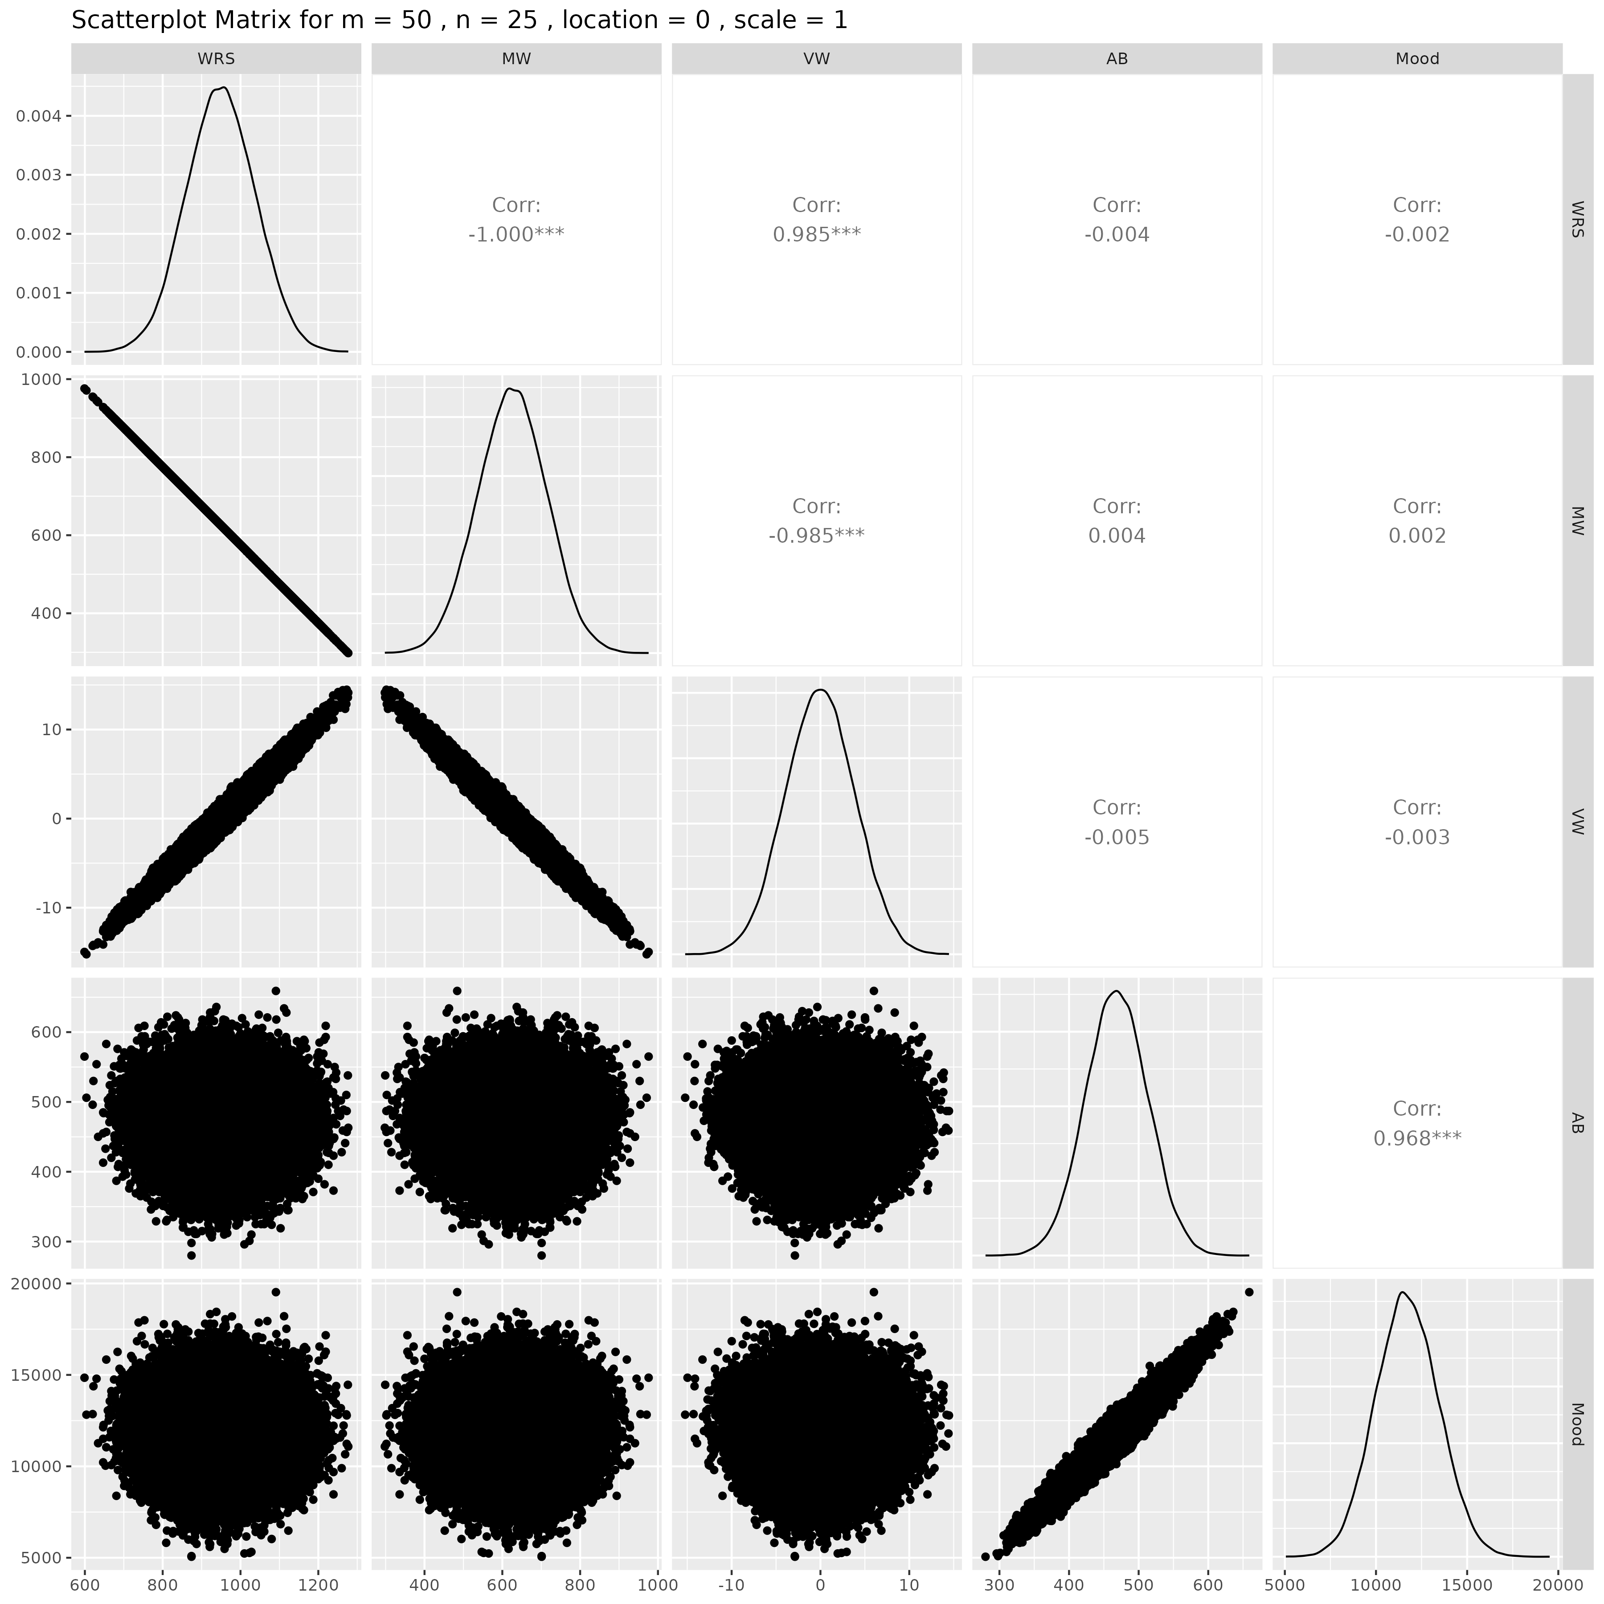

## Results for m = 50 , n = 30 , location = 0 , scale = 1

### Correlation Matrix

| Statistic | WRS | MW | VW | AB | Mood |
| --- | --- | --- | --- | --- | --- |
| character | Numeric | numeric | numeric | numeric | numeric |
| WRS | 1.0000 | -1.0000 | 0.9852 | -0.0008 | -0.0007 |
| MW | -1.0000 | 1.0000 | -0.9852 | 0.0008 | 0.0007 |
| VW | 0.9852 | -0.9852 | 1.0000 | -0.0008 | -0.0007 |
| AB | -0.0008 | 0.0008 | -0.0008 | 1.0000 | 0.9684 |
| Mood | -0.0007 | 0.0007 | -0.0007 | 0.9684 | 1.0000 |
| n: 5 | | | | | |

### P-Value Matrix

| Statistic | WRS | MW | VW | AB | Mood |
| --- | --- | --- | --- | --- | --- |
| character | numeric | numeric | numeric | numeric | numeric |
| WRS |  | 0.0000 | 0.0000 | 0.8538 | 0.8715 |
| MW | 0.0000 |  | 0.0000 | 0.8538 | 0.8715 |
| VW | 0.0000 | 0.0000 |  | 0.8667 | 0.8720 |
| AB | 0.8538 | 0.8538 | 0.8667 |  | 0.0000 |
| Mood | 0.8715 | 0.8715 | 0.8720 | 0.0000 |  |
| n: 5 | | | | | |

### Scatter Plot Matrix:

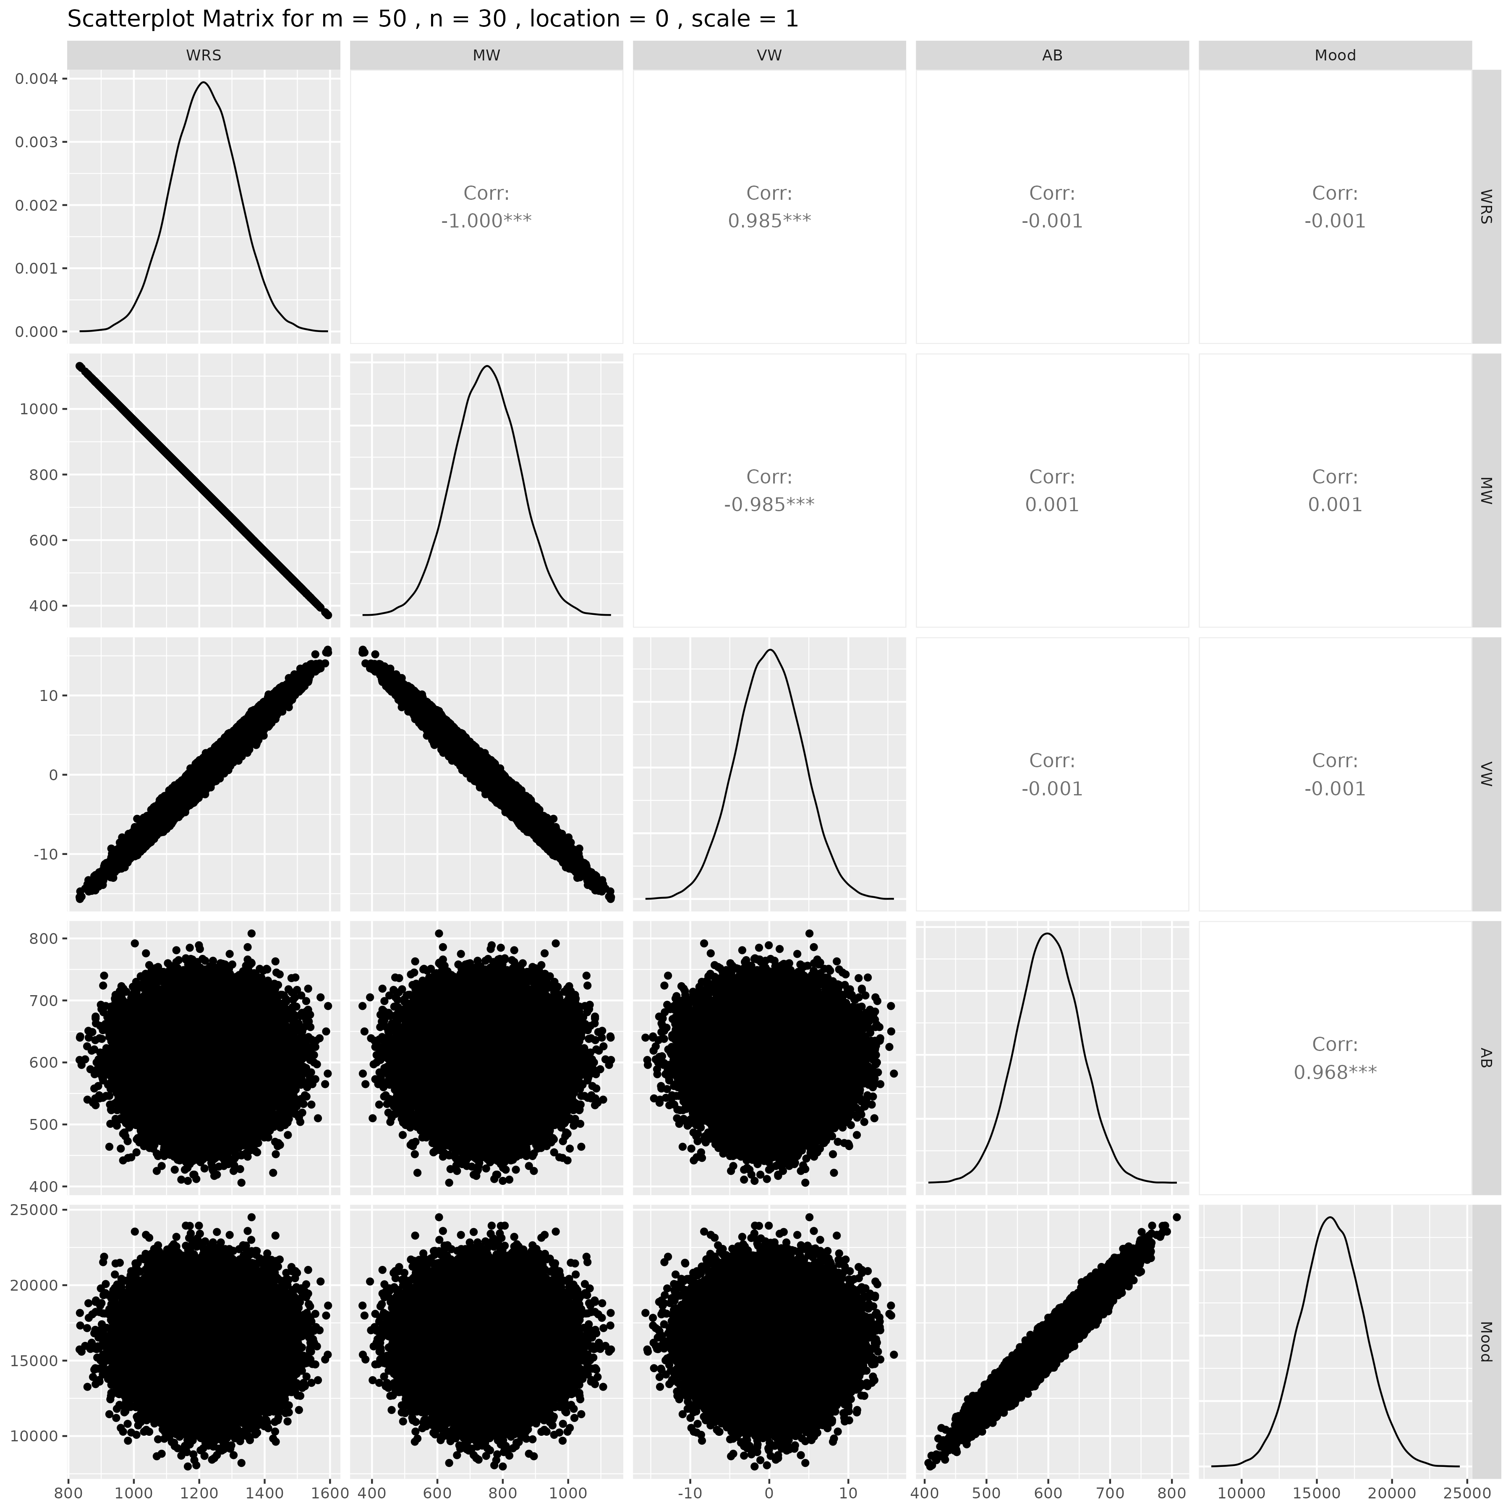

## Results for m = 50 , n = 50 , location = 0 , scale = 1

### Correlation Matrix

| Statistic | WRS | MW | VW | AB | Mood |
| --- | --- | --- | --- | --- | --- |
| character | numeric | numeric | numeric | numeric | numeric |
| WRS | 1.0000 | -1.0000 | 0.9843 | 0.0004 | 0.0006 |
| MW | -1.0000 | 1.0000 | -0.9843 | -0.0004 | -0.0006 |
| VW | 0.9843 | -0.9843 | 1.0000 | 0.0013 | 0.0015 |
| AB | 0.0004 | -0.0004 | 0.0013 | 1.0000 | 0.9674 |
| Mood | 0.0006 | -0.0006 | 0.0015 | 0.9674 | 1.0000 |
| n: 5 | | | | | |

### P-Value Matrix

| Statistic | WRS | MW | VW | AB | Mood |
| --- | --- | --- | --- | --- | --- |
| character | numeric | numeric | numeric | numeric | numeric |
| WRS |  | 0.0000 | 0.0000 | 0.9222 | 0.8895 |
| MW | 0.0000 |  | 0.0000 | 0.9222 | 0.8895 |
| VW | 0.0000 | 0.0000 |  | 0.7742 | 0.7388 |
| AB | 0.9222 | 0.9222 | 0.7742 |  | 0.0000 |
| Mood | 0.8895 | 0.8895 | 0.7388 | 0.0000 |  |
| n: 5 | | | | | |

### Scatter Plot Matrix:

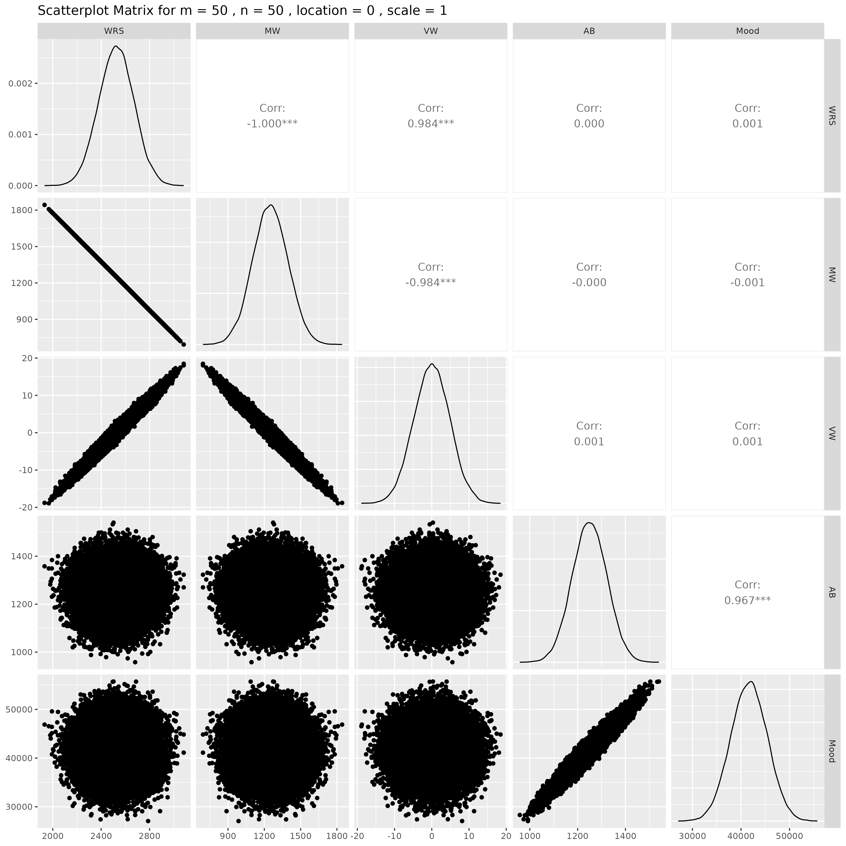

## Results for m = 75 , n = 5 , location = 0 , scale = 1

### Correlation Matrix

| Statistic | WRS | MW | VW | AB | Mood |
| --- | --- | --- | --- | --- | --- |
| character | numeric | numeric | numeric | numeric | numeric |
| WRS | 1.0000 | -1.0000 | 0.9853 | 0.0029 | -0.0001 |
| MW | -1.0000 | 1.0000 | -0.9853 | -0.0029 | 0.0001 |
| VW | 0.9853 | -0.9853 | 1.0000 | 0.0020 | -0.0010 |
| AB | 0.0029 | -0.0029 | 0.0020 | 1.0000 | 0.9685 |
| Mood | -0.0001 | 0.0001 | -0.0010 | 0.9685 | 1.0000 |
| n: 5 | | | | | |

### P-Value Matrix

| Statistic | WRS | MW | VW | AB | Mood |
| --- | --- | --- | --- | --- | --- |
| character | numeric | numeric | numeric | numeric | Numeric |
| WRS |  | 0.0000 | 0.0000 | 0.5233 | 0.9872 |
| MW | 0.0000 |  | 0.0000 | 0.5233 | 0.9872 |
| VW | 0.0000 | 0.0000 |  | 0.6603 | 0.8268 |
| AB | 0.5233 | 0.5233 | 0.6603 |  | 0.0000 |
| Mood | 0.9872 | 0.9872 | 0.8268 | 0.0000 |  |
| n: 5 | | | | | |

### Scatter Plot Matrix:

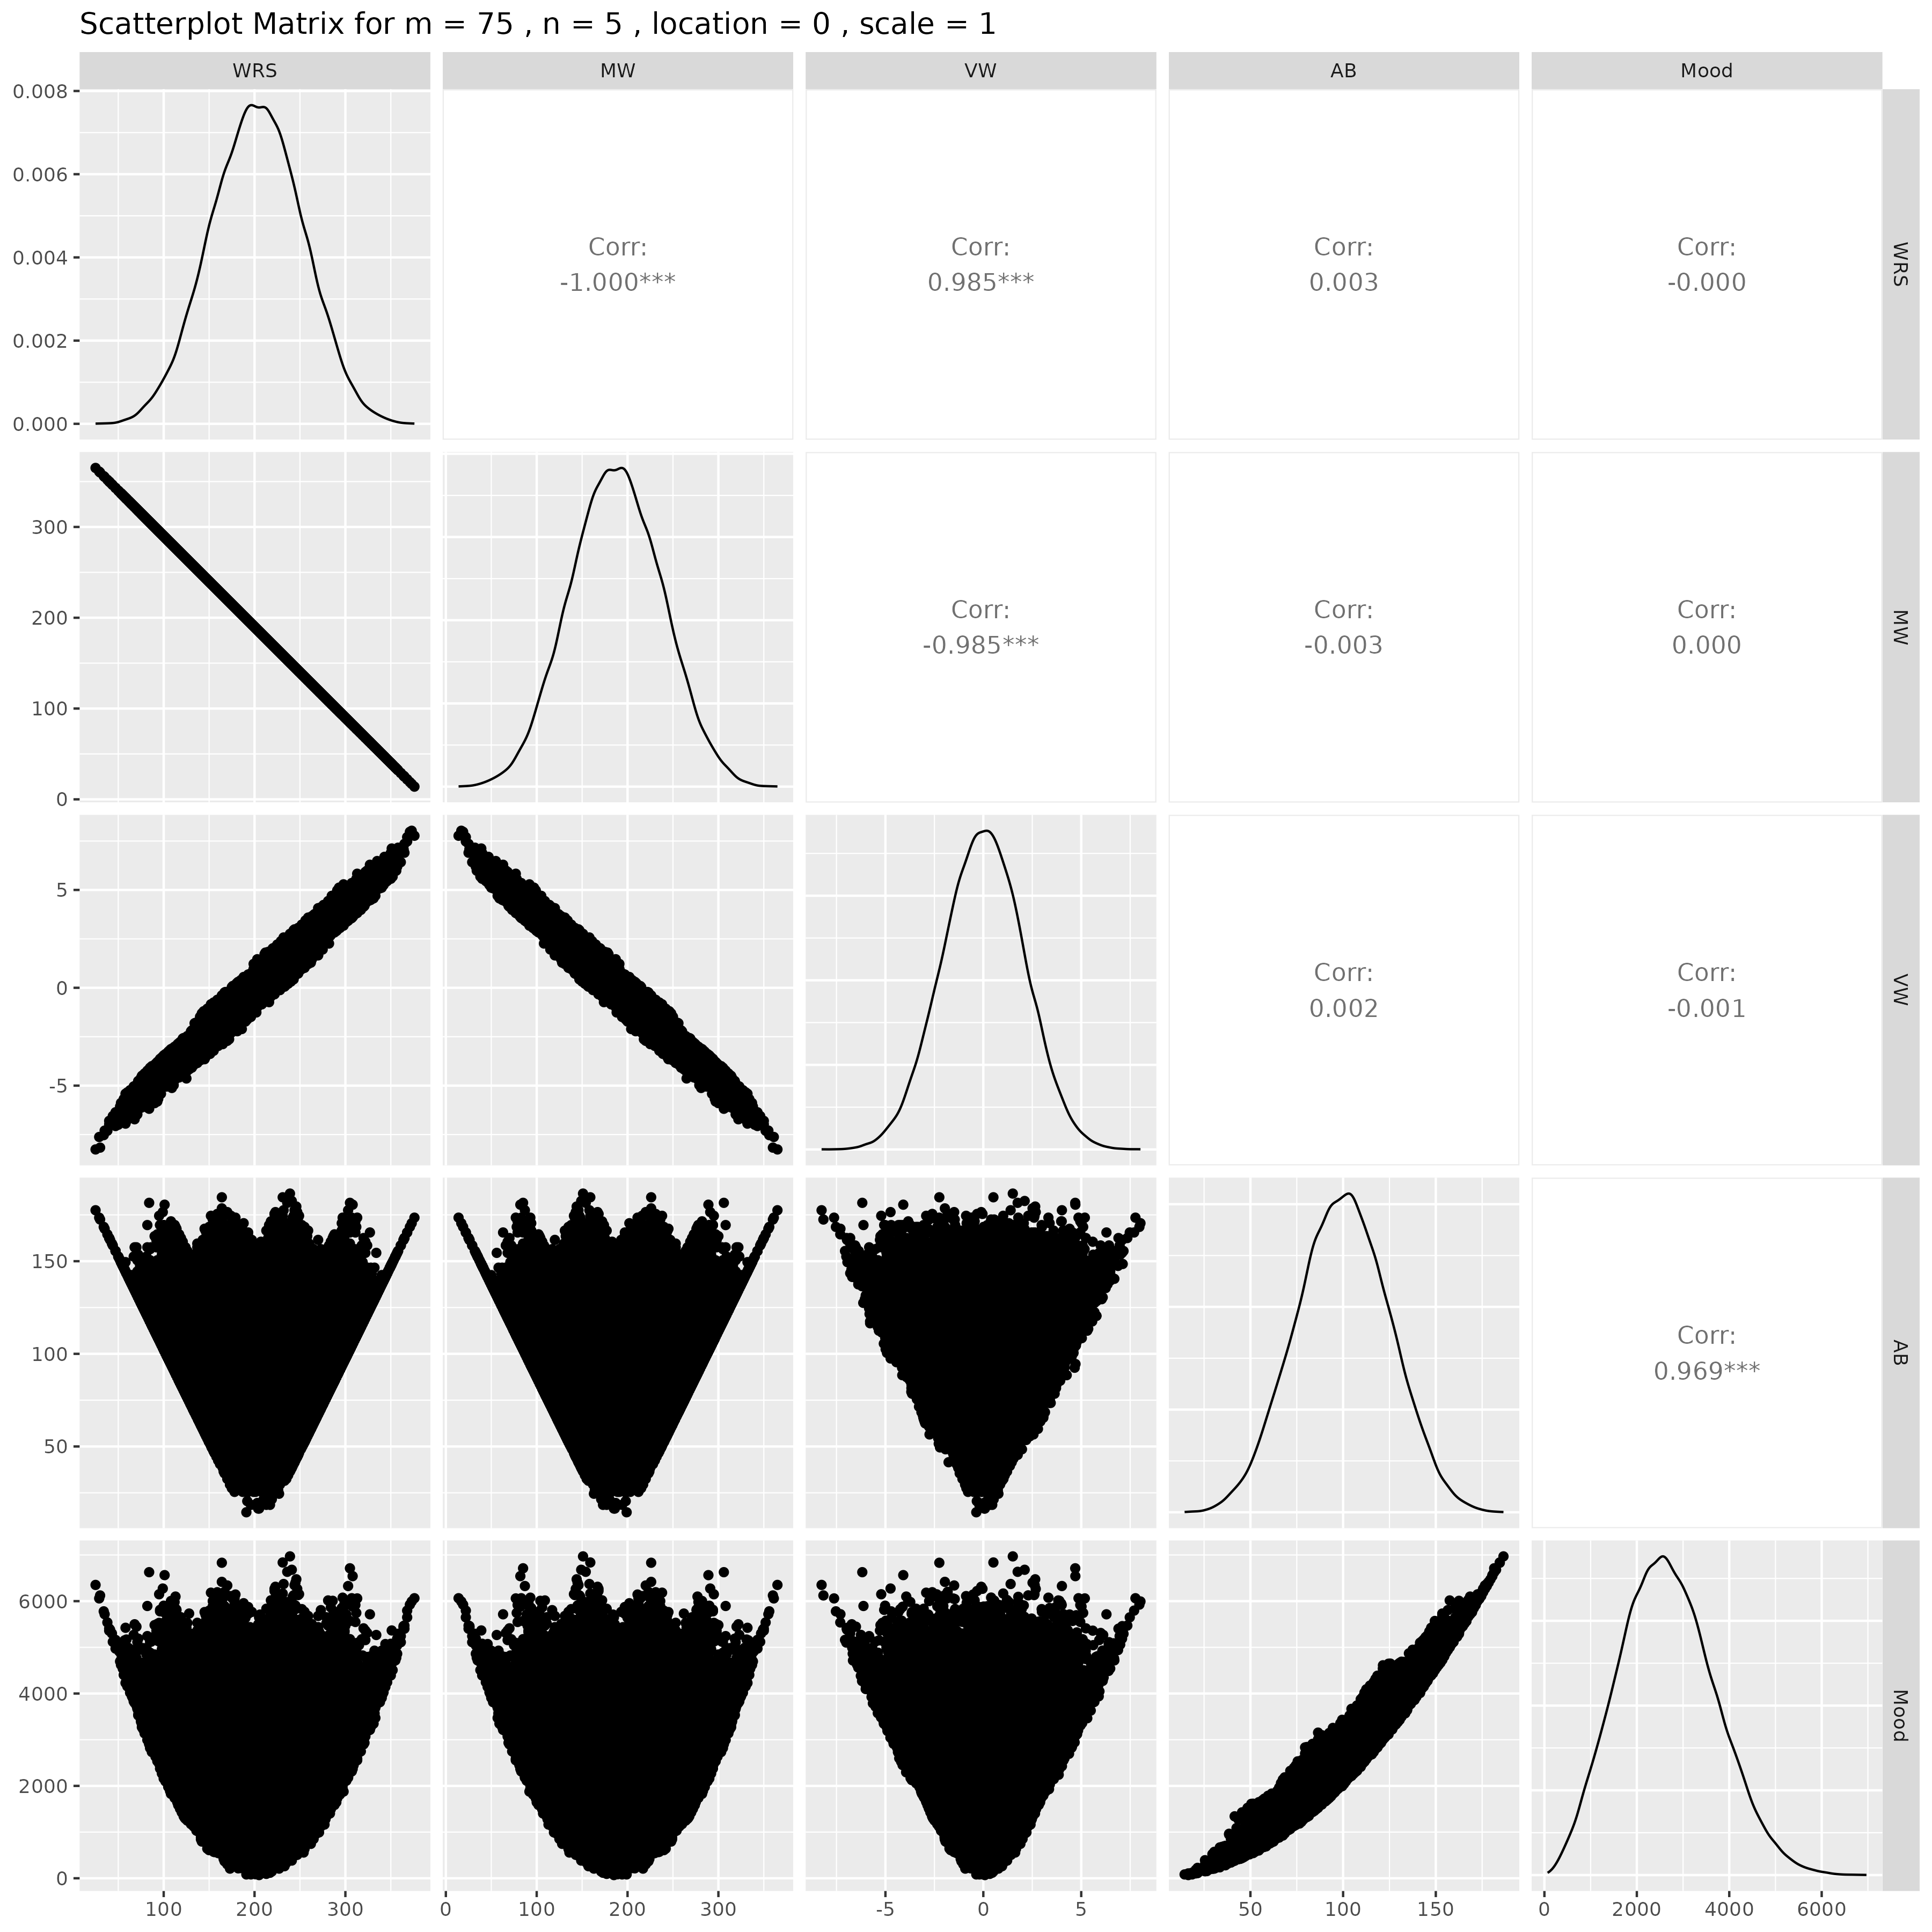

## Results for m = 75 , n = 10 , location = 0 , scale = 1

### Correlation Matrix

| Statistic | WRS | MW | VW | AB | Mood |
| --- | --- | --- | --- | --- | --- |
| character | numeric | numeric | numeric | numeric | Numeric |
| WRS | 1.0000 | -1.0000 | 0.9851 | 0.0060 | 0.0069 |
| MW | -1.0000 | 1.0000 | -0.9851 | -0.0060 | -0.0069 |
| VW | 0.9851 | -0.9851 | 1.0000 | 0.0071 | 0.0083 |
| AB | 0.0060 | -0.0060 | 0.0071 | 1.0000 | 0.9681 |
| Mood | 0.0069 | -0.0069 | 0.0083 | 0.9681 | 1.0000 |
| n: 5 | | | | | |

### P-Value Matrix

| Statistic | WRS | MW | VW | AB | Mood |
| --- | --- | --- | --- | --- | --- |
| character | numeric | numeric | numeric | numeric | Numeric |
| WRS |  | 0.0000 | 0.0000 | 0.1790 | 0.1218 |
| MW | 0.0000 |  | 0.0000 | 0.1790 | 0.1218 |
| VW | 0.0000 | 0.0000 |  | 0.1123 | 0.0634 |
| AB | 0.1790 | 0.1790 | 0.1123 |  | 0.0000 |
| Mood | 0.1218 | 0.1218 | 0.0634 | 0.0000 |  |
| n: 5 | | | | | |

### Scatter Plot Matrix:

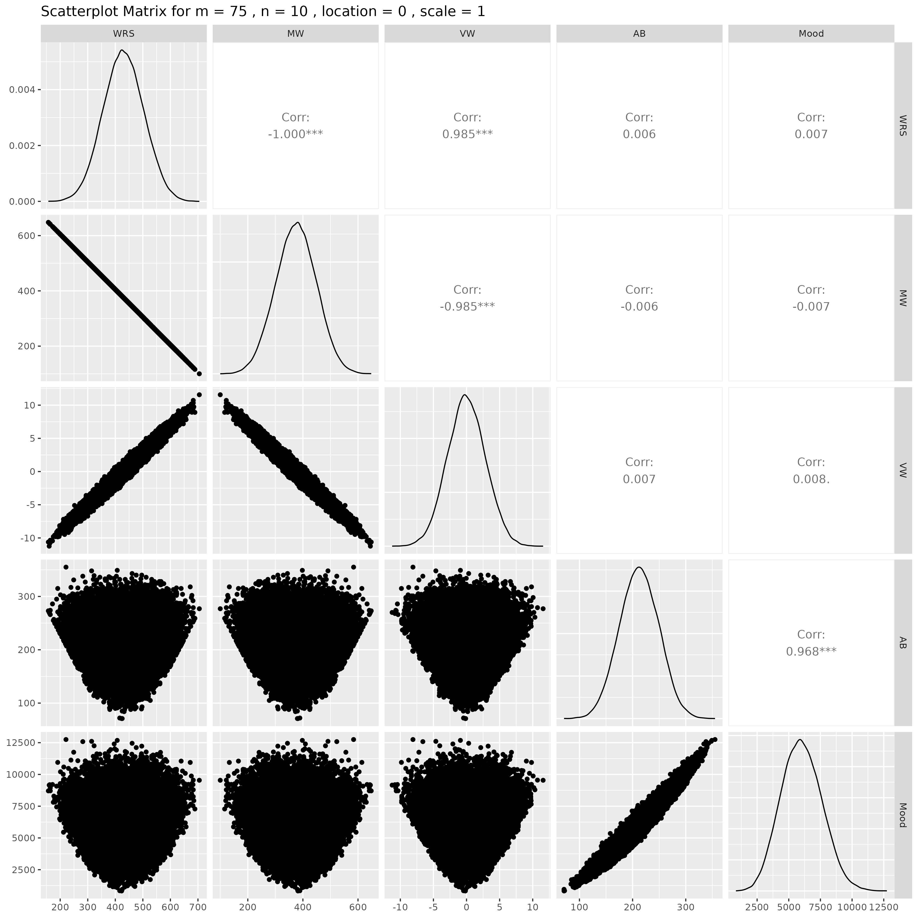

## Results for m = 75 , n = 15 , location = 0 , scale = 1

### Correlation Matrix

| Statistic | WRS | MW | VW | AB | Mood |
| --- | --- | --- | --- | --- | --- |
| character | numeric | numeric | numeric | numeric | Numeric |
| WRS | 1.0000 | -1.0000 | 0.9848 | 0.0049 | 0.0052 |
| MW | -1.0000 | 1.0000 | -0.9848 | -0.0049 | -0.0052 |
| VW | 0.9848 | -0.9848 | 1.0000 | 0.0047 | 0.0051 |
| AB | 0.0049 | -0.0049 | 0.0047 | 1.0000 | 0.9679 |
| Mood | 0.0052 | -0.0052 | 0.0051 | 0.9679 | 1.0000 |
| n: 5 | | | | | |

### P-Value Matrix

| Statistic | WRS | MW | VW | AB | Mood |
| --- | --- | --- | --- | --- | --- |
| character | numeric | numeric | numeric | numeric | Numeric |
| WRS |  | 0.0000 | 0.0000 | 0.2732 | 0.2448 |
| MW | 0.0000 |  | 0.0000 | 0.2732 | 0.2448 |
| VW | 0.0000 | 0.0000 |  | 0.2904 | 0.2554 |
| AB | 0.2732 | 0.2732 | 0.2904 |  | 0.0000 |
| Mood | 0.2448 | 0.2448 | 0.2554 | 0.0000 |  |
| n: 5 | | | | | |

### Scatter Plot Matrix:

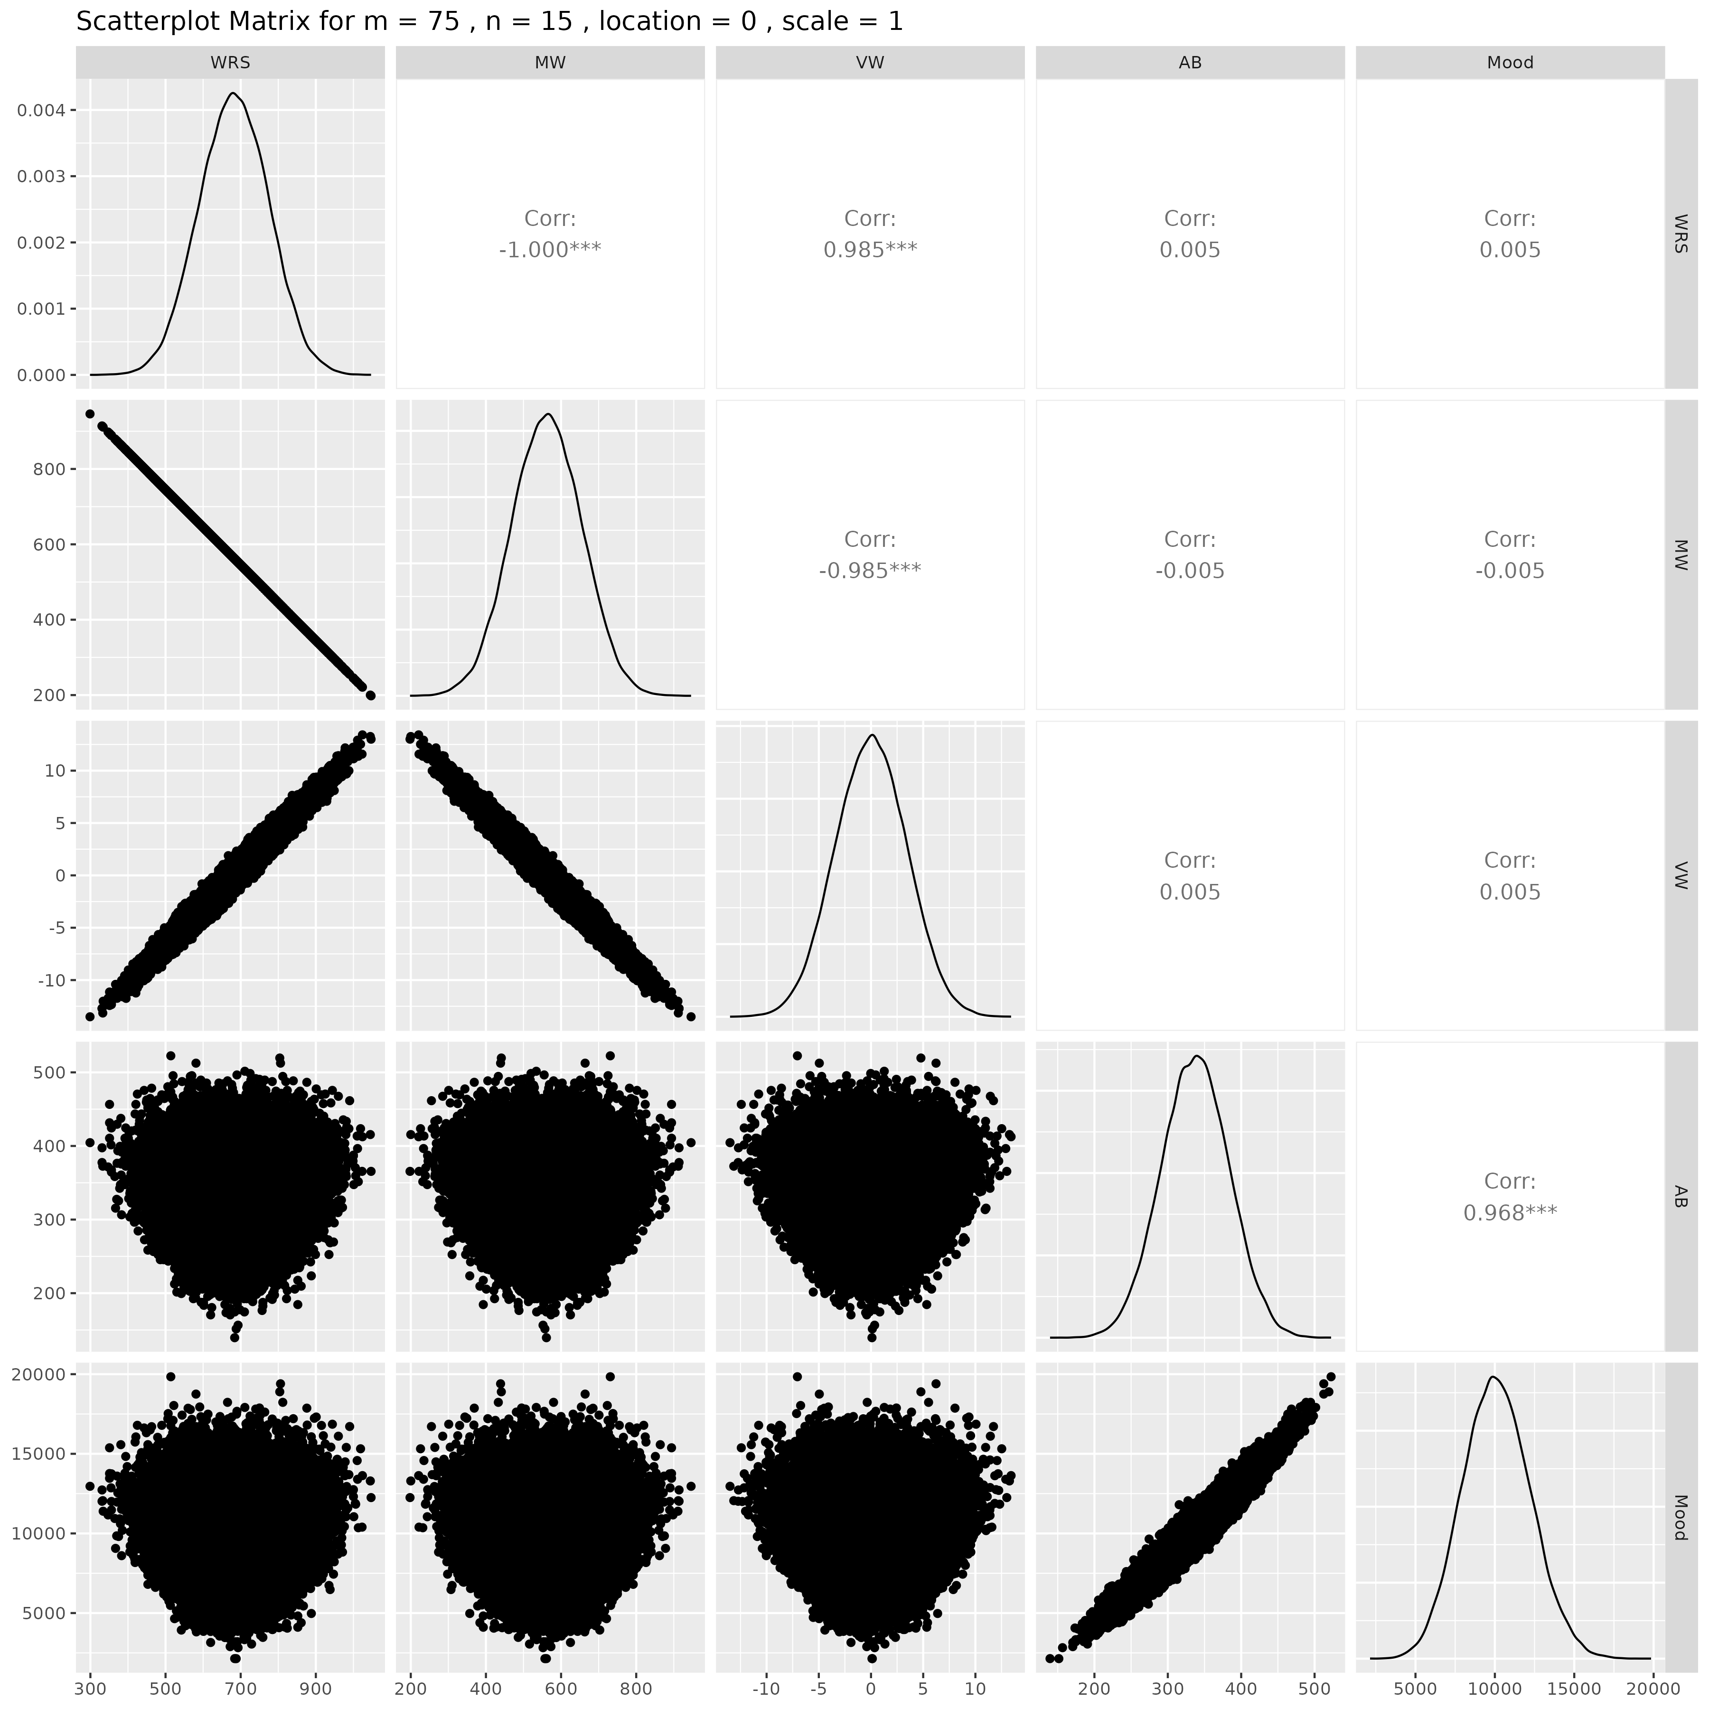

## Results for m = 75 , n = 20 , location = 0 , scale = 1

### Correlation Matrix

| Statistic | WRS | MW | VW | AB | Mood |
| --- | --- | --- | --- | --- | --- |
| character | numeric | numeric | numeric | numeric | Numeric |
| WRS | 1.0000 | -1.0000 | 0.9844 | 0.0016 | 0.0005 |
| MW | -1.0000 | 1.0000 | -0.9844 | -0.0016 | -0.0005 |
| VW | 0.9844 | -0.9844 | 1.0000 | 0.0031 | 0.0019 |
| AB | 0.0016 | -0.0016 | 0.0031 | 1.0000 | 0.9682 |
| Mood | 0.0005 | -0.0005 | 0.0019 | 0.9682 | 1.0000 |
| n: 5 | | | | | |

### P-Value Matrix

| Statistic | WRS | MW | VW | AB | Mood |
| --- | --- | --- | --- | --- | --- |
| character | numeric | numeric | numeric | numeric | Numeric |
| WRS |  | 0.0000 | 0.0000 | 0.7191 | 0.9120 |
| MW | 0.0000 |  | 0.0000 | 0.7191 | 0.9120 |
| VW | 0.0000 | 0.0000 |  | 0.4846 | 0.6752 |
| AB | 0.7191 | 0.7191 | 0.4846 |  | 0.0000 |
| Mood | 0.9120 | 0.9120 | 0.6752 | 0.0000 |  |
| n: 5 | | | | | |

### Scatter Plot Matrix:

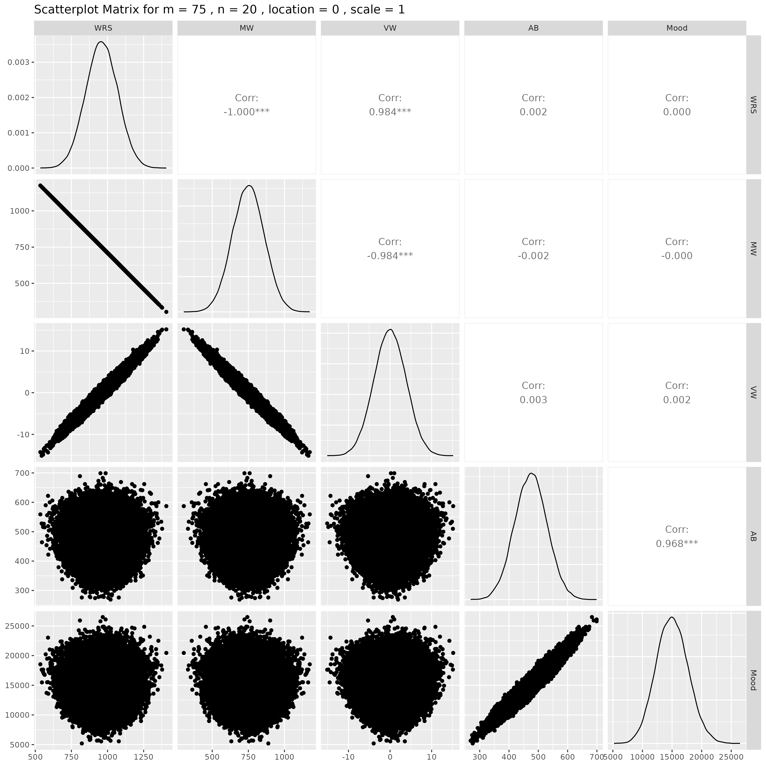

## Results for m = 75 , n = 25 , location = 0 , scale = 1

### Correlation Matrix

| Statistic | WRS | MW | VW | AB | Mood |
| --- | --- | --- | --- | --- | --- |
| character | numeric | numeric | numeric | numeric | Numeric |
| WRS | 1.0000 | -1.0000 | 0.9842 | -0.0014 | 0.0005 |
| MW | -1.0000 | 1.0000 | -0.9842 | 0.0014 | -0.0005 |
| VW | 0.9842 | -0.9842 | 1.0000 | -0.0003 | 0.0018 |
| AB | -0.0014 | 0.0014 | -0.0003 | 1.0000 | 0.9686 |
| Mood | 0.0005 | -0.0005 | 0.0018 | 0.9686 | 1.0000 |
| n: 5 | | | | | |

### P-Value Matrix

| Statistic | WRS | MW | VW | AB | Mood |
| --- | --- | --- | --- | --- | --- |
| character | numeric | numeric | numeric | numeric | Numeric |
| WRS |  | 0.0000 | 0.0000 | 0.7486 | 0.9059 |
| MW | 0.0000 |  | 0.0000 | 0.7486 | 0.9059 |
| VW | 0.0000 | 0.0000 |  | 0.9477 | 0.6799 |
| AB | 0.7486 | 0.7486 | 0.9477 |  | 0.0000 |
| Mood | 0.9059 | 0.9059 | 0.6799 | 0.0000 |  |
| n: 5 | | | | | |

### Scatter Plot Matrix:

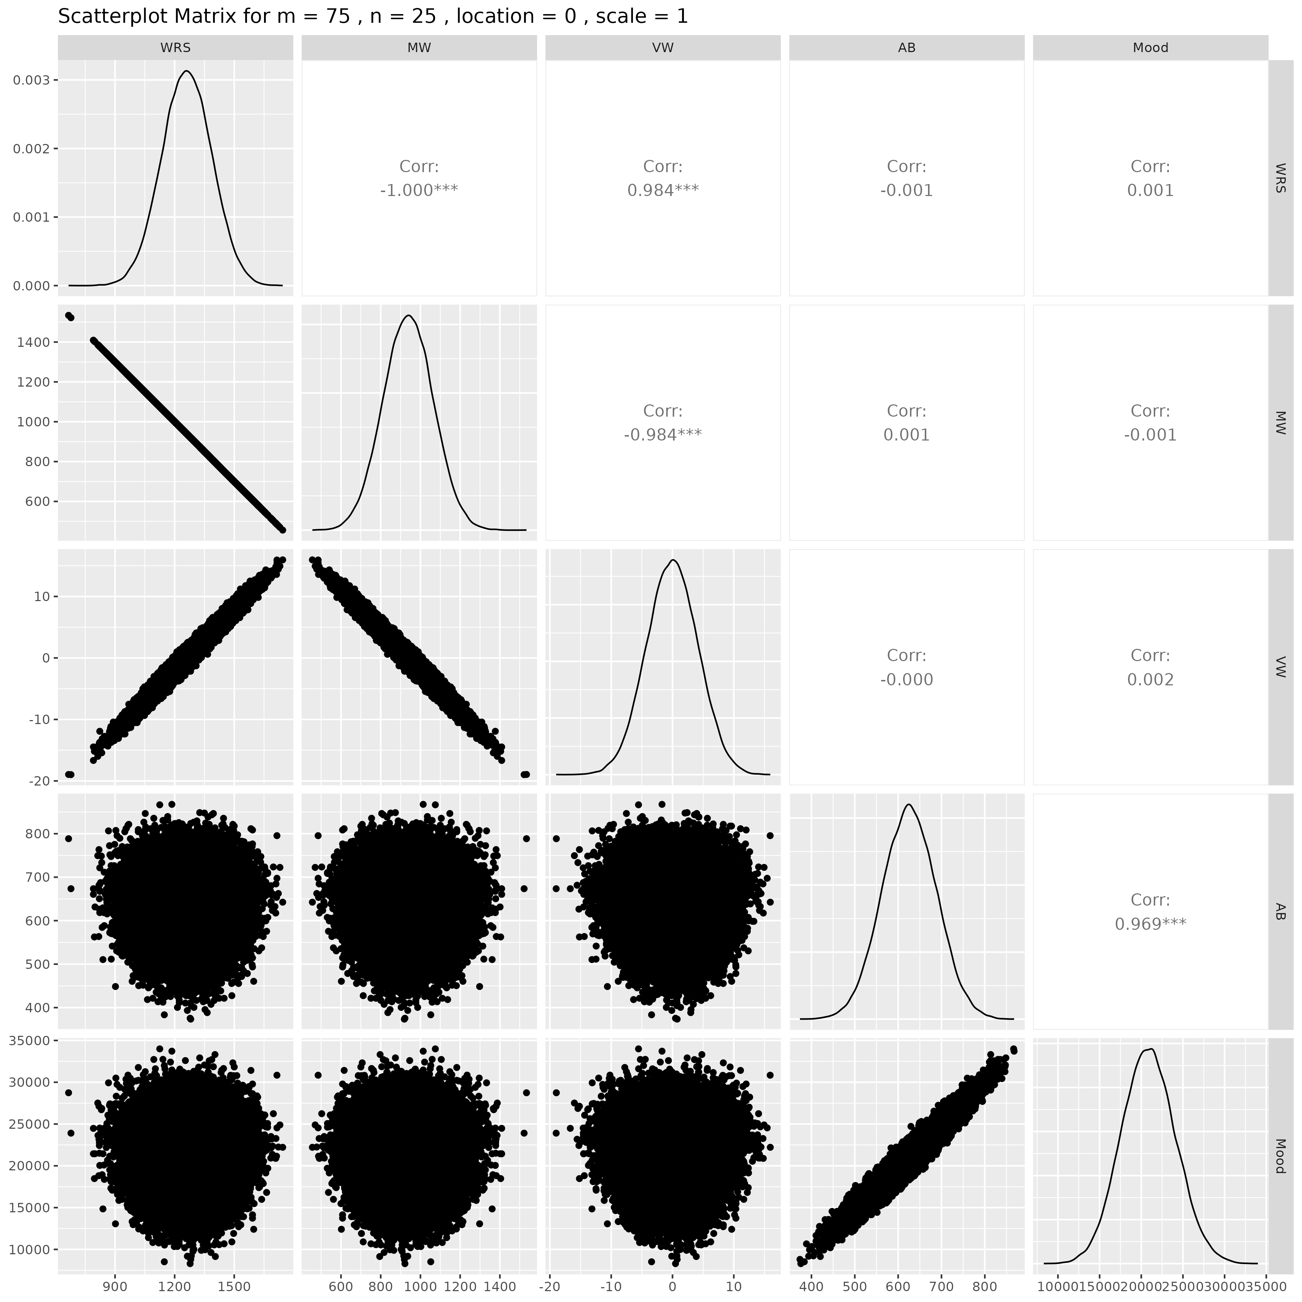

## Results for m = 75 , n = 30 , location = 0 , scale = 1

### Correlation Matrix

| Statistic | WRS | MW | VW | AB | Mood |
| --- | --- | --- | --- | --- | --- |
| character | numeric | numeric | numeric | numeric | Numeric |
| WRS | 1.0000 | -1.0000 | 0.9840 | 0.0021 | 0.0025 |
| MW | -1.0000 | 1.0000 | -0.9840 | -0.0021 | -0.0025 |
| VW | 0.9840 | -0.9840 | 1.0000 | 0.0011 | 0.0015 |
| AB | 0.0021 | -0.0021 | 0.0011 | 1.0000 | 0.9680 |
| Mood | 0.0025 | -0.0025 | 0.0015 | 0.9680 | 1.0000 |
| n: 5 | | | | | |

### P-Value Matrix

| Statistic | WRS | MW | VW | AB | Mood |
| --- | --- | --- | --- | --- | --- |
| character | numeric | numeric | numeric | numeric | Numeric |
| WRS |  | 0.0000 | 0.0000 | 0.6392 | 0.5780 |
| MW | 0.0000 |  | 0.0000 | 0.6392 | 0.5780 |
| VW | 0.0000 | 0.0000 |  | 0.8122 | 0.7348 |
| AB | 0.6392 | 0.6392 | 0.8122 |  | 0.0000 |
| Mood | 0.5780 | 0.5780 | 0.7348 | 0.0000 |  |
| n: 5 | | | | | |

### Scatter Plot Matrix:

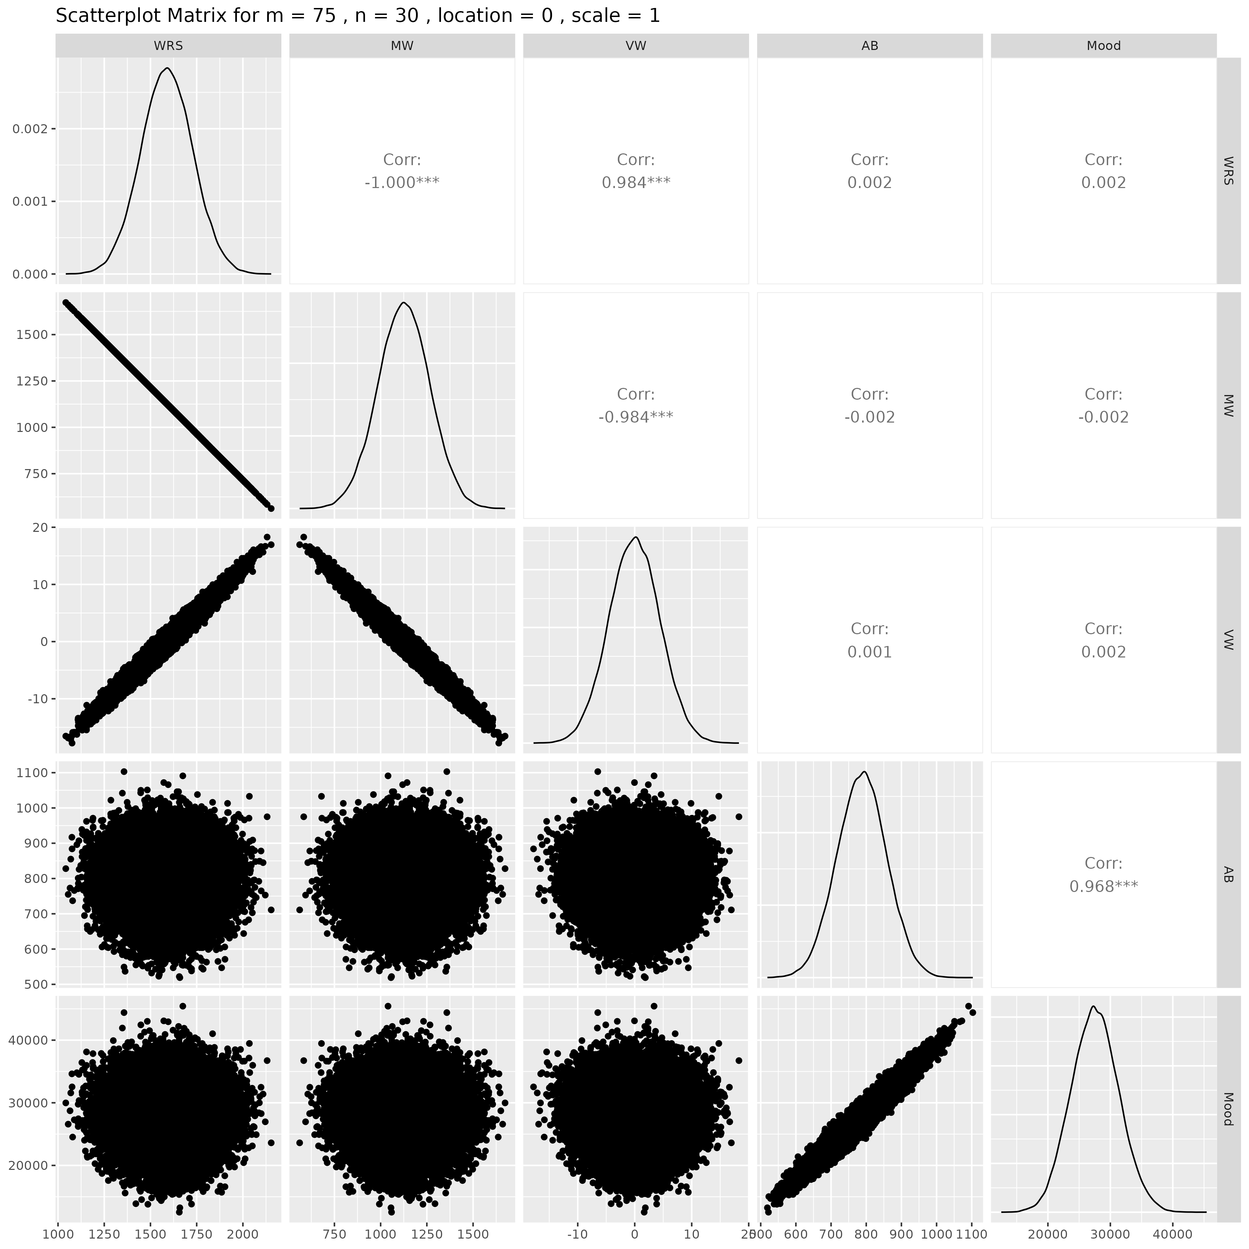

## Results for m = 75 , n = 50 , location = 0 , scale = 1

### Correlation Matrix

| Statistic | WRS | MW | VW | AB | Mood |
| --- | --- | --- | --- | --- | --- |
| character | numeric | numeric | numeric | numeric | Numeric |
| WRS | 1.0000 | -1.0000 | 0.9833 | -0.0018 | -0.0012 |
| MW | -1.0000 | 1.0000 | -0.9833 | 0.0018 | 0.0012 |
| VW | 0.9833 | -0.9833 | 1.0000 | -0.0004 | 0.0000 |
| AB | -0.0018 | 0.0018 | -0.0004 | 1.0000 | 0.9684 |
| Mood | -0.0012 | 0.0012 | 0.0000 | 0.9684 | 1.0000 |
| n: 5 | | | | | |

### P-Value Matrix

| Statistic | WRS | MW | VW | AB | Mood |
| --- | --- | --- | --- | --- | --- |
| character | numeric | numeric | numeric | numeric | Numeric |
| WRS |  | 0.0000 | 0.0000 | 0.6865 | 0.7933 |
| MW | 0.0000 |  | 0.0000 | 0.6865 | 0.7933 |
| VW | 0.0000 | 0.0000 |  | 0.9319 | 0.9977 |
| AB | 0.6865 | 0.6865 | 0.9319 |  | 0.0000 |
| Mood | 0.7933 | 0.7933 | 0.9977 | 0.0000 |  |
| n: 5 | | | | | |

### Scatter Plot Matrix:

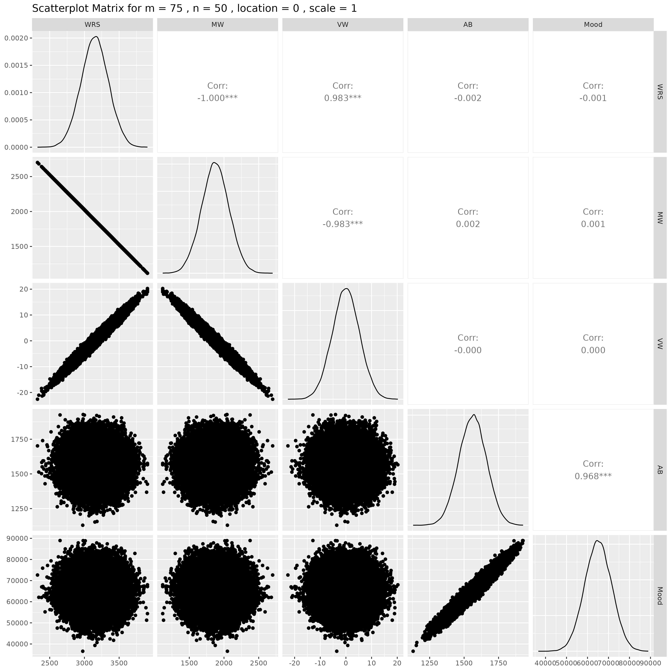

## Results for m = 100 , n = 5 , location = 0 , scale = 1

### Correlation Matrix

| Statistic | WRS | MW | VW | AB | Mood |
| --- | --- | --- | --- | --- | --- |
| character | numeric | numeric | numeric | numeric | Numeric |
| WRS | 1.0000 | -1.0000 | 0.9840 | -0.0068 | -0.0064 |
| MW | -1.0000 | 1.0000 | -0.9840 | 0.0068 | 0.0064 |
| VW | 0.9840 | -0.9840 | 1.0000 | -0.0066 | -0.0061 |
| AB | -0.0068 | 0.0068 | -0.0066 | 1.0000 | 0.9688 |
| Mood | -0.0064 | 0.0064 | -0.0061 | 0.9688 | 1.0000 |
| n: 5 | | | | | |

### P-Value Matrix

| Statistic | WRS | MW | VW | AB | Mood |
| --- | --- | --- | --- | --- | --- |
| character | numeric | numeric | numeric | numeric | Numeric |
| WRS |  | 0.0000 | 0.0000 | 0.1306 | 0.1530 |
| MW | 0.0000 |  | 0.0000 | 0.1306 | 0.1530 |
| VW | 0.0000 | 0.0000 |  | 0.1424 | 0.1733 |
| AB | 0.1306 | 0.1306 | 0.1424 |  | 0.0000 |
| Mood | 0.1530 | 0.1530 | 0.1733 | 0.0000 |  |
| n: 5 | | | | | |

### Scatter Plot Matrix:

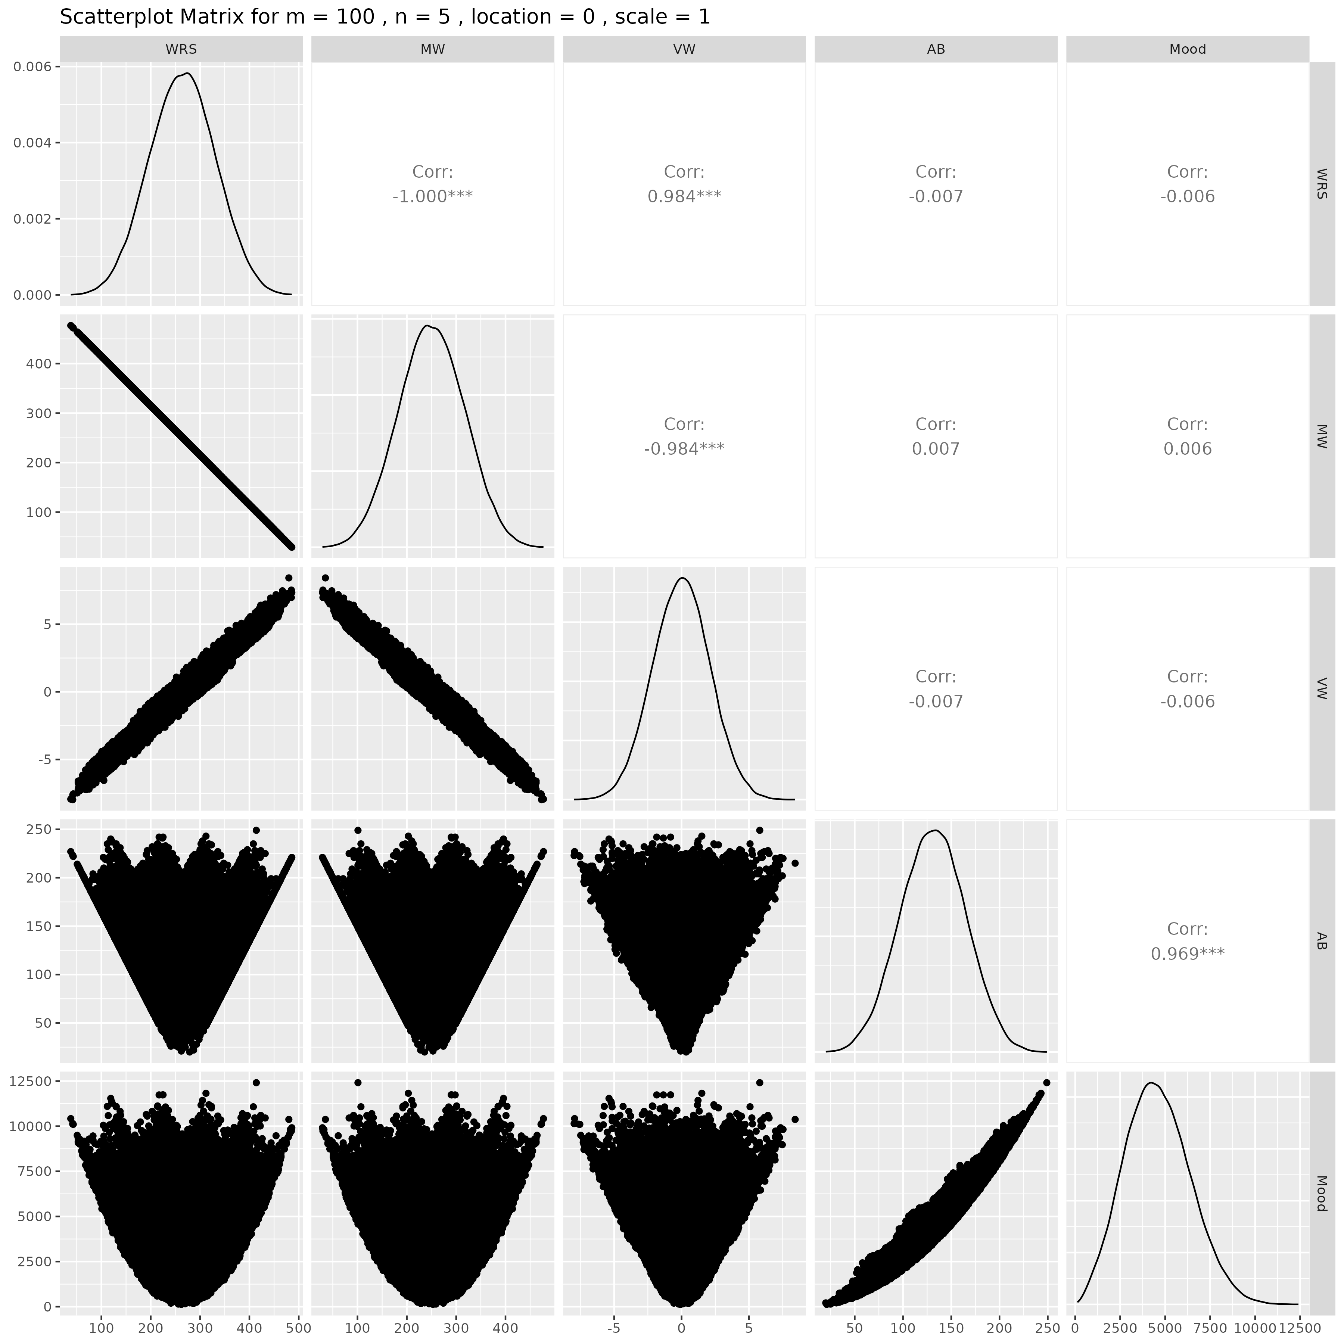

## Results for m = 100 , n = 10 , location = 0 , scale = 1

### Correlation Matrix

| Statistic | WRS | MW | VW | AB | Mood |
| --- | --- | --- | --- | --- | --- |
| character | numeric | numeric | numeric | numeric | Numeric |
| WRS | 1.0000 | -1.0000 | 0.9841 | 0.0023 | 0.0034 |
| MW | -1.0000 | 1.0000 | -0.9841 | -0.0023 | -0.0034 |
| VW | 0.9841 | -0.9841 | 1.0000 | 0.0026 | 0.0039 |
| AB | 0.0023 | -0.0023 | 0.0026 | 1.0000 | 0.9686 |
| Mood | 0.0034 | -0.0034 | 0.0039 | 0.9686 | 1.0000 |
| n: 5 | | | | | |

### P-Value Matrix

| Statistic | WRS | MW | VW | AB | Mood |
| --- | --- | --- | --- | --- | --- |
| character | numeric | numeric | numeric | numeric | Numeric |
| WRS |  | 0.0000 | 0.0000 | 0.6139 | 0.4530 |
| MW | 0.0000 |  | 0.0000 | 0.6139 | 0.4530 |
| VW | 0.0000 | 0.0000 |  | 0.5536 | 0.3822 |
| AB | 0.6139 | 0.6139 | 0.5536 |  | 0.0000 |
| Mood | 0.4530 | 0.4530 | 0.3822 | 0.0000 |  |
| n: 5 | | | | | |

### Scatter Plot Matrix:

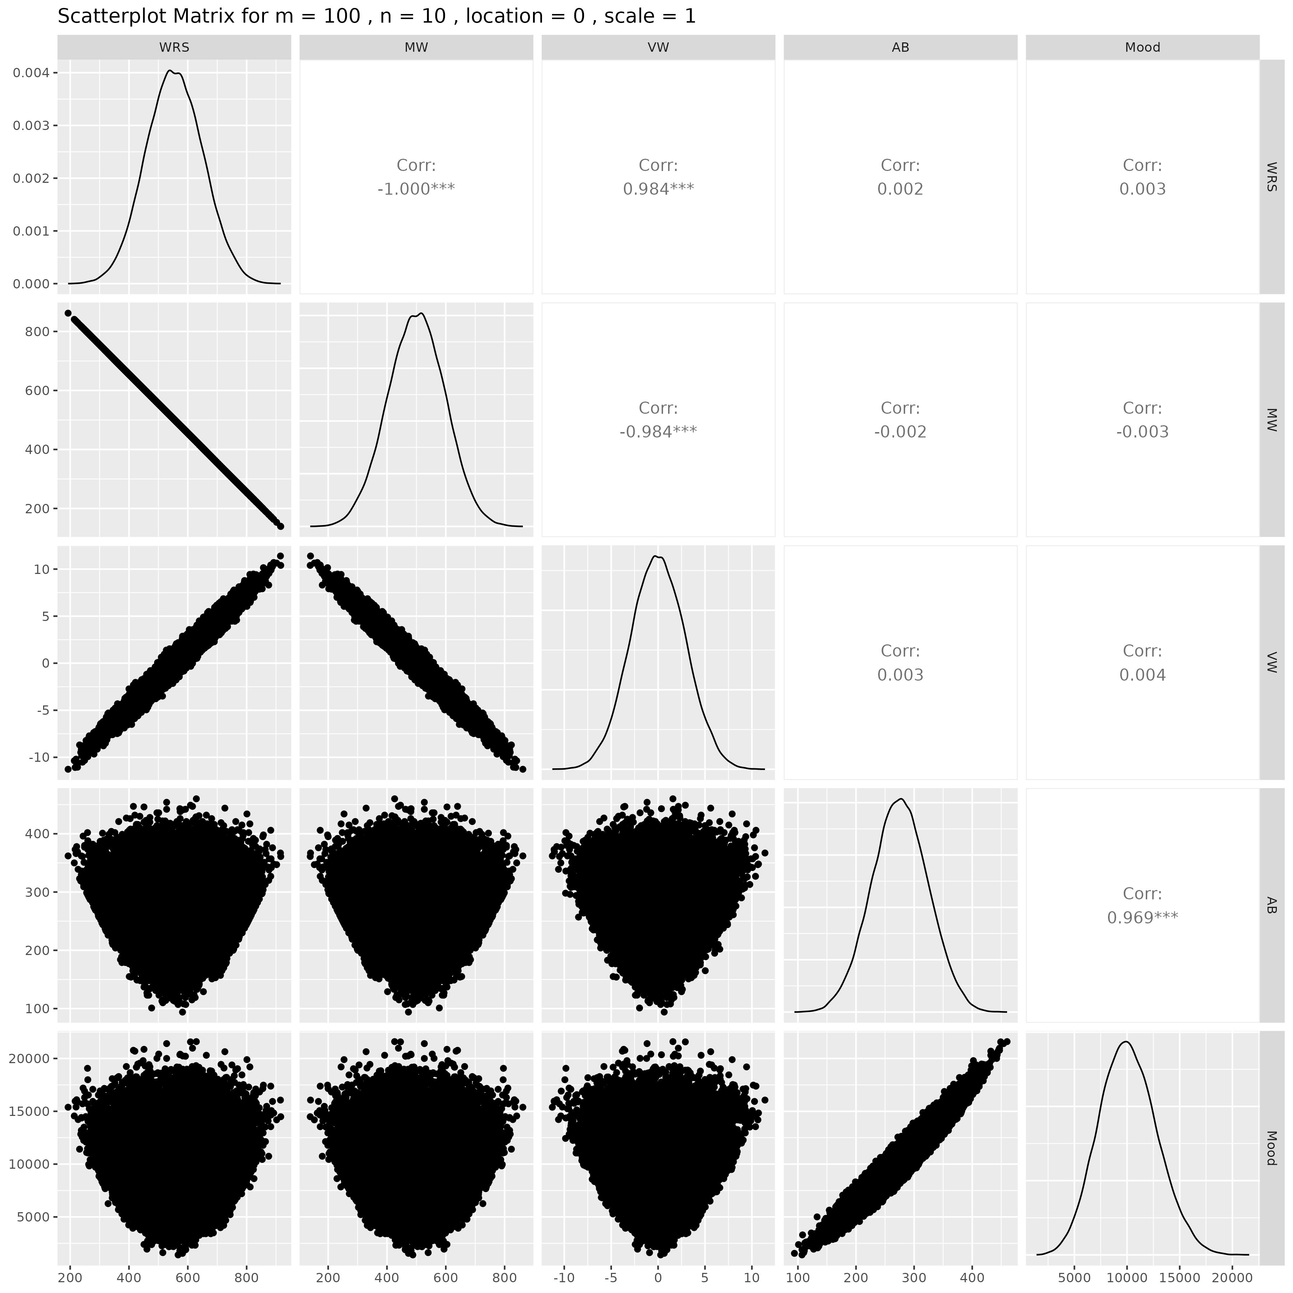

## Results for m = 100 , n = 15 , location = 0 , scale = 1

### Correlation Matrix

| Statistic | WRS | MW | VW | AB | Mood |
| --- | --- | --- | --- | --- | --- |
| character | numeric | numeric | numeric | numeric | Numeric |
| WRS | 1.0000 | -1.0000 | 0.9836 | -0.0058 | -0.0033 |
| MW | -1.0000 | 1.0000 | -0.9836 | 0.0058 | 0.0033 |
| VW | 0.9836 | -0.9836 | 1.0000 | -0.0055 | -0.0032 |
| AB | -0.0058 | 0.0058 | -0.0055 | 1.0000 | 0.9684 |
| Mood | -0.0033 | 0.0033 | -0.0032 | 0.9684 | 1.0000 |
| n: 5 | | | | | |

### P-Value Matrix

| Statistic | WRS | MW | VW | AB | Mood |
| --- | --- | --- | --- | --- | --- |
| character | numeric | numeric | numeric | numeric | Numeric |
| WRS |  | 0.0000 | 0.0000 | 0.1913 | 0.4591 |
| MW | 0.0000 |  | 0.0000 | 0.1913 | 0.4591 |
| VW | 0.0000 | 0.0000 |  | 0.2178 | 0.4789 |
| AB | 0.1913 | 0.1913 | 0.2178 |  | 0.0000 |
| Mood | 0.4591 | 0.4591 | 0.4789 | 0.0000 |  |
| n: 5 | | | | | |

### Scatter Plot Matrix:

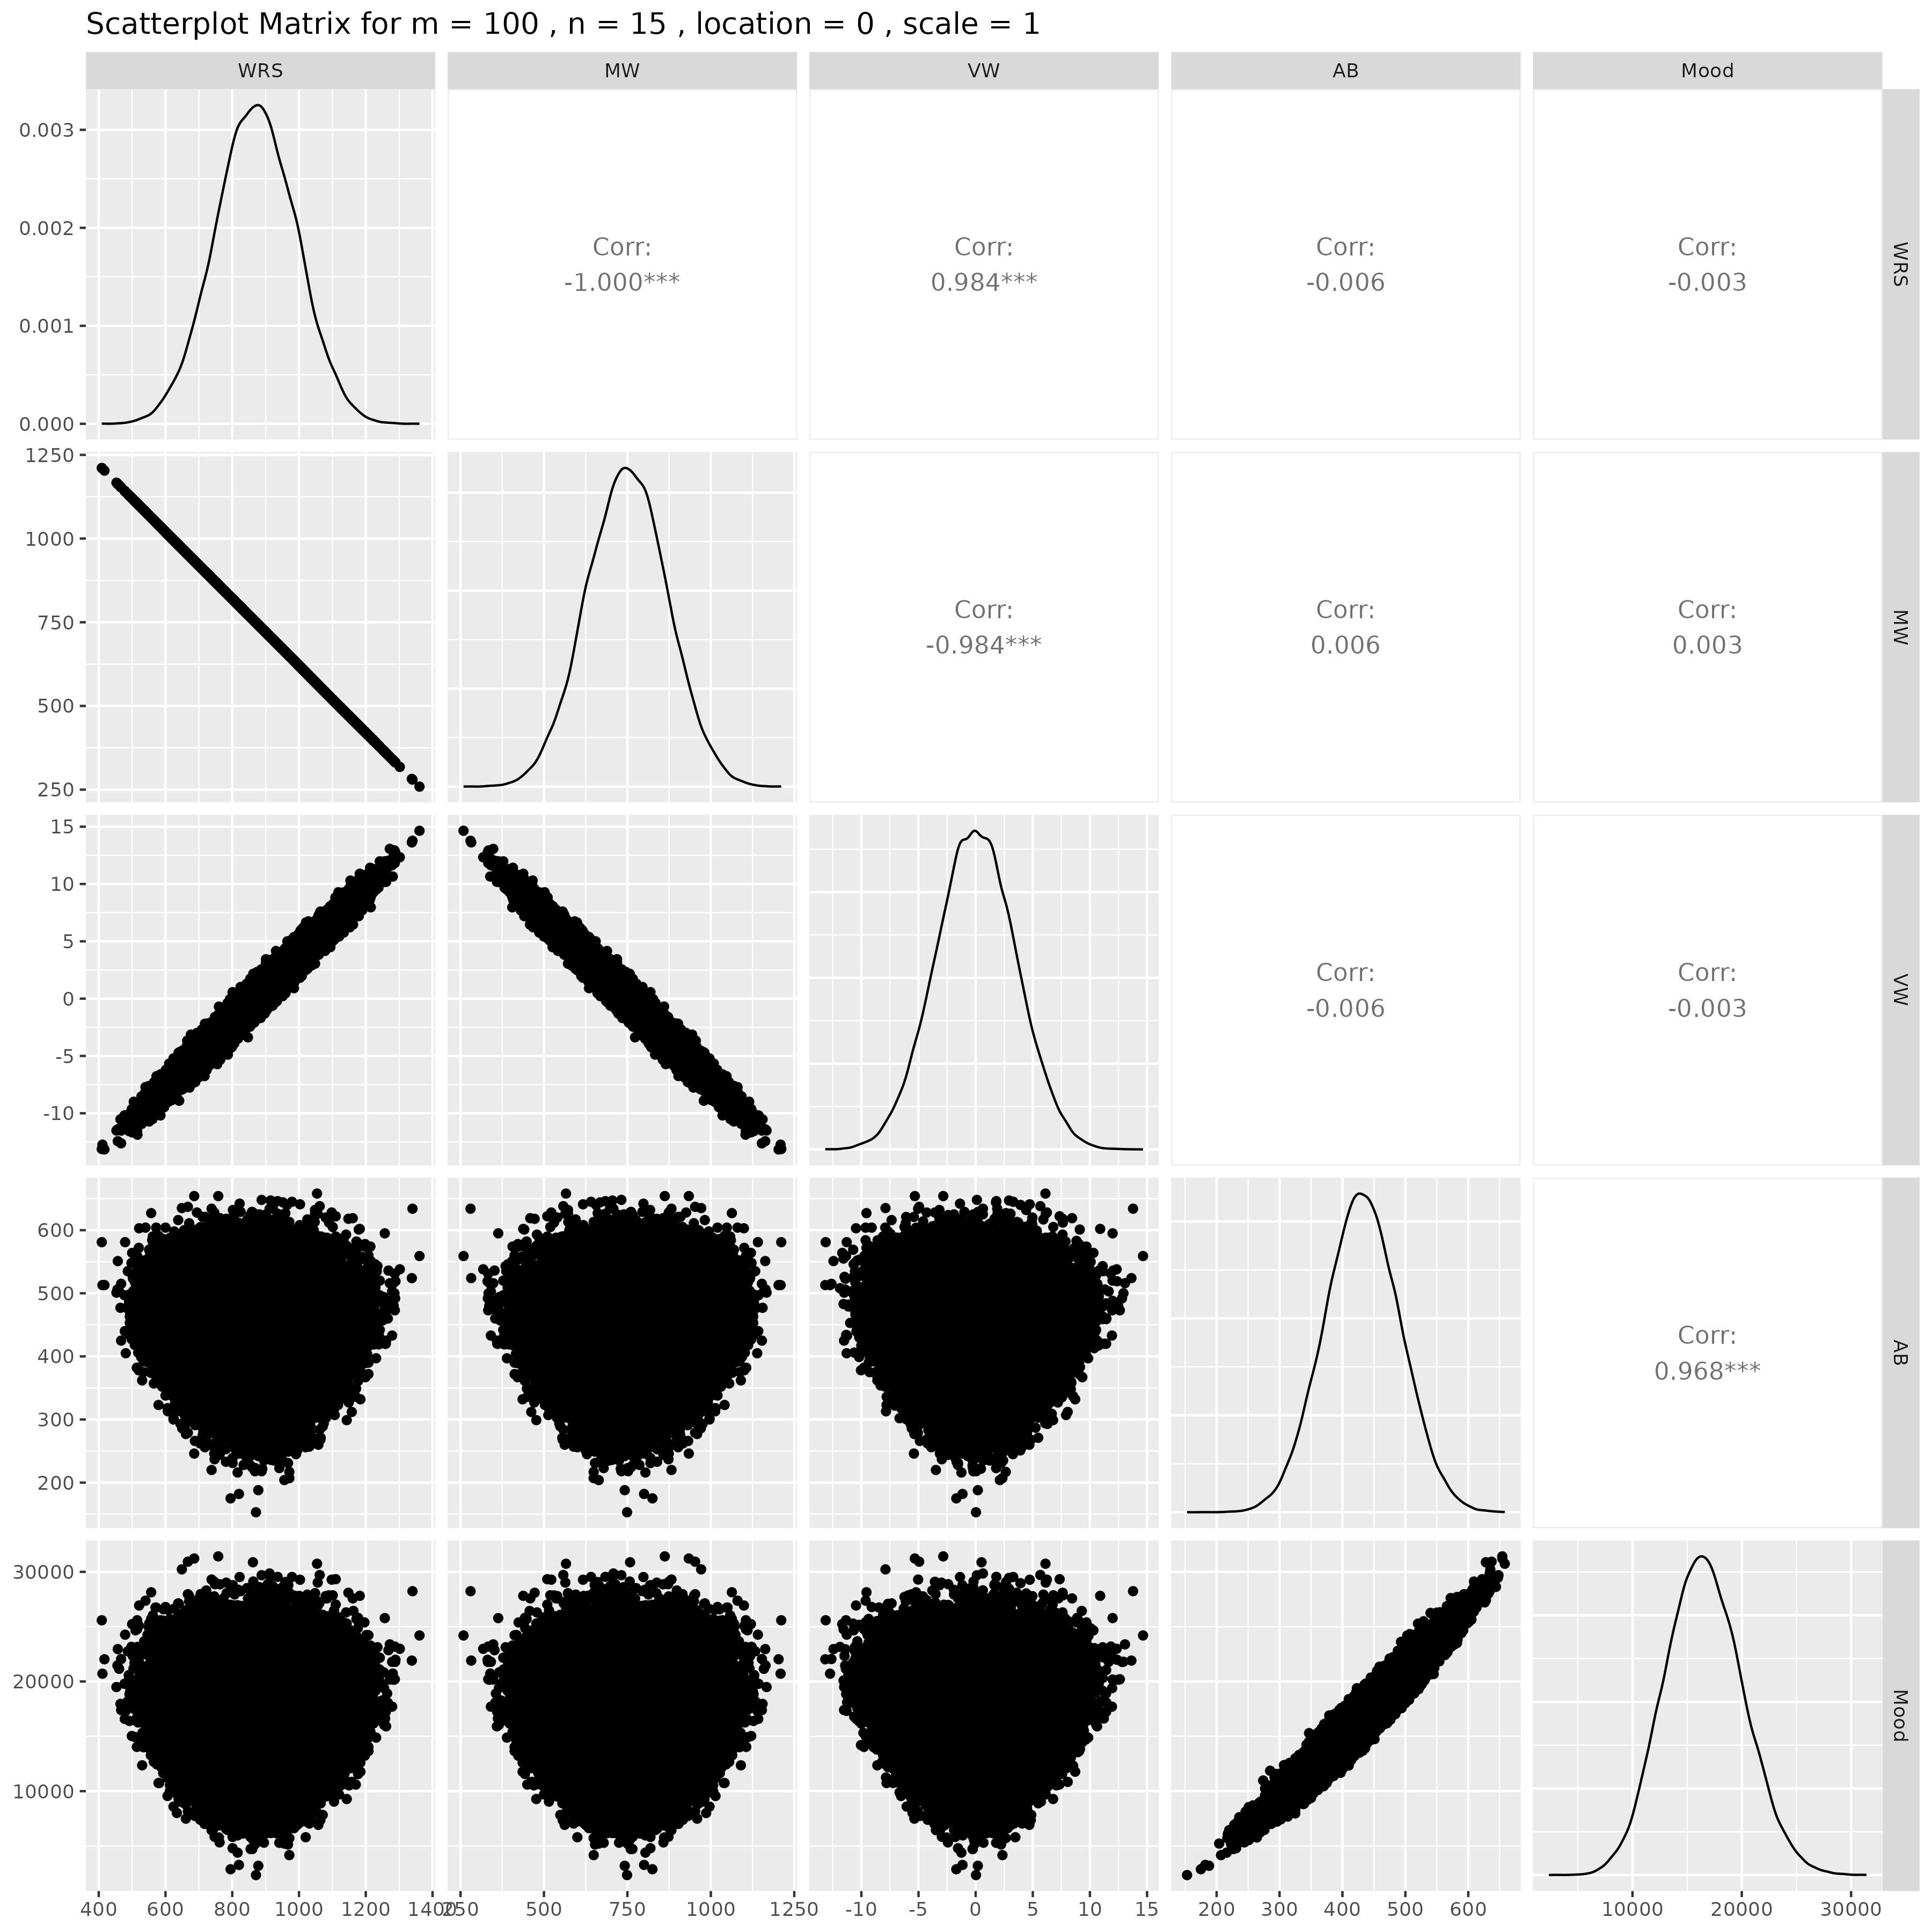

## Results for m = 100 , n = 20 , location = 0 , scale = 1

### Correlation Matrix

| Statistic | WRS | MW | VW | AB | Mood |
| --- | --- | --- | --- | --- | --- |
| character | numeric | numeric | numeric | numeric | Numeric |
| WRS | 1.0000 | -1.0000 | 0.9840 | -0.0023 | -0.0024 |
| MW | -1.0000 | 1.0000 | -0.9840 | 0.0023 | 0.0024 |
| VW | 0.9840 | -0.9840 | 1.0000 | -0.0000 | -0.0003 |
| AB | -0.0023 | 0.0023 | -0.0000 | 1.0000 | 0.9686 |
| Mood | -0.0024 | 0.0024 | -0.0003 | 0.9686 | 1.0000 |
| n: 5 | | | | | |

### P-Value Matrix

| Statistic | WRS | MW | VW | AB | Mood |
| --- | --- | --- | --- | --- | --- |
| character | numeric | numeric | numeric | numeric | Numeric |
| WRS |  | 0.0000 | 0.0000 | 0.6105 | 0.5853 |
| MW | 0.0000 |  | 0.0000 | 0.6105 | 0.5853 |
| VW | 0.0000 | 0.0000 |  | 0.9914 | 0.9441 |
| AB | 0.6105 | 0.6105 | 0.9914 |  | 0.0000 |
| Mood | 0.5853 | 0.5853 | 0.9441 | 0.0000 |  |
| n: 5 | | | | | |

### Scatter Plot Matrix:

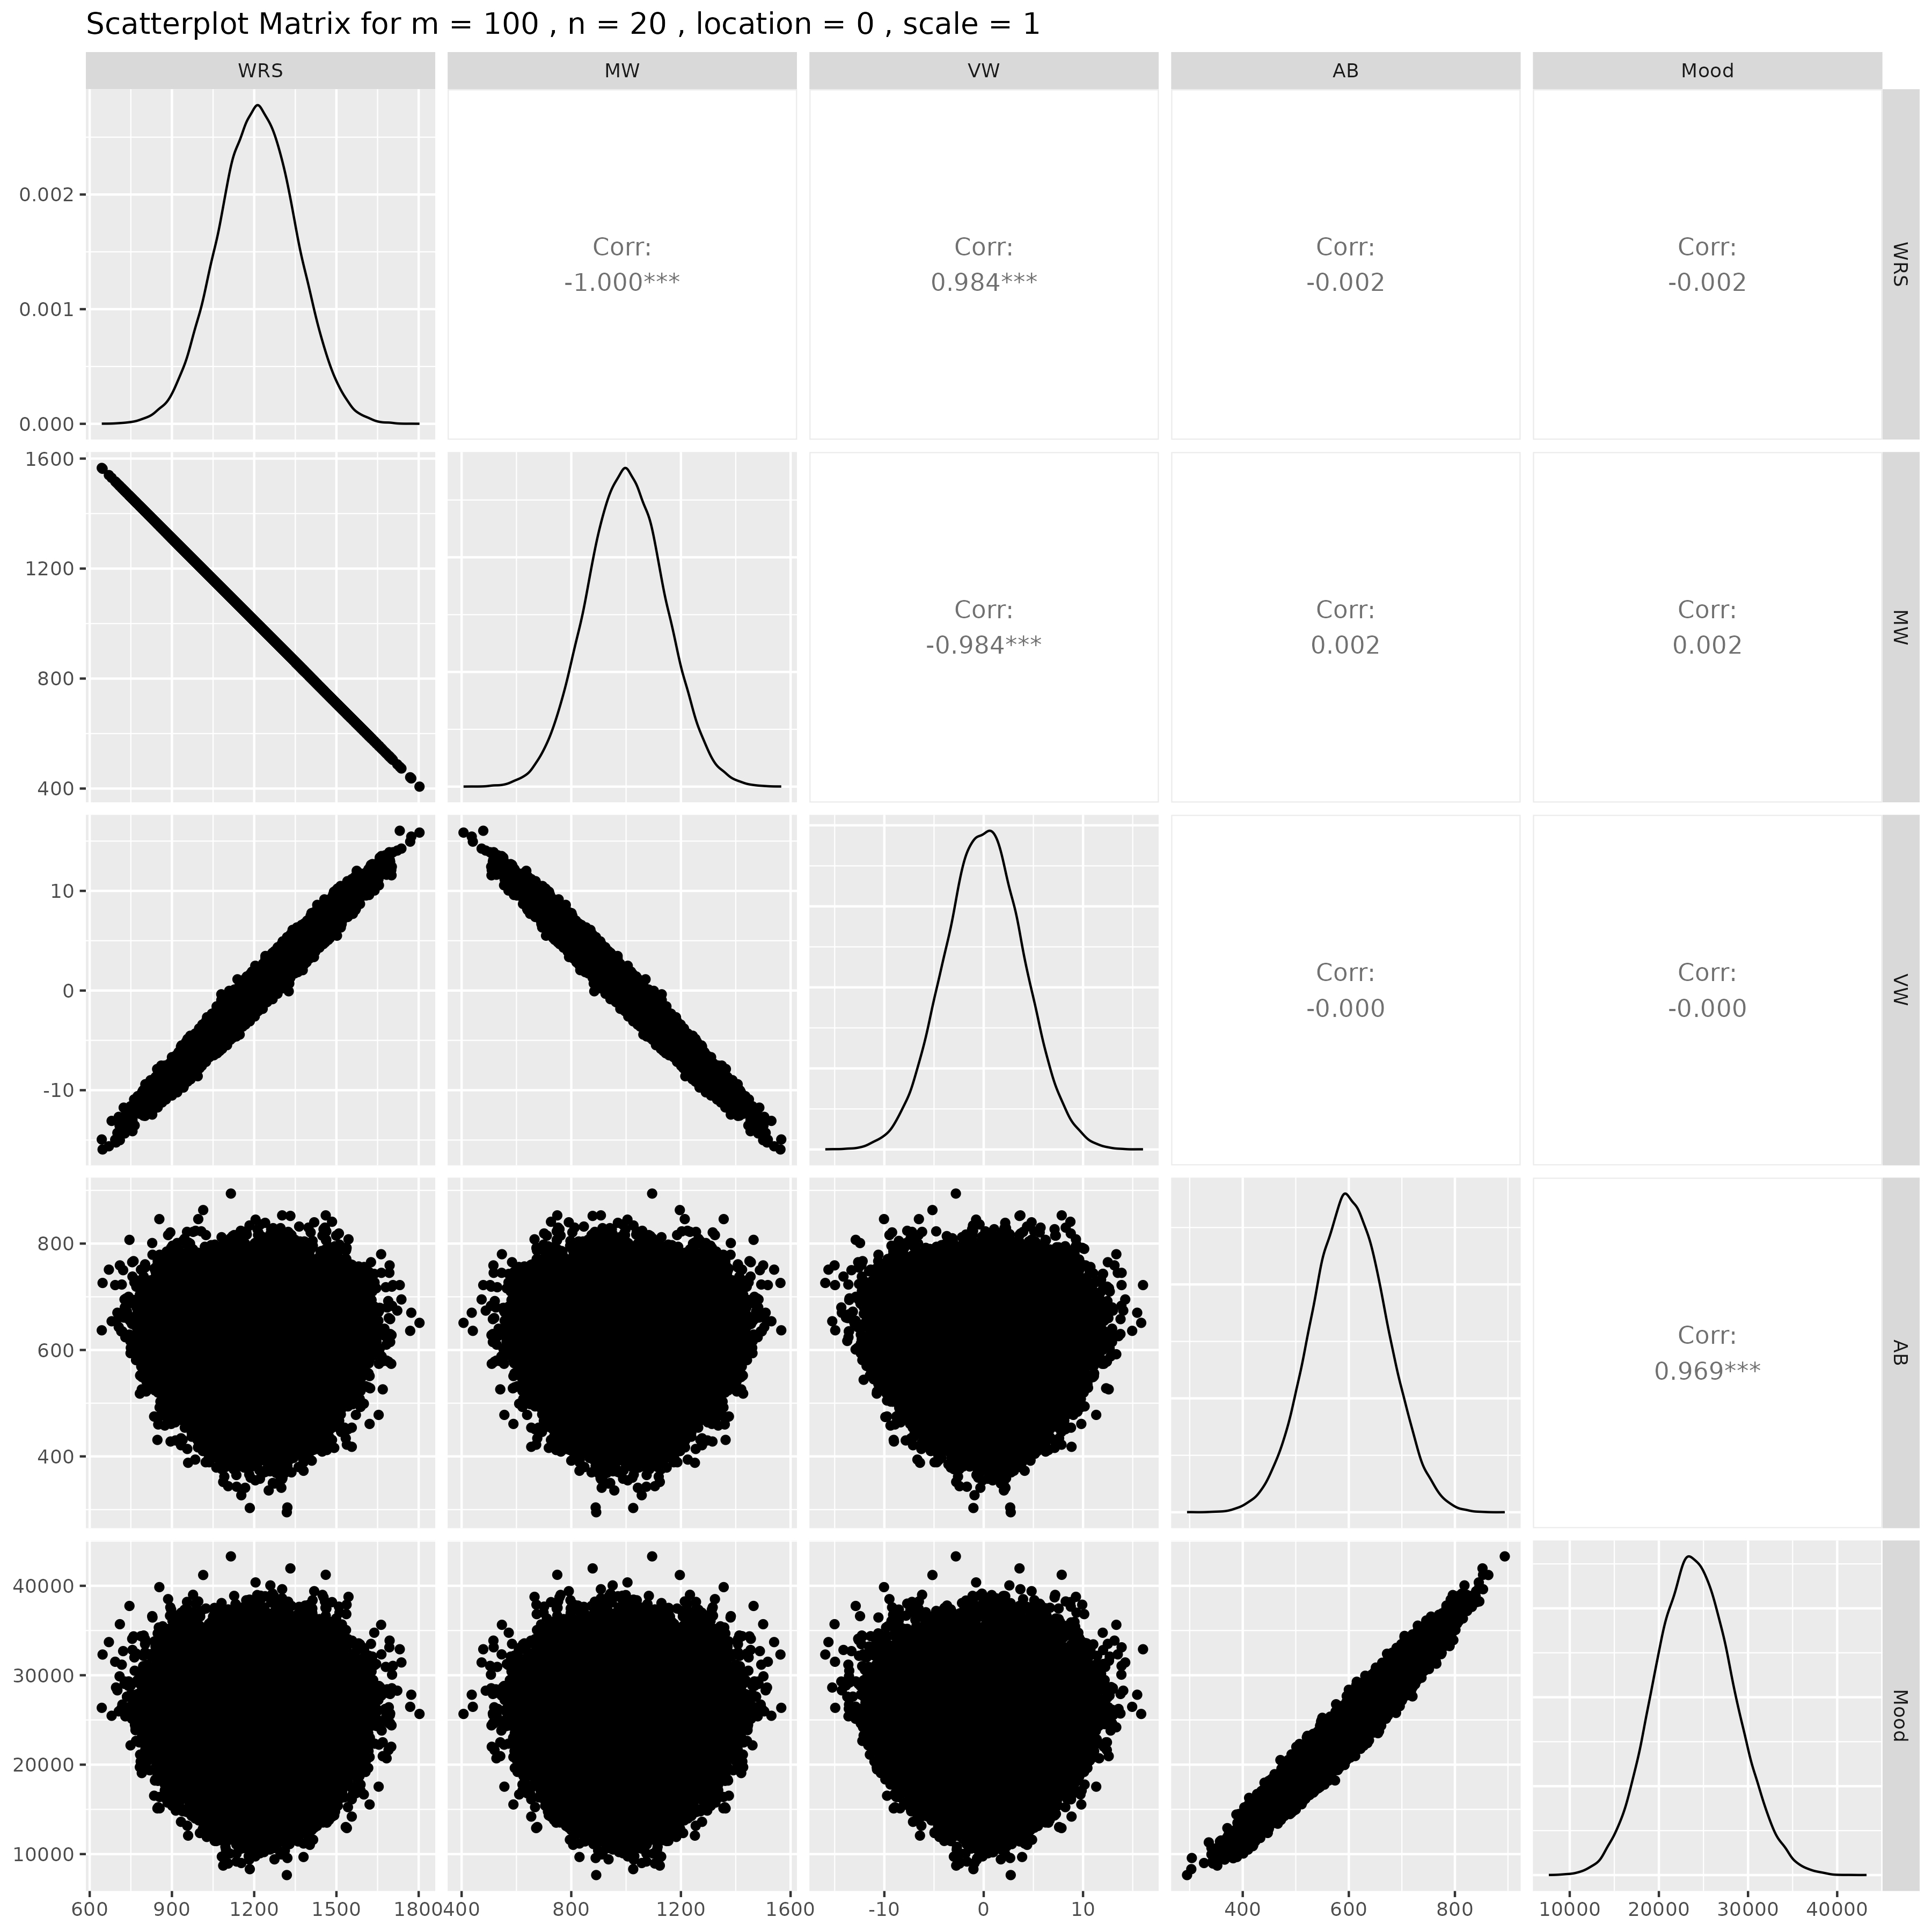

## Results for m = 100 , n = 25 , location = 0 , scale = 1

### Correlation Matrix

| Statistic | WRS | MW | VW | AB | Mood |
| --- | --- | --- | --- | --- | --- |
| character | numeric | numeric | numeric | numeric | Numeric |
| WRS | 1.0000 | -1.0000 | 0.9835 | -0.0044 | -0.0042 |
| MW | -1.0000 | 1.0000 | -0.9835 | 0.0044 | 0.0042 |
| VW | 0.9835 | -0.9835 | 1.0000 | -0.0049 | -0.0049 |
| AB | -0.0044 | 0.0044 | -0.0049 | 1.0000 | 0.9686 |
| Mood | -0.0042 | 0.0042 | -0.0049 | 0.9686 | 1.0000 |
| n: 5 | | | | | |

### P-Value Matrix

| Statistic | WRS | MW | VW | AB | Mood |
| --- | --- | --- | --- | --- | --- |
| character | numeric | numeric | numeric | numeric | Numeric |
| WRS |  | 0.0000 | 0.0000 | 0.3253 | 0.3422 |
| MW | 0.0000 |  | 0.0000 | 0.3253 | 0.3422 |
| VW | 0.0000 | 0.0000 |  | 0.2690 | 0.2738 |
| AB | 0.3253 | 0.3253 | 0.2690 |  | 0.0000 |
| Mood | 0.3422 | 0.3422 | 0.2738 | 0.0000 |  |
| n: 5 | | | | | |

### Scatter Plot Matrix:

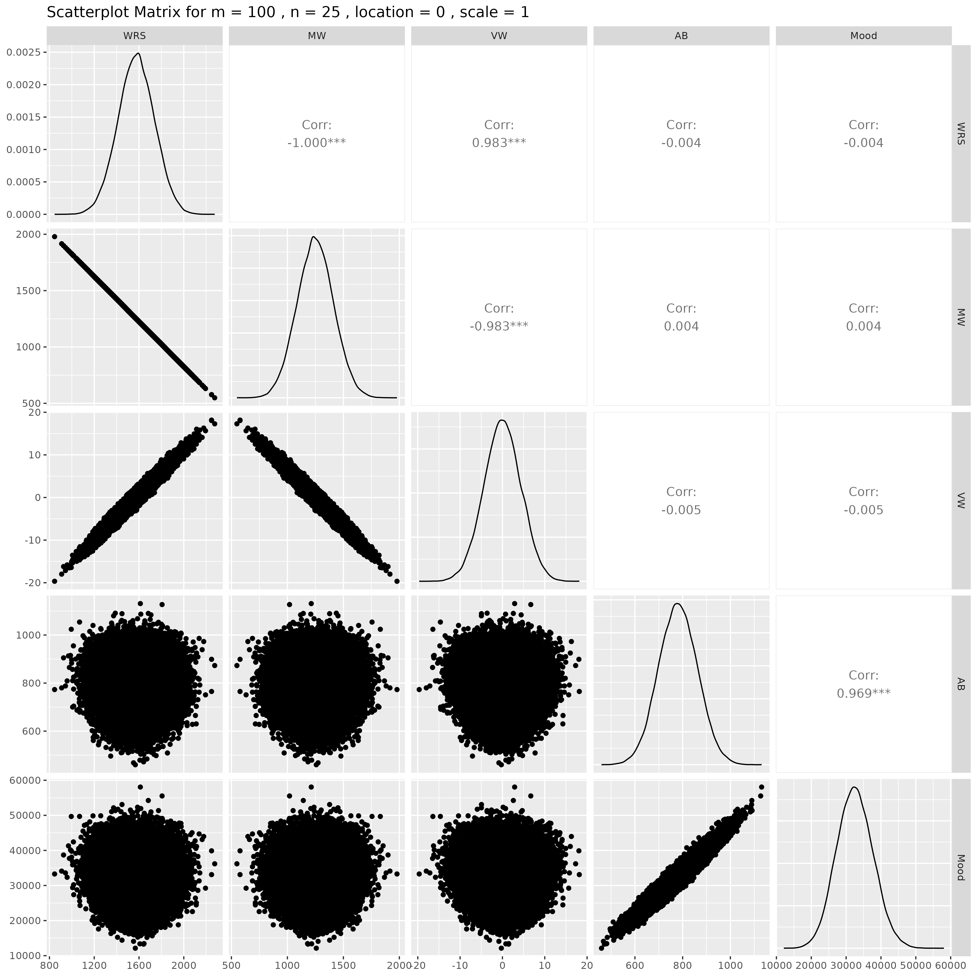

## Results for m = 100 , n = 30 , location = 0 , scale = 1

### Correlation Matrix

| Statistic | WRS | MW | VW | AB | Mood |
| --- | --- | --- | --- | --- | --- |
| character | numeric | numeric | numeric | numeric | Numeric |
| WRS | 1.0000 | -1.0000 | 0.9832 | 0.0046 | 0.0070 |
| MW | -1.0000 | 1.0000 | -0.9832 | -0.0046 | -0.0070 |
| VW | 0.9832 | -0.9832 | 1.0000 | 0.0049 | 0.0075 |
| AB | 0.0046 | -0.0046 | 0.0049 | 1.0000 | 0.9683 |
| Mood | 0.0070 | -0.0070 | 0.0075 | 0.9683 | 1.0000 |
| n: 5 | | | | | |

### P-Value Matrix

| Statistic | WRS | MW | VW | AB | Mood |
| --- | --- | --- | --- | --- | --- |
| character | numeric | numeric | numeric | numeric | Numeric |
| WRS |  | 0.0000 | 0.0000 | 0.3006 | 0.1151 |
| MW | 0.0000 |  | 0.0000 | 0.3006 | 0.1151 |
| VW | 0.0000 | 0.0000 |  | 0.2704 | 0.0939 |
| AB | 0.3006 | 0.3006 | 0.2704 |  | 0.0000 |
| Mood | 0.1151 | 0.1151 | 0.0939 | 0.0000 |  |
| n: 5 | | | | | |

### Scatter Plot Matrix:

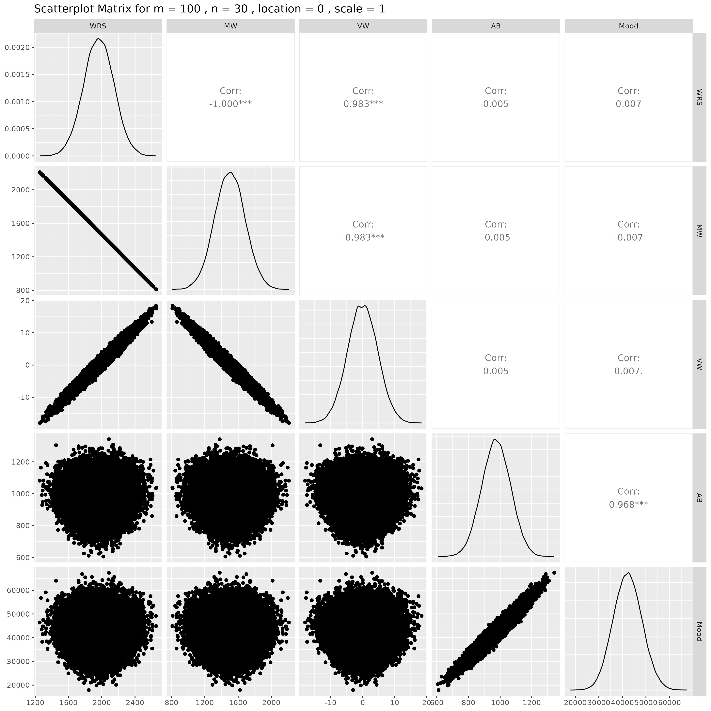

## Results for m = 100 , n = 50 , location = 0 , scale = 1

### Correlation Matrix

| Statistic | WRS | MW | VW | AB | Mood |
| --- | --- | --- | --- | --- | --- |
| character | numeric | numeric | numeric | numeric | Numeric |
| WRS | 1.0000 | -1.0000 | 0.9828 | 0.0028 | 0.0038 |
| MW | -1.0000 | 1.0000 | -0.9828 | -0.0028 | -0.0038 |
| VW | 0.9828 | -0.9828 | 1.0000 | 0.0027 | 0.0036 |
| AB | 0.0028 | -0.0028 | 0.0027 | 1.0000 | 0.9685 |
| Mood | 0.0038 | -0.0038 | 0.0036 | 0.9685 | 1.0000 |
| n: 5 | | | | | |

### P-Value Matrix

| Statistic | WRS | MW | VW | AB | Mood |
| --- | --- | --- | --- | --- | --- |
| character | numeric | numeric | numeric | numeric | Numeric |
| WRS |  | 0.0000 | 0.0000 | 0.5372 | 0.3918 |
| MW | 0.0000 |  | 0.0000 | 0.5372 | 0.3918 |
| VW | 0.0000 | 0.0000 |  | 0.5393 | 0.4255 |
| AB | 0.5372 | 0.5372 | 0.5393 |  | 0.0000 |
| Mood | 0.3918 | 0.3918 | 0.4255 | 0.0000 |  |
| n: 5 | | | | | |

### Scatter Plot Matrix:

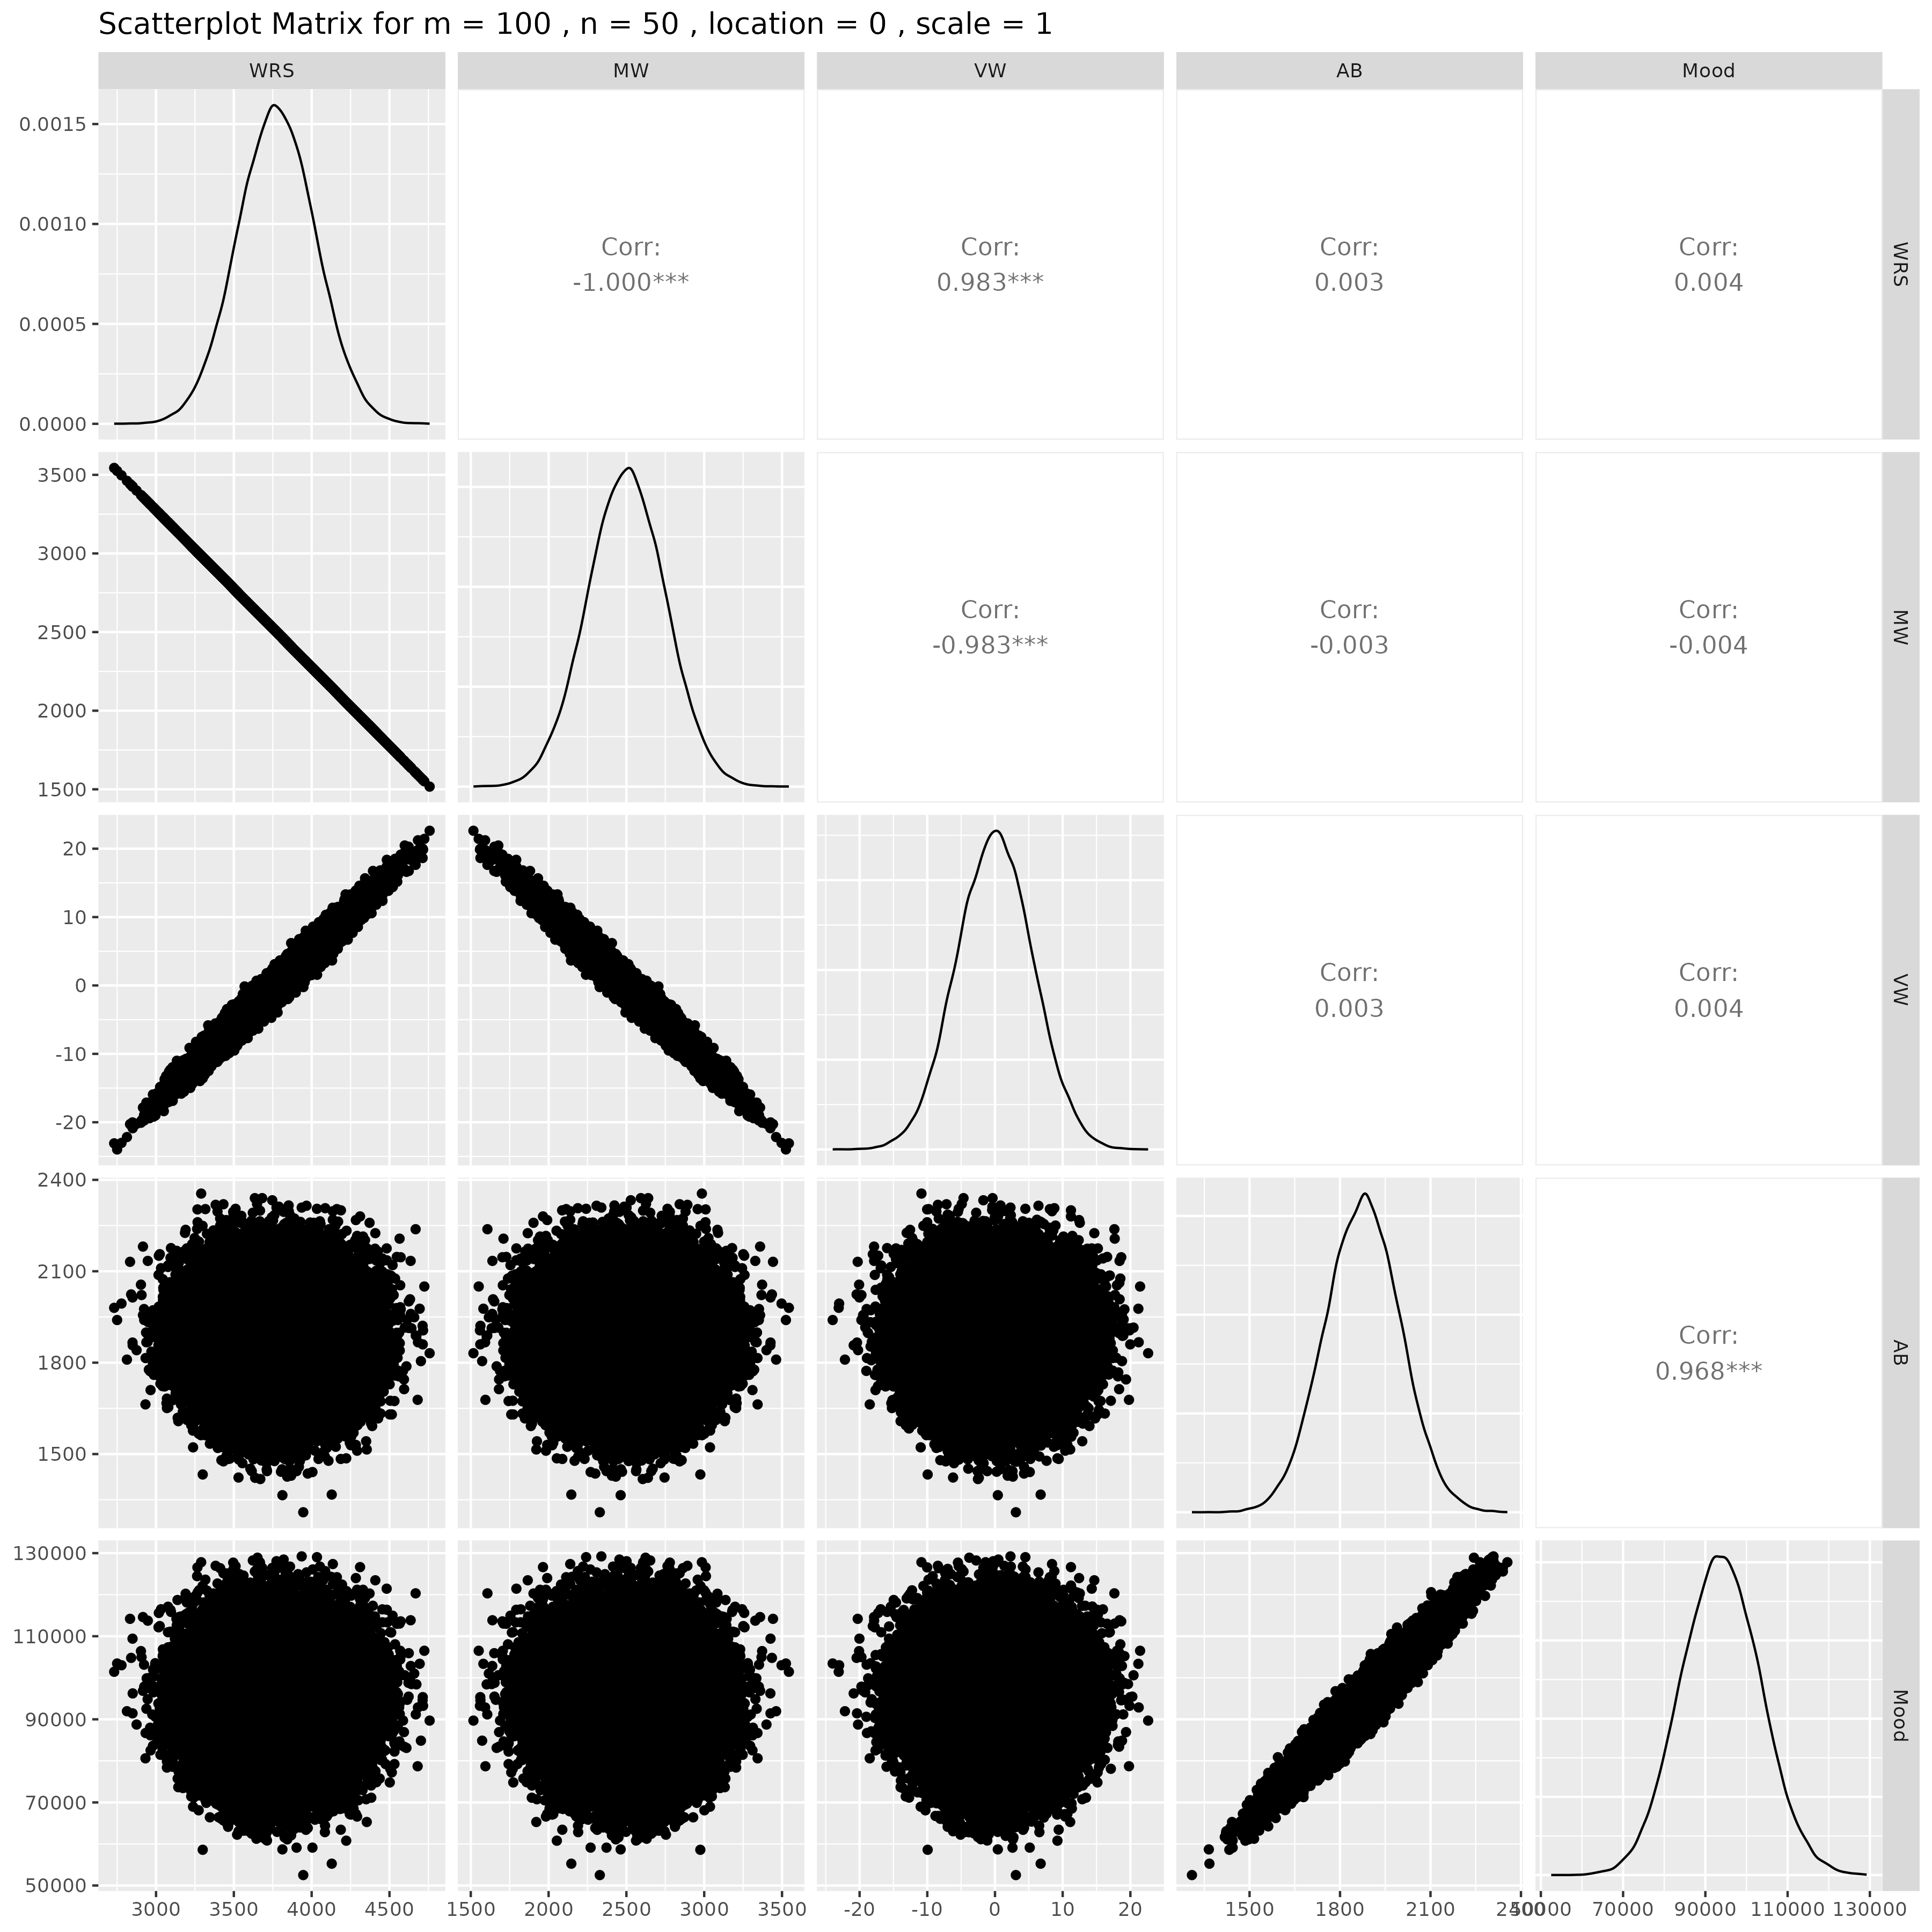

## Results for m = 125 , n = 5 , location = 0 , scale = 1

### Correlation Matrix

| Statistic | WRS | MW | VW | AB | Mood |
| --- | --- | --- | --- | --- | --- |
| character | numeric | numeric | numeric | numeric | Numeric |
| WRS | 1.0000 | -1.0000 | 0.9835 | 0.0062 | 0.0070 |
| MW | -1.0000 | 1.0000 | -0.9835 | -0.0062 | -0.0070 |
| VW | 0.9835 | -0.9835 | 1.0000 | 0.0057 | 0.0062 |
| AB | 0.0062 | -0.0062 | 0.0057 | 1.0000 | 0.9685 |
| Mood | 0.0070 | -0.0070 | 0.0062 | 0.9685 | 1.0000 |
| n: 5 | | | | | |

### P-Value Matrix

| Statistic | WRS | MW | VW | AB | Mood |
| --- | --- | --- | --- | --- | --- |
| character | numeric | numeric | numeric | numeric | Numeric |
| WRS |  | 0.0000 | 0.0000 | 0.1630 | 0.1201 |
| MW | 0.0000 |  | 0.0000 | 0.1630 | 0.1201 |
| VW | 0.0000 | 0.0000 |  | 0.2049 | 0.1638 |
| AB | 0.1630 | 0.1630 | 0.2049 |  | 0.0000 |
| Mood | 0.1201 | 0.1201 | 0.1638 | 0.0000 |  |
| n: 5 | | | | | |

### Scatter Plot Matrix:

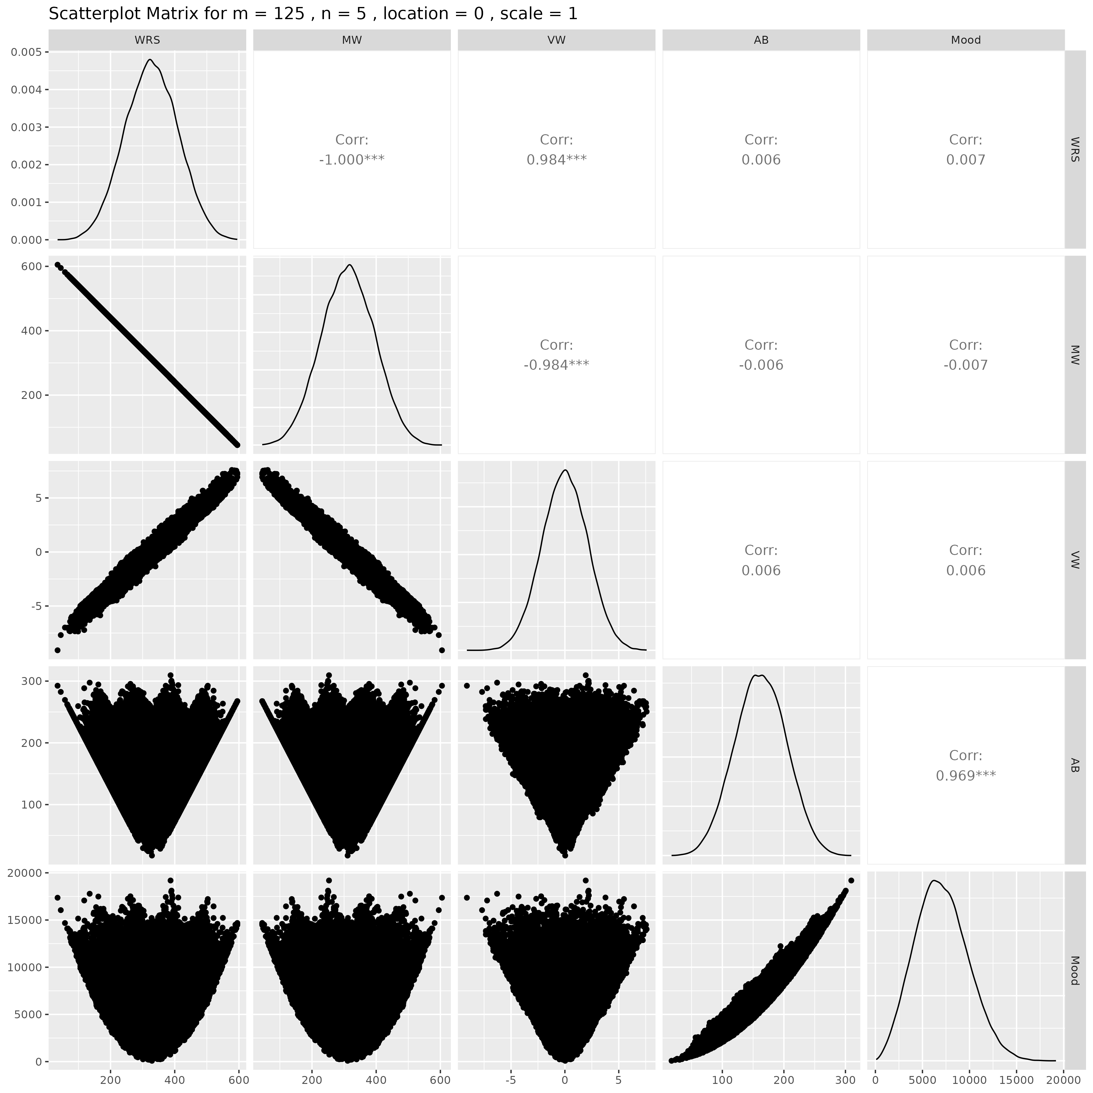

## Results for m = 125 , n = 10 , location = 0 , scale = 1

### Correlation Matrix

| Statistic | WRS | MW | VW | AB | Mood |
| --- | --- | --- | --- | --- | --- |
| character | numeric | numeric | numeric | numeric | Numeric |
| WRS | 1.0000 | -1.0000 | 0.9832 | 0.0007 | 0.0020 |
| MW | -1.0000 | 1.0000 | -0.9832 | -0.0007 | -0.0020 |
| VW | 0.9832 | -0.9832 | 1.0000 | 0.0015 | 0.0028 |
| AB | 0.0007 | -0.0007 | 0.0015 | 1.0000 | 0.9682 |
| Mood | 0.0020 | -0.0020 | 0.0028 | 0.9682 | 1.0000 |
| n: 5 | | | | | |

### P-Value Matrix

| Statistic | WRS | MW | VW | AB | Mood |
| --- | --- | --- | --- | --- | --- |
| character | numeric | numeric | numeric | numeric | Numeric |
| WRS |  | 0.0000 | 0.0000 | 0.8821 | 0.6550 |
| MW | 0.0000 |  | 0.0000 | 0.8821 | 0.6550 |
| VW | 0.0000 | 0.0000 |  | 0.7358 | 0.5286 |
| AB | 0.8821 | 0.8821 | 0.7358 |  | 0.0000 |
| Mood | 0.6550 | 0.6550 | 0.5286 | 0.0000 |  |
| n: 5 | | | | | |

### Scatter Plot Matrix:

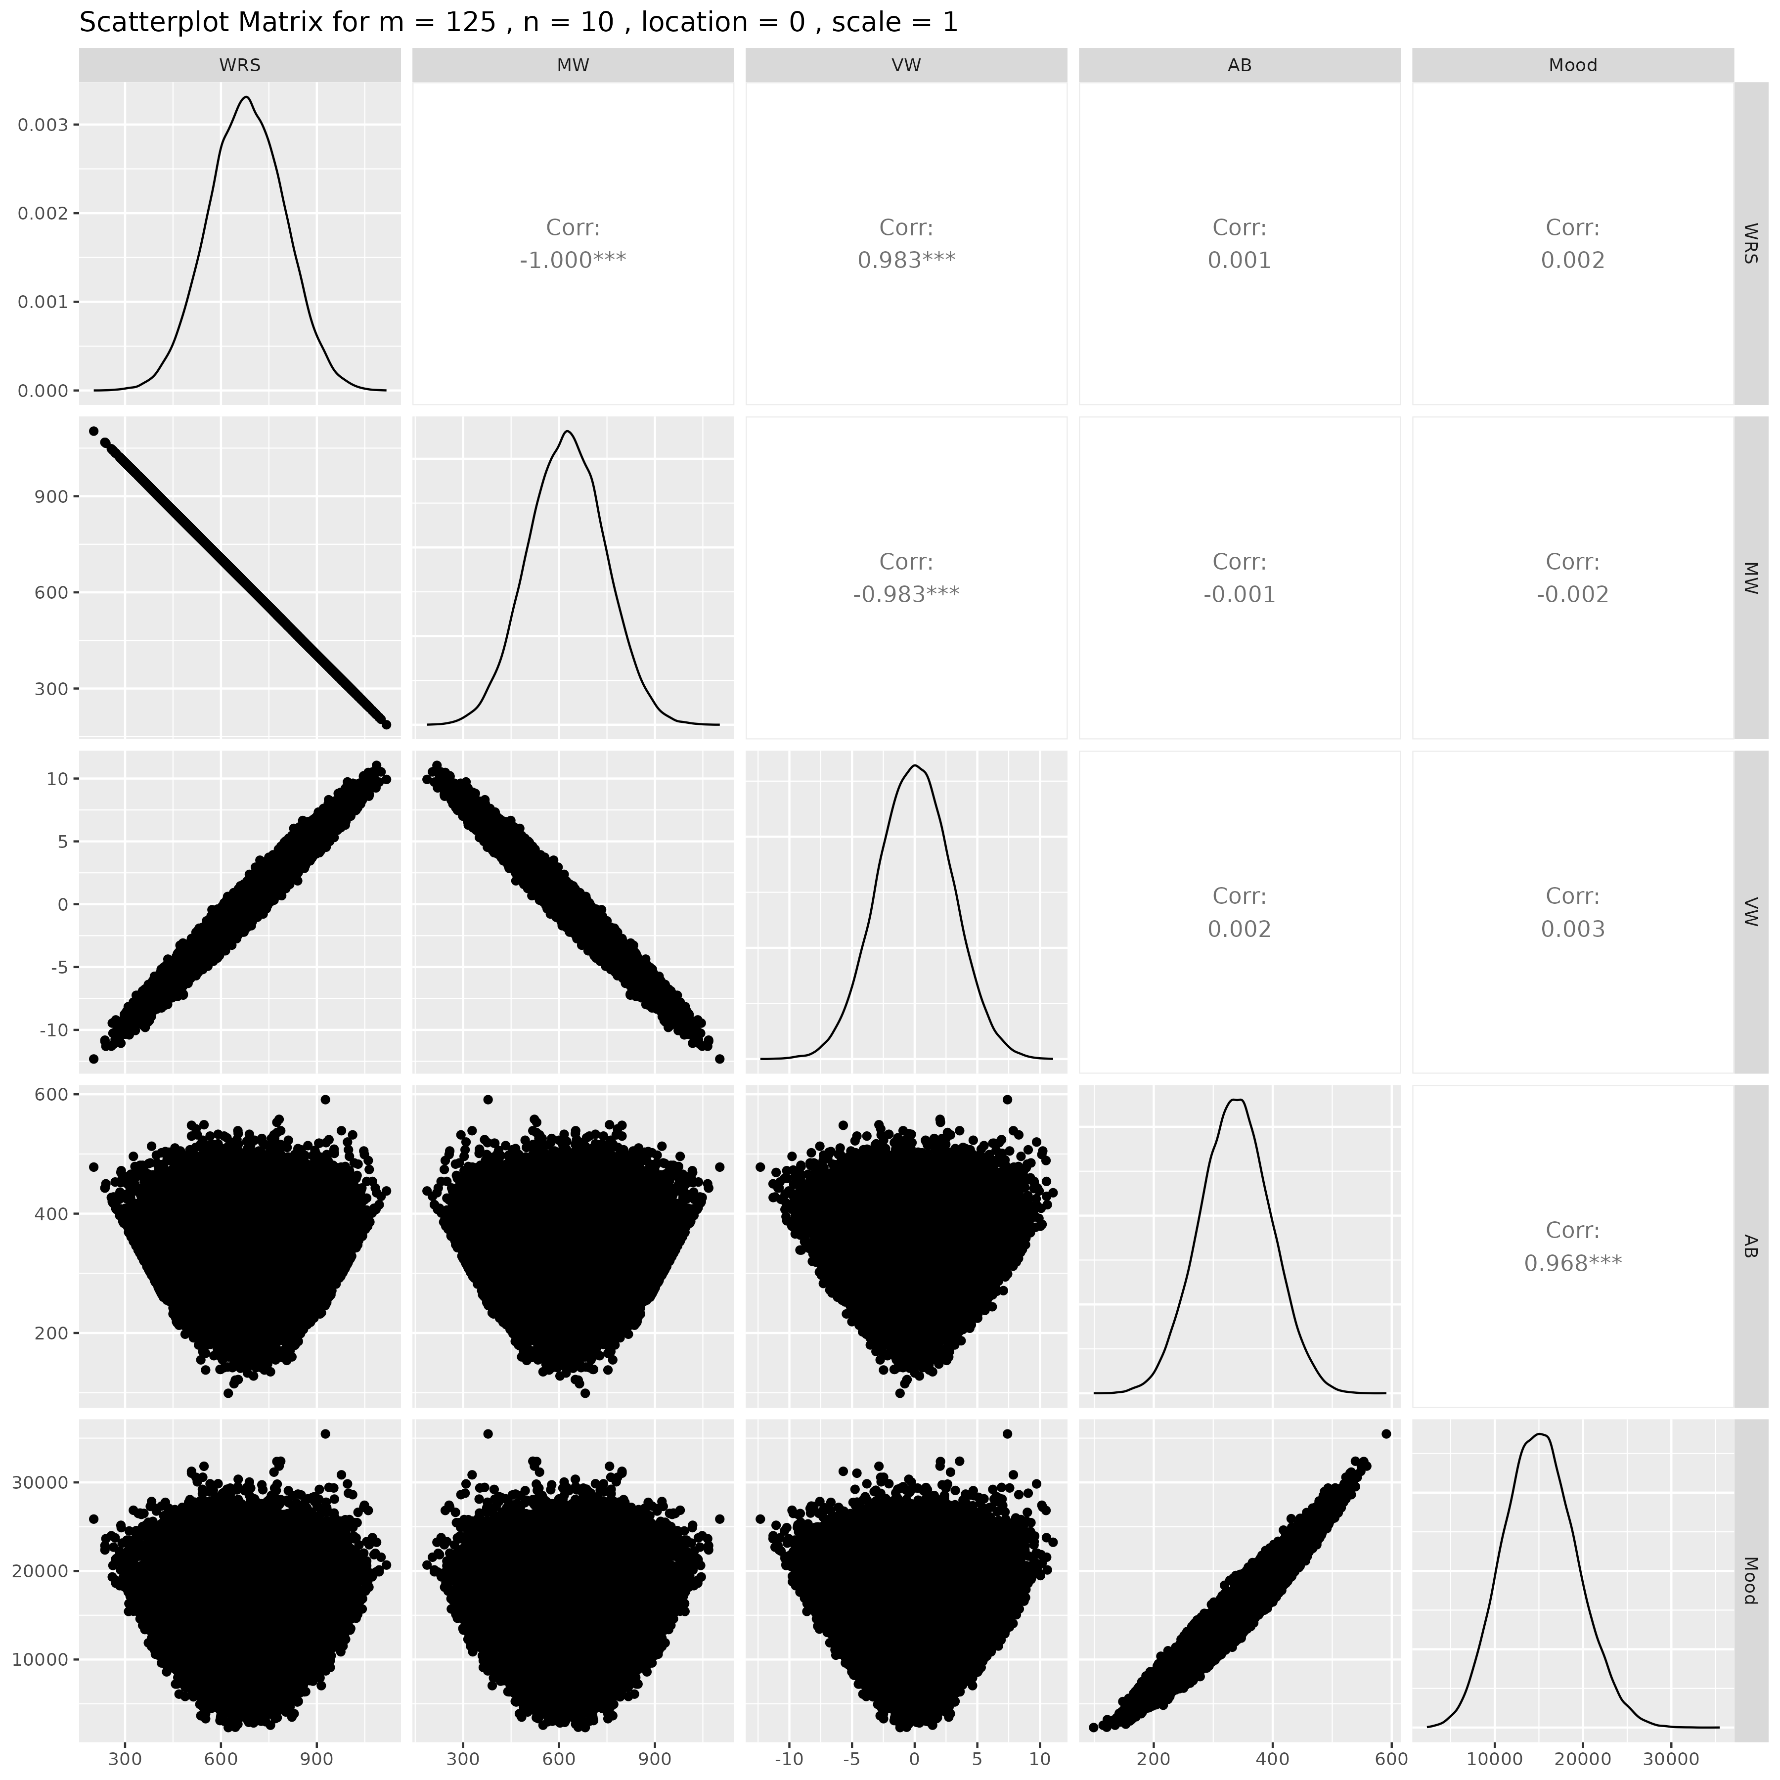

## Results for m = 125 , n = 15 , location = 0 , scale = 1

### Correlation Matrix

| Statistic | WRS | MW | VW | AB | Mood |
| --- | --- | --- | --- | --- | --- |
| character | numeric | numeric | numeric | numeric | Numeric |
| WRS | 1.0000 | -1.0000 | 0.9830 | -0.0055 | -0.0060 |
| MW | -1.0000 | 1.0000 | -0.9830 | 0.0055 | 0.0060 |
| VW | 0.9830 | -0.9830 | 1.0000 | -0.0052 | -0.0060 |
| AB | -0.0055 | 0.0055 | -0.0052 | 1.0000 | 0.9684 |
| Mood | -0.0060 | 0.0060 | -0.0060 | 0.9684 | 1.0000 |
| n: 5 | | | | | |

### P-Value Matrix

| Statistic | WRS | MW | VW | AB | Mood |
| --- | --- | --- | --- | --- | --- |
| character | numeric | numeric | numeric | numeric | numeric |
| WRS |  | 0.0000 | 0.0000 | 0.2165 | 0.1769 |
| MW | 0.0000 |  | 0.0000 | 0.2165 | 0.1769 |
| VW | 0.0000 | 0.0000 |  | 0.2435 | 0.1814 |
| AB | 0.2165 | 0.2165 | 0.2435 |  | 0.0000 |
| Mood | 0.1769 | 0.1769 | 0.1814 | 0.0000 |  |
| n: 5 | | | | | |

### Scatter Plot Matrix:

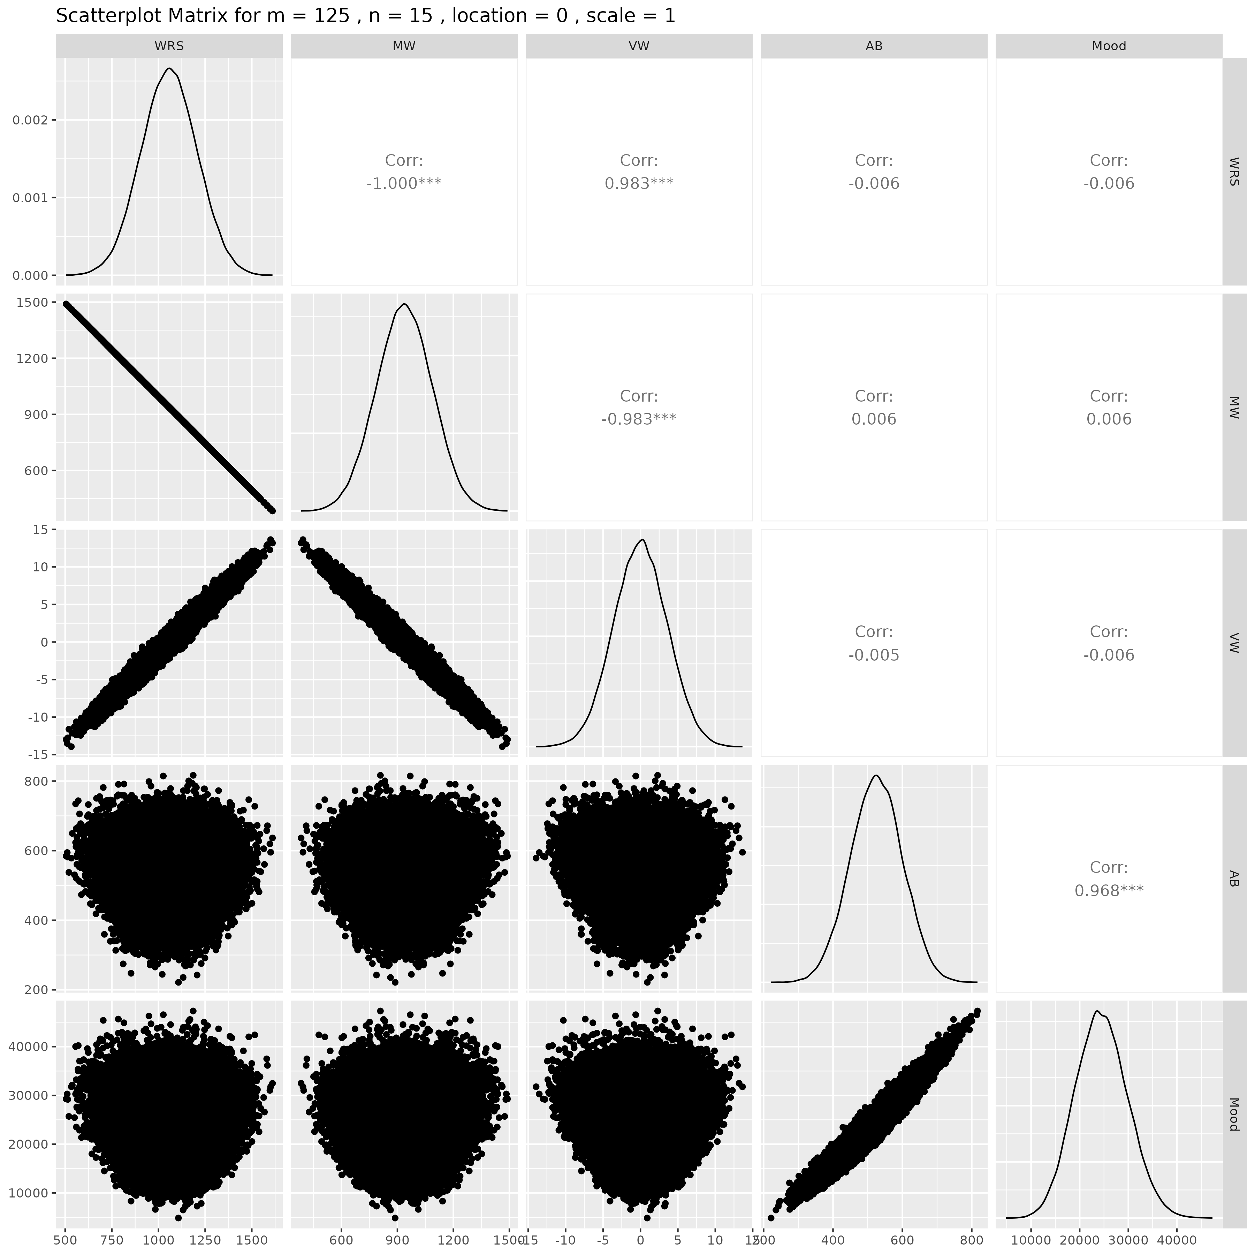

## Results for m = 125 , n = 20 , location = 0 , scale = 1

### Correlation Matrix

| Statistic | WRS | MW | VW | AB | Mood |
| --- | --- | --- | --- | --- | --- |
| character | numeric | numeric | numeric | numeric | numeric |
| WRS | 1.0000 | -1.0000 | 0.9828 | 0.0061 | 0.0045 |
| MW | -1.0000 | 1.0000 | -0.9828 | -0.0061 | -0.0045 |
| VW | 0.9828 | -0.9828 | 1.0000 | 0.0070 | 0.0054 |
| AB | 0.0061 | -0.0061 | 0.0070 | 1.0000 | 0.9681 |
| Mood | 0.0045 | -0.0045 | 0.0054 | 0.9681 | 1.0000 |
| n: 5 | | | | | |

### P-Value Matrix

| Statistic | WRS | MW | VW | AB | Mood |
| --- | --- | --- | --- | --- | --- |
| character | numeric | numeric | numeric | numeric | numeric |
| WRS |  | 0.0000 | 0.0000 | 0.1722 | 0.3157 |
| MW | 0.0000 |  | 0.0000 | 0.1722 | 0.3157 |
| VW | 0.0000 | 0.0000 |  | 0.1183 | 0.2268 |
| AB | 0.1722 | 0.1722 | 0.1183 |  | 0.0000 |
| Mood | 0.3157 | 0.3157 | 0.2268 | 0.0000 |  |
| n: 5 | | | | | |

### Scatter Plot Matrix:

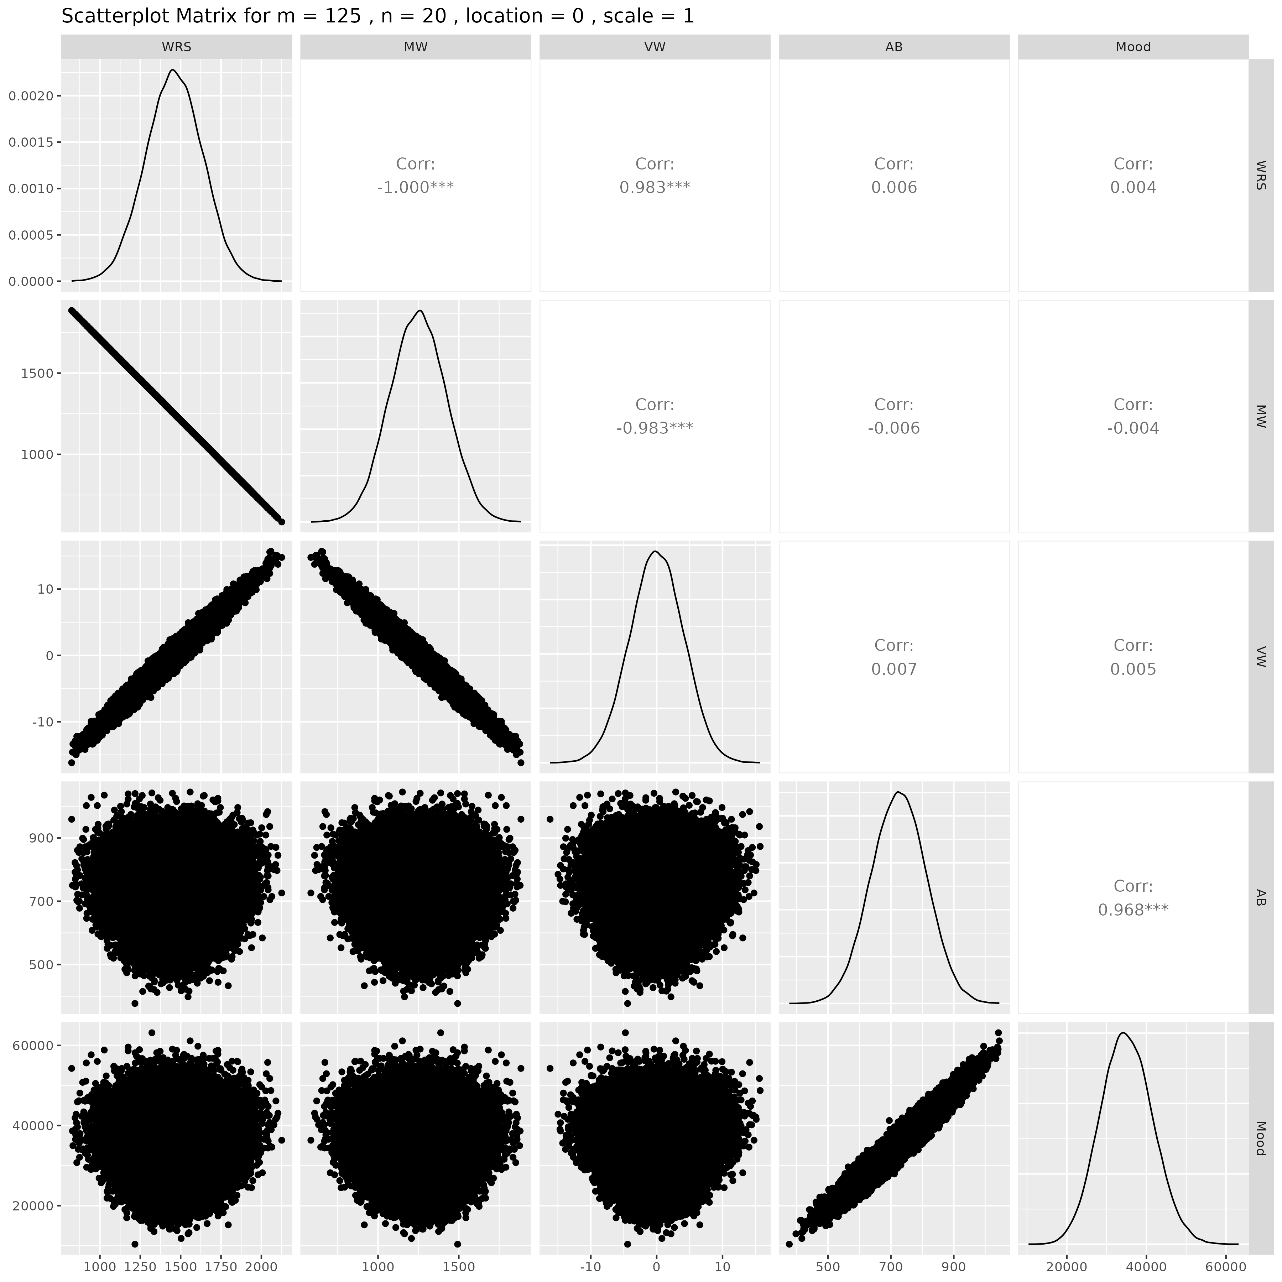

## Results for m = 125 , n = 25 , location = 0 , scale = 1

### Correlation Matrix

| Statistic | WRS | MW | VW | AB | Mood |
| --- | --- | --- | --- | --- | --- |
| character | numeric | numeric | numeric | numeric | numeric |
| WRS | 1.0000 | -1.0000 | 0.9829 | 0.0044 | 0.0040 |
| MW | -1.0000 | 1.0000 | -0.9829 | -0.0044 | -0.0040 |
| VW | 0.9829 | -0.9829 | 1.0000 | 0.0043 | 0.0039 |
| AB | 0.0044 | -0.0044 | 0.0043 | 1.0000 | 0.9687 |
| Mood | 0.0040 | -0.0040 | 0.0039 | 0.9687 | 1.0000 |
| n: 5 | | | | | |

### P-Value Matrix

| Statistic | WRS | MW | VW | AB | Mood |
| --- | --- | --- | --- | --- | --- |
| character | numeric | numeric | numeric | numeric | numeric |
| WRS |  | 0.0000 | 0.0000 | 0.3261 | 0.3704 |
| MW | 0.0000 |  | 0.0000 | 0.3261 | 0.3704 |
| VW | 0.0000 | 0.0000 |  | 0.3407 | 0.3821 |
| AB | 0.3261 | 0.3261 | 0.3407 |  | 0.0000 |
| Mood | 0.3704 | 0.3704 | 0.3821 | 0.0000 |  |
| n: 5 | | | | | |

### Scatter Plot Matrix:

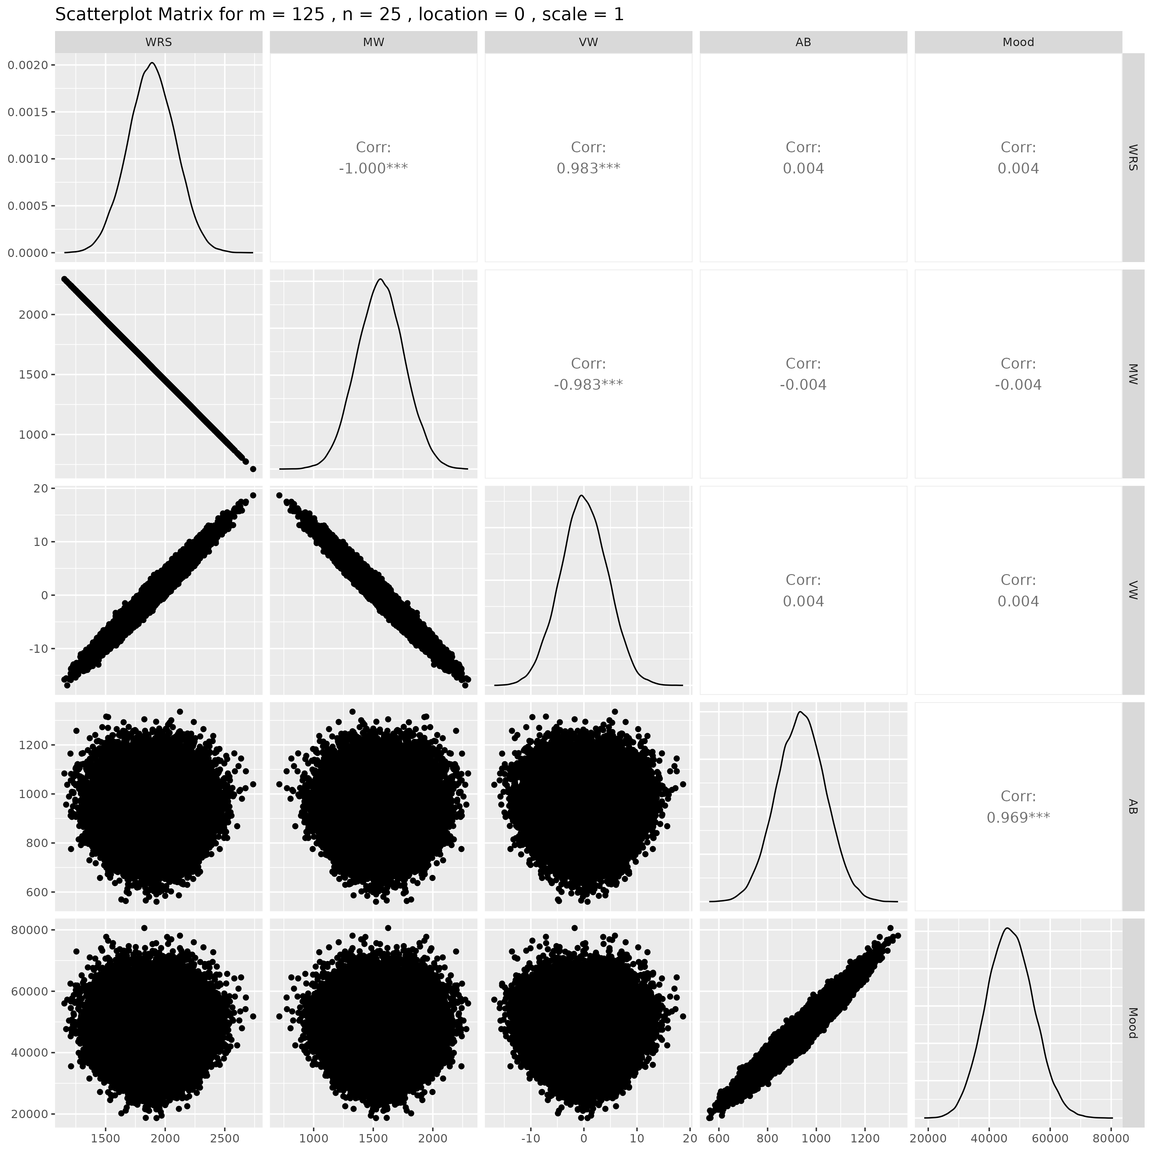

## Results for m = 125 , n = 30 , location = 0 , scale = 1

### Correlation Matrix

| Statistic | WRS | MW | VW | AB | Mood |
| --- | --- | --- | --- | --- | --- |
| character | numeric | numeric | numeric | numeric | numeric |
| WRS | 1.0000 | -1.0000 | 0.9830 | 0.0082 | 0.0085 |
| MW | -1.0000 | 1.0000 | -0.9830 | -0.0082 | -0.0085 |
| VW | 0.9830 | -0.9830 | 1.0000 | 0.0089 | 0.0094 |
| AB | 0.0082 | -0.0082 | 0.0089 | 1.0000 | 0.9681 |
| Mood | 0.0085 | -0.0085 | 0.0094 | 0.9681 | 1.0000 |
| n: 5 | | | | | |

### P-Value Matrix

| Statistic | WRS | MW | VW | AB | Mood |
| --- | --- | --- | --- | --- | --- |
| character | numeric | numeric | numeric | numeric | numeric |
| WRS |  | 0.0000 | 0.0000 | 0.0674 | 0.0567 |
| MW | 0.0000 |  | 0.0000 | 0.0674 | 0.0567 |
| VW | 0.0000 | 0.0000 |  | 0.0455 | 0.0347 |
| AB | 0.0674 | 0.0674 | 0.0455 |  | 0.0000 |
| Mood | 0.0567 | 0.0567 | 0.0347 | 0.0000 |  |
| n: 5 | | | | | |

### Scatter Plot Matrix:

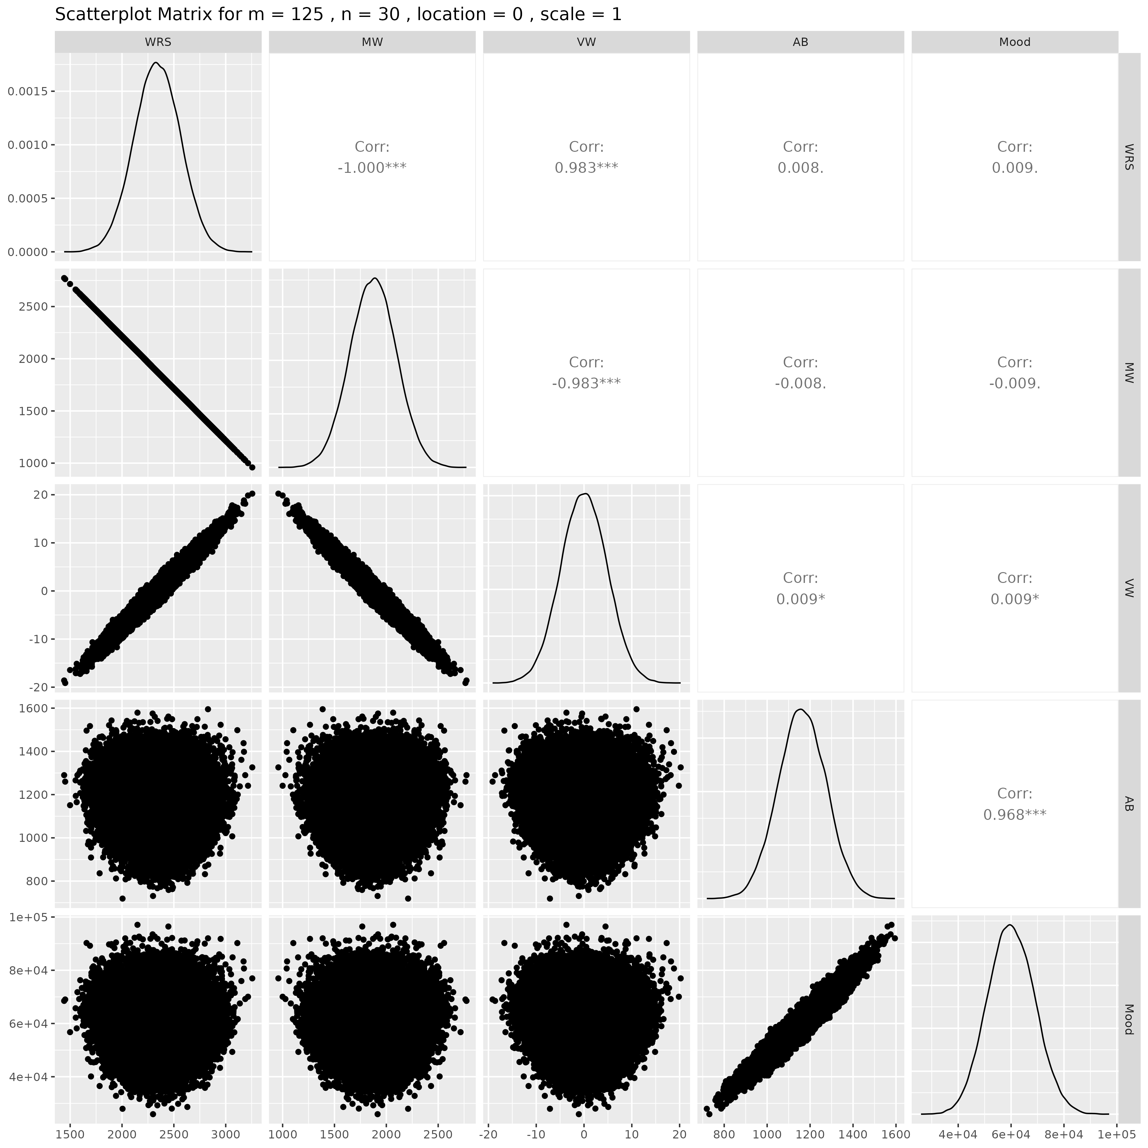

## Results for m = 125 , n = 50 , location = 0 , scale = 1

### Correlation Matrix

| Statistic | WRS | MW | VW | AB | Mood |
| --- | --- | --- | --- | --- | --- |
| character | numeric | numeric | numeric | numeric | numeric |
| WRS | 1.0000 | -1.0000 | 0.9822 | -0.0074 | -0.0073 |
| MW | -1.0000 | 1.0000 | -0.9822 | 0.0074 | 0.0073 |
| VW | 0.9822 | -0.9822 | 1.0000 | -0.0081 | -0.0085 |
| AB | -0.0074 | 0.0074 | -0.0081 | 1.0000 | 0.9686 |
| Mood | -0.0073 | 0.0073 | -0.0085 | 0.9686 | 1.0000 |
| n: 5 | | | | | |

### P-Value Matrix

| Statistic | WRS | MW | VW | AB | Mood |
| --- | --- | --- | --- | --- | --- |
| character | numeric | numeric | numeric | numeric | numeric |
| WRS |  | 0.0000 | 0.0000 | 0.0972 | 0.1028 |
| MW | 0.0000 |  | 0.0000 | 0.0972 | 0.1028 |
| VW | 0.0000 | 0.0000 |  | 0.0687 | 0.0576 |
| AB | 0.0972 | 0.0972 | 0.0687 |  | 0.0000 |
| Mood | 0.1028 | 0.1028 | 0.0576 | 0.0000 |  |
| n: 5 | | | | | |

### Scatter Plot Matrix:

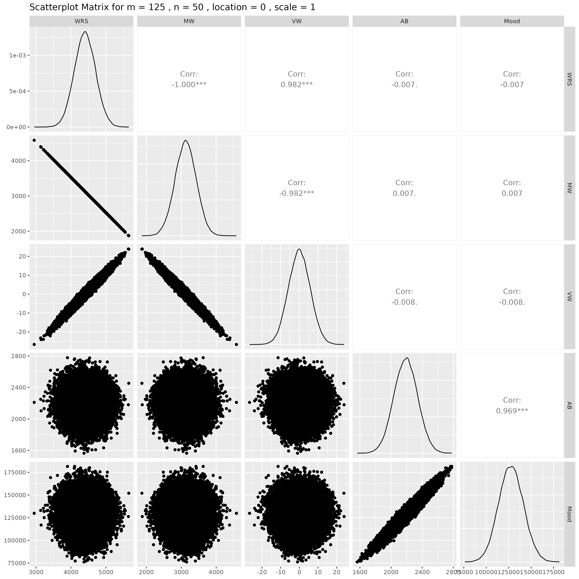

## Results for m = 150 , n = 5 , location = 0 , scale = 1

### Correlation Matrix

| Statistic | WRS | MW | VW | AB | Mood |
| --- | --- | --- | --- | --- | --- |
| character | numeric | numeric | numeric | numeric | numeric |
| WRS | 1.0000 | -1.0000 | 0.9825 | 0.0089 | 0.0107 |
| MW | -1.0000 | 1.0000 | -0.9825 | -0.0089 | -0.0107 |
| VW | 0.9825 | -0.9825 | 1.0000 | 0.0096 | 0.0114 |
| AB | 0.0089 | -0.0089 | 0.0096 | 1.0000 | 0.9687 |
| Mood | 0.0107 | -0.0107 | 0.0114 | 0.9687 | 1.0000 |
| n: 5 | | | | | |

### P-Value Matrix

| Statistic | WRS | MW | VW | AB | Mood |
| --- | --- | --- | --- | --- | --- |
| character | numeric | numeric | numeric | numeric | numeric |
| WRS |  | 0.0000 | 0.0000 | 0.0469 | 0.0164 |
| MW | 0.0000 |  | 0.0000 | 0.0469 | 0.0164 |
| VW | 0.0000 | 0.0000 |  | 0.0321 | 0.0105 |
| AB | 0.0469 | 0.0469 | 0.0321 |  | 0.0000 |
| Mood | 0.0164 | 0.0164 | 0.0105 | 0.0000 |  |
| n: 5 | | | | | |

### Scatter Plot Matrix:

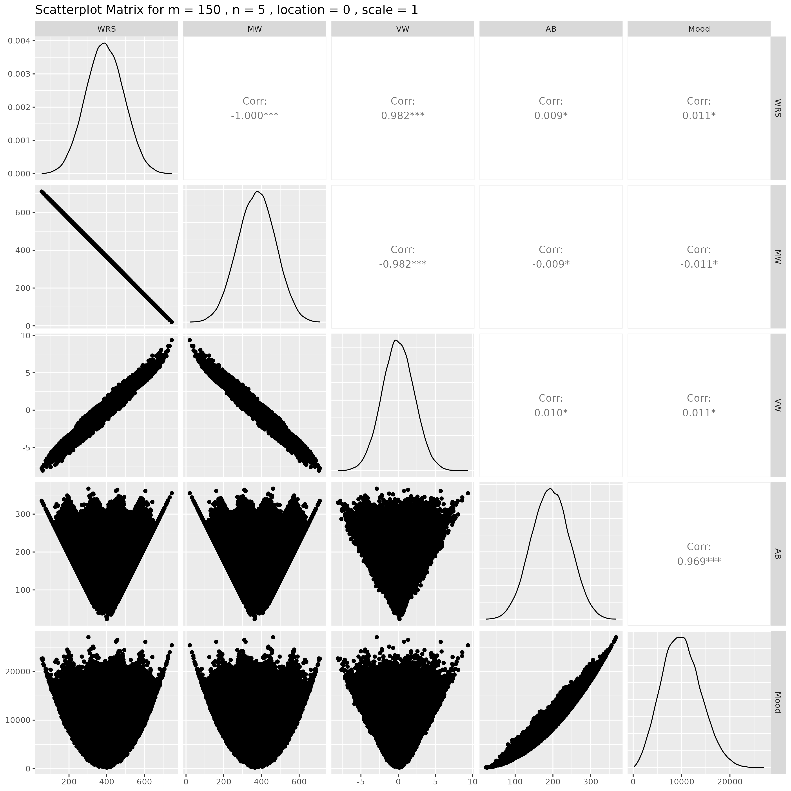

## Results for m = 150 , n = 10 , location = 0 , scale = 1

### Correlation Matrix

| Statistic | WRS | MW | VW | AB | Mood |
| --- | --- | --- | --- | --- | --- |
| character | numeric | numeric | numeric | numeric | numeric |
| WRS | 1.0000 | -1.0000 | 0.9823 | 0.0028 | 0.0031 |
| MW | -1.0000 | 1.0000 | -0.9823 | -0.0028 | -0.0031 |
| VW | 0.9823 | -0.9823 | 1.0000 | 0.0014 | 0.0016 |
| AB | 0.0028 | -0.0028 | 0.0014 | 1.0000 | 0.9687 |
| Mood | 0.0031 | -0.0031 | 0.0016 | 0.9687 | 1.0000 |
| n: 5 | | | | | |

### P-Value Matrix

| Statistic | WRS | MW | VW | AB | Mood |
| --- | --- | --- | --- | --- | --- |
| character | numeric | numeric | numeric | numeric | numeric |
| WRS |  | 0.0000 | 0.0000 | 0.5316 | 0.4905 |
| MW | 0.0000 |  | 0.0000 | 0.5316 | 0.4905 |
| VW | 0.0000 | 0.0000 |  | 0.7608 | 0.7226 |
| AB | 0.5316 | 0.5316 | 0.7608 |  | 0.0000 |
| Mood | 0.4905 | 0.4905 | 0.7226 | 0.0000 |  |
| n: 5 | | | | | |

### Scatter Plot Matrix:

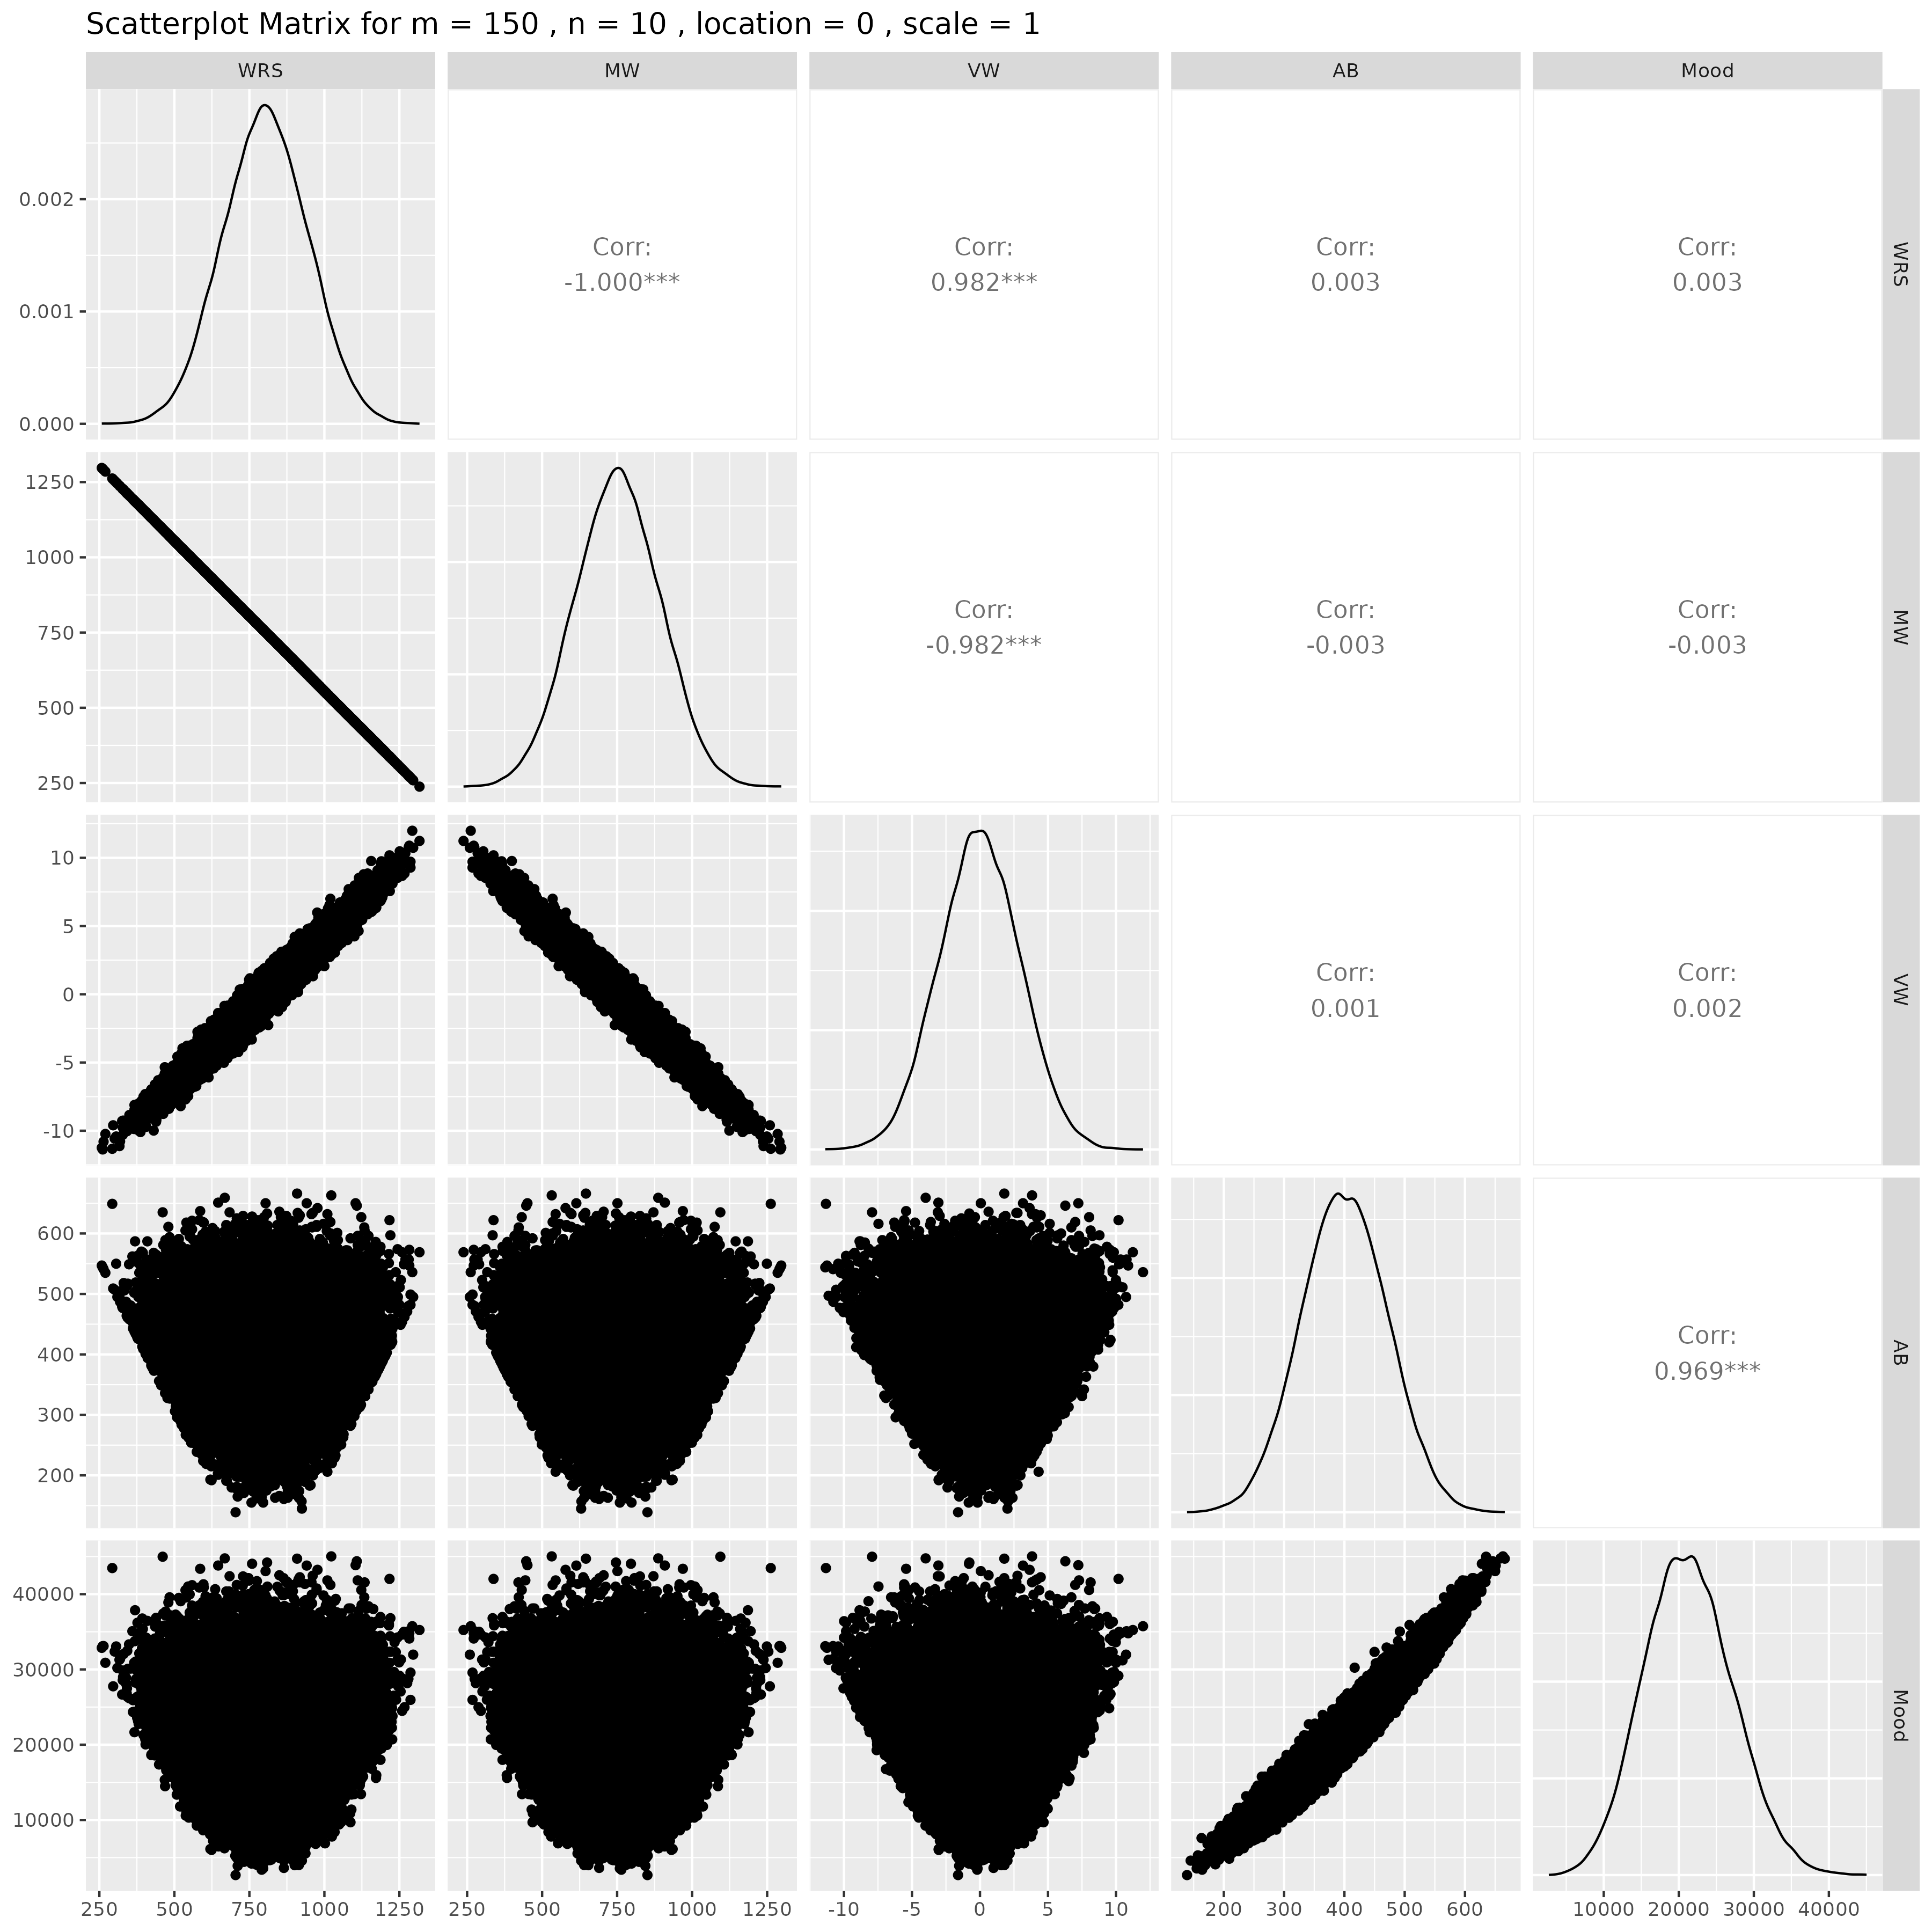

## Results for m = 150 , n = 15 , location = 0 , scale = 1

### Correlation Matrix

| Statistic | WRS | MW | VW | AB | Mood |
| --- | --- | --- | --- | --- | --- |
| character | numeric | numeric | numeric | numeric | numeric |
| WRS | 1.0000 | -1.0000 | 0.9826 | 0.0080 | 0.0068 |
| MW | -1.0000 | 1.0000 | -0.9826 | -0.0080 | -0.0068 |
| VW | 0.9826 | -0.9826 | 1.0000 | 0.0082 | 0.0072 |
| AB | 0.0080 | -0.0080 | 0.0082 | 1.0000 | 0.9685 |
| Mood | 0.0068 | -0.0068 | 0.0072 | 0.9685 | 1.0000 |
| n: 5 | | | | | |

### P-Value Matrix

| Statistic | WRS | MW | VW | AB | Mood |
| --- | --- | --- | --- | --- | --- |
| character | numeric | numeric | numeric | numeric | numeric |
| WRS |  | 0.0000 | 0.0000 | 0.0728 | 0.1285 |
| MW | 0.0000 |  | 0.0000 | 0.0728 | 0.1285 |
| VW | 0.0000 | 0.0000 |  | 0.0654 | 0.1078 |
| AB | 0.0728 | 0.0728 | 0.0654 |  | 0.0000 |
| Mood | 0.1285 | 0.1285 | 0.1078 | 0.0000 |  |
| n: 5 | | | | | |

### Scatter Plot Matrix:

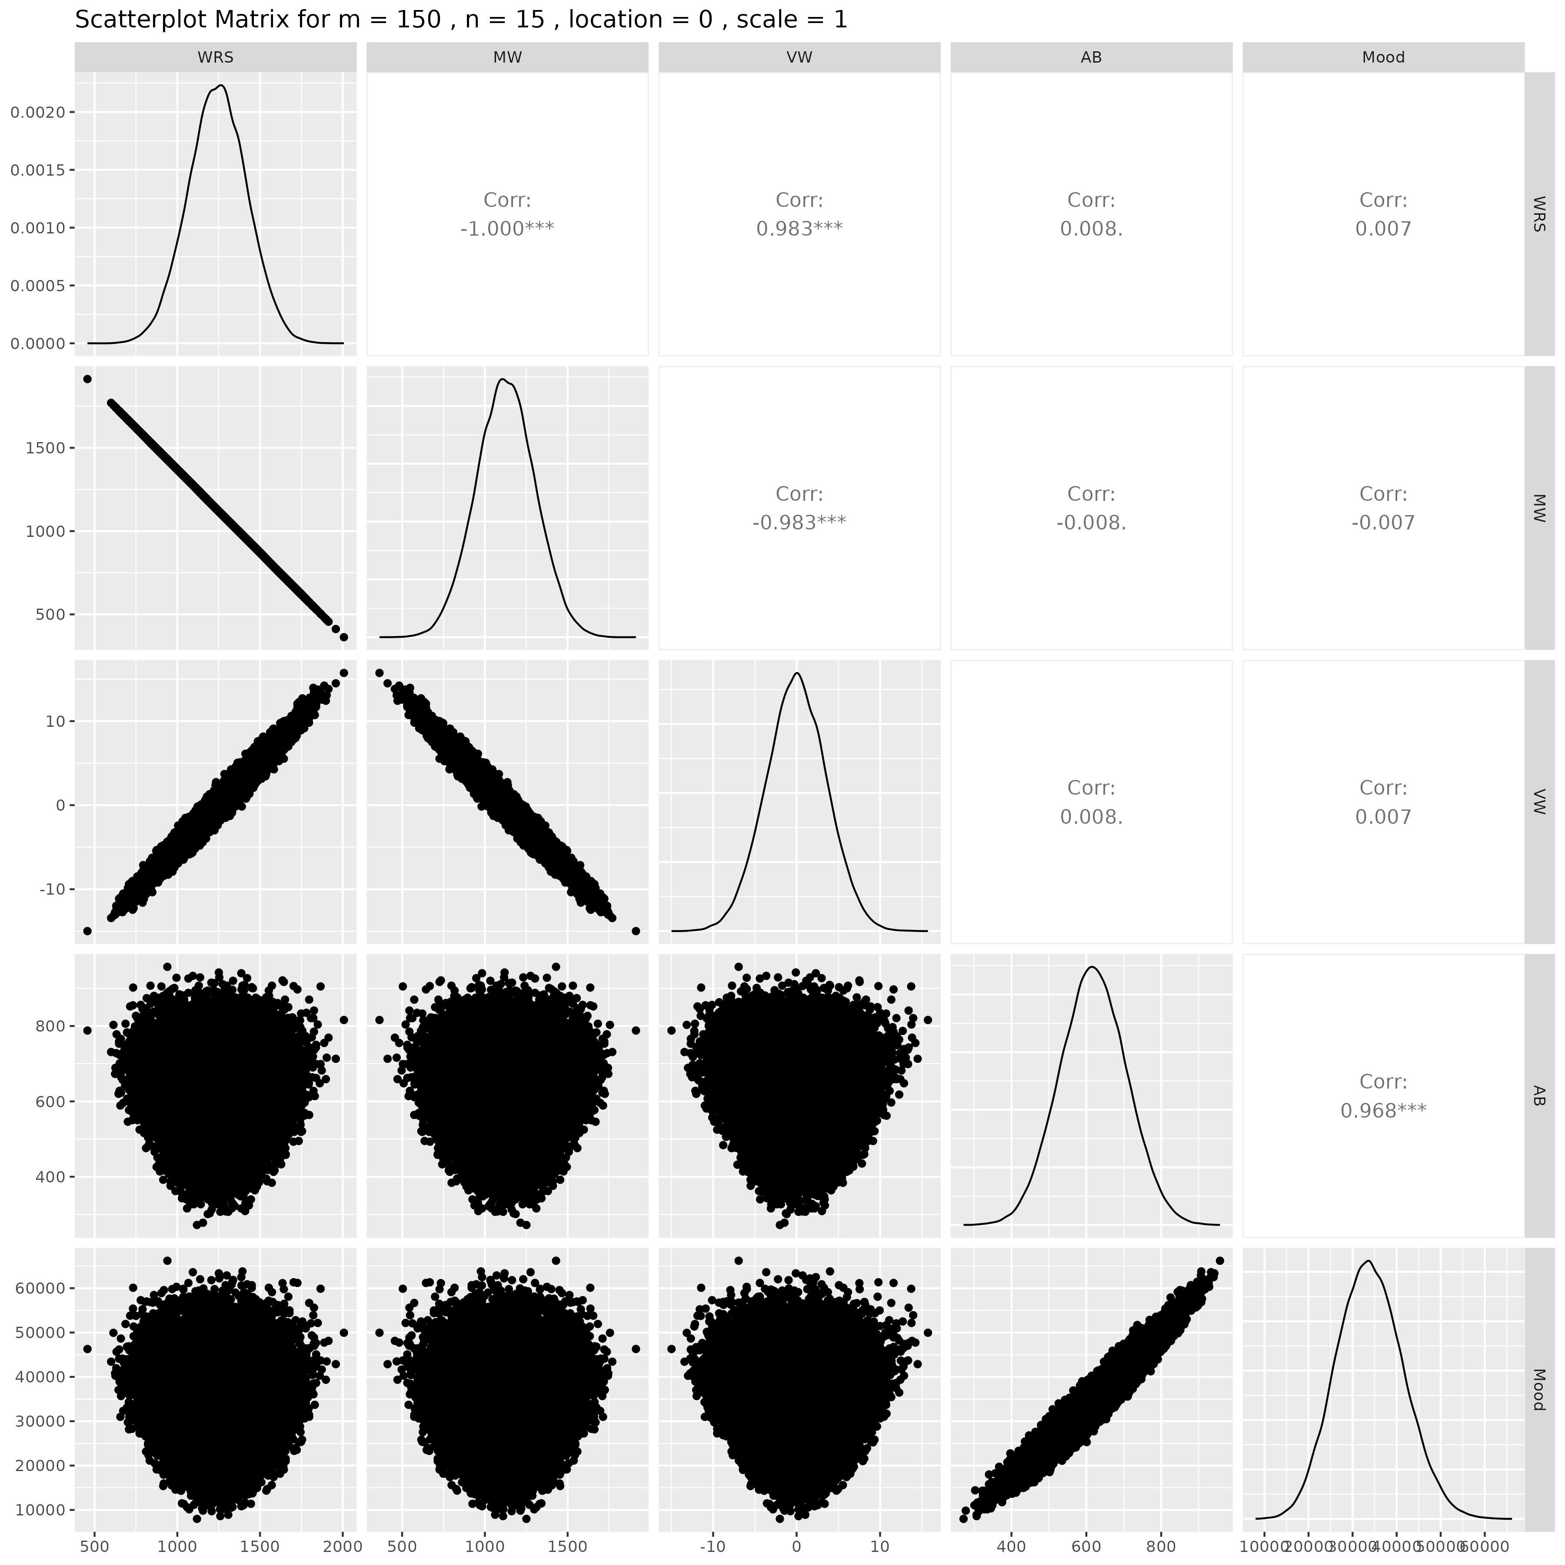

## Results for m = 150 , n = 20 , location = 0 , scale = 1

### Correlation Matrix

| Statistic | WRS | MW | VW | AB | Mood |
| --- | --- | --- | --- | --- | --- |
| character | numeric | numeric | numeric | numeric | numeric |
| WRS | 1.0000 | -1.0000 | 0.9823 | 0.0020 | 0.0023 |
| MW | -1.0000 | 1.0000 | -0.9823 | -0.0020 | -0.0023 |
| VW | 0.9823 | -0.9823 | 1.0000 | 0.0016 | 0.0023 |
| AB | 0.0020 | -0.0020 | 0.0016 | 1.0000 | 0.9683 |
| Mood | 0.0023 | -0.0023 | 0.0023 | 0.9683 | 1.0000 |
| n: 5 | | | | | |

### P-Value Matrix

| Statistic | WRS | MW | VW | AB | Mood |
| --- | --- | --- | --- | --- | --- |
| character | numeric | numeric | numeric | numeric | numeric |
| WRS |  | 0.0000 | 0.0000 | 0.6627 | 0.6050 |
| MW | 0.0000 |  | 0.0000 | 0.6627 | 0.6050 |
| VW | 0.0000 | 0.0000 |  | 0.7253 | 0.6003 |
| AB | 0.6627 | 0.6627 | 0.7253 |  | 0.0000 |
| Mood | 0.6050 | 0.6050 | 0.6003 | 0.0000 |  |
| n: 5 | | | | | |

### Scatter Plot Matrix:

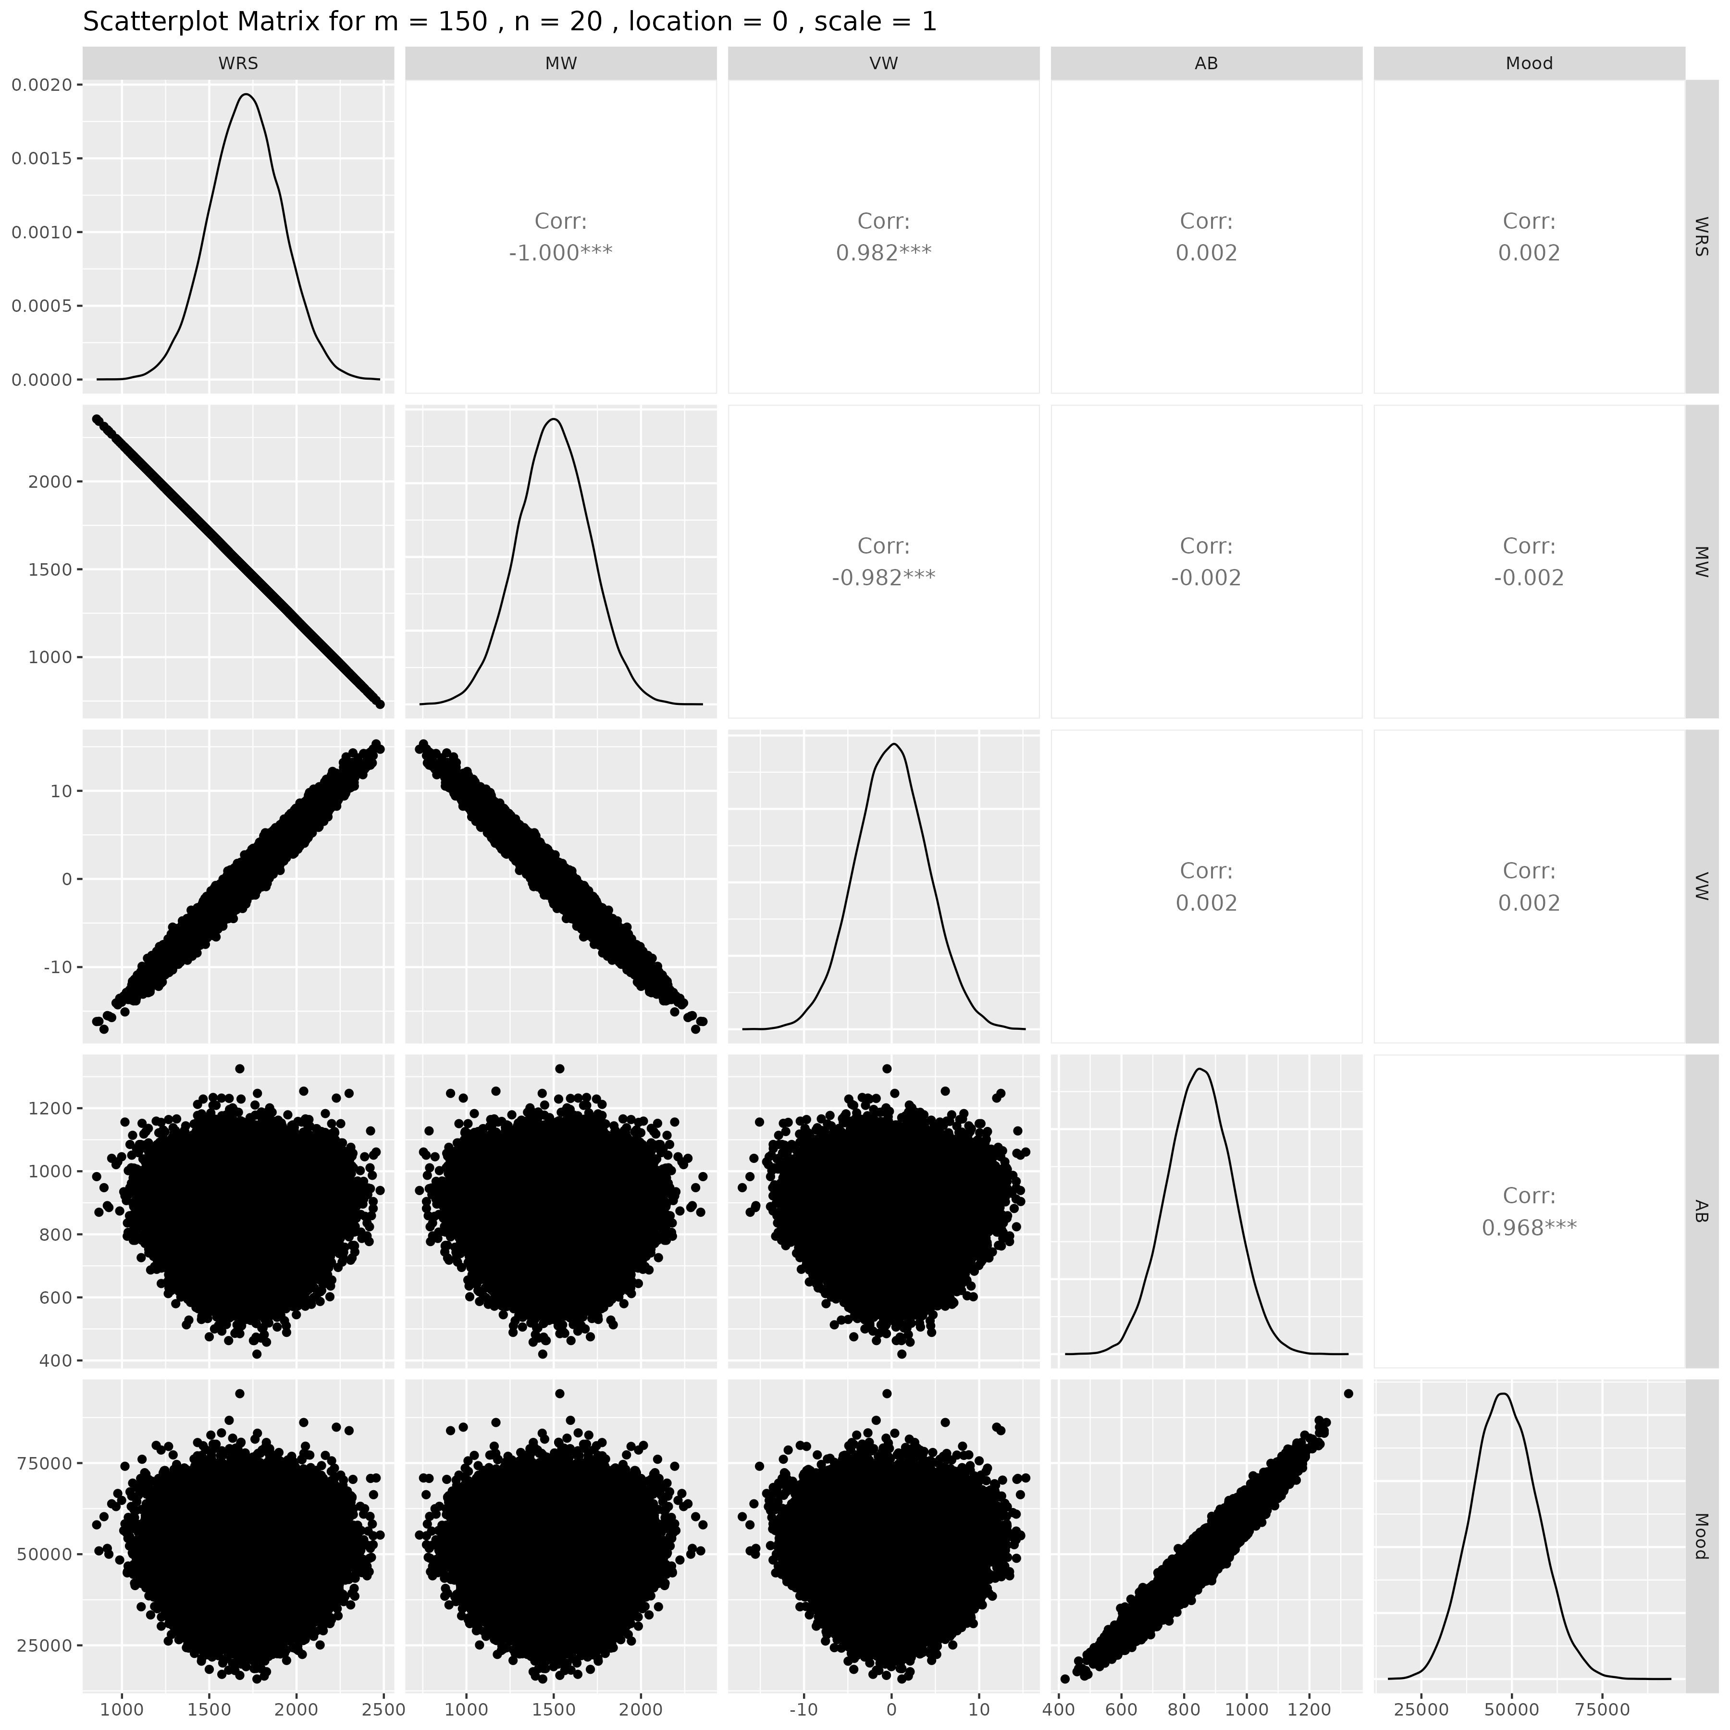

## Results for m = 150 , n = 25 , location = 0 , scale = 1

### Correlation Matrix

| Statistic | WRS | MW | VW | AB | Mood |
| --- | --- | --- | --- | --- | --- |
| character | numeric | numeric | numeric | numeric | numeric |
| WRS | 1.0000 | -1.0000 | 0.9825 | -0.0031 | -0.0019 |
| MW | -1.0000 | 1.0000 | -0.9825 | 0.0031 | 0.0019 |
| VW | 0.9825 | -0.9825 | 1.0000 | -0.0037 | -0.0029 |
| AB | -0.0031 | 0.0031 | -0.0037 | 1.0000 | 0.9681 |
| Mood | -0.0019 | 0.0019 | -0.0029 | 0.9681 | 1.0000 |
| n: 5 | | | | | |

### P-Value Matrix

| Statistic | WRS | MW | VW | AB | Mood |
| --- | --- | --- | --- | --- | --- |
| character | numeric | numeric | numeric | numeric | numeric |
| WRS |  | 0.0000 | 0.0000 | 0.4876 | 0.6729 |
| MW | 0.0000 |  | 0.0000 | 0.4876 | 0.6729 |
| VW | 0.0000 | 0.0000 |  | 0.4065 | 0.5115 |
| AB | 0.4876 | 0.4876 | 0.4065 |  | 0.0000 |
| Mood | 0.6729 | 0.6729 | 0.5115 | 0.0000 |  |
| n: 5 | | | | | |

### Scatter Plot Matrix:

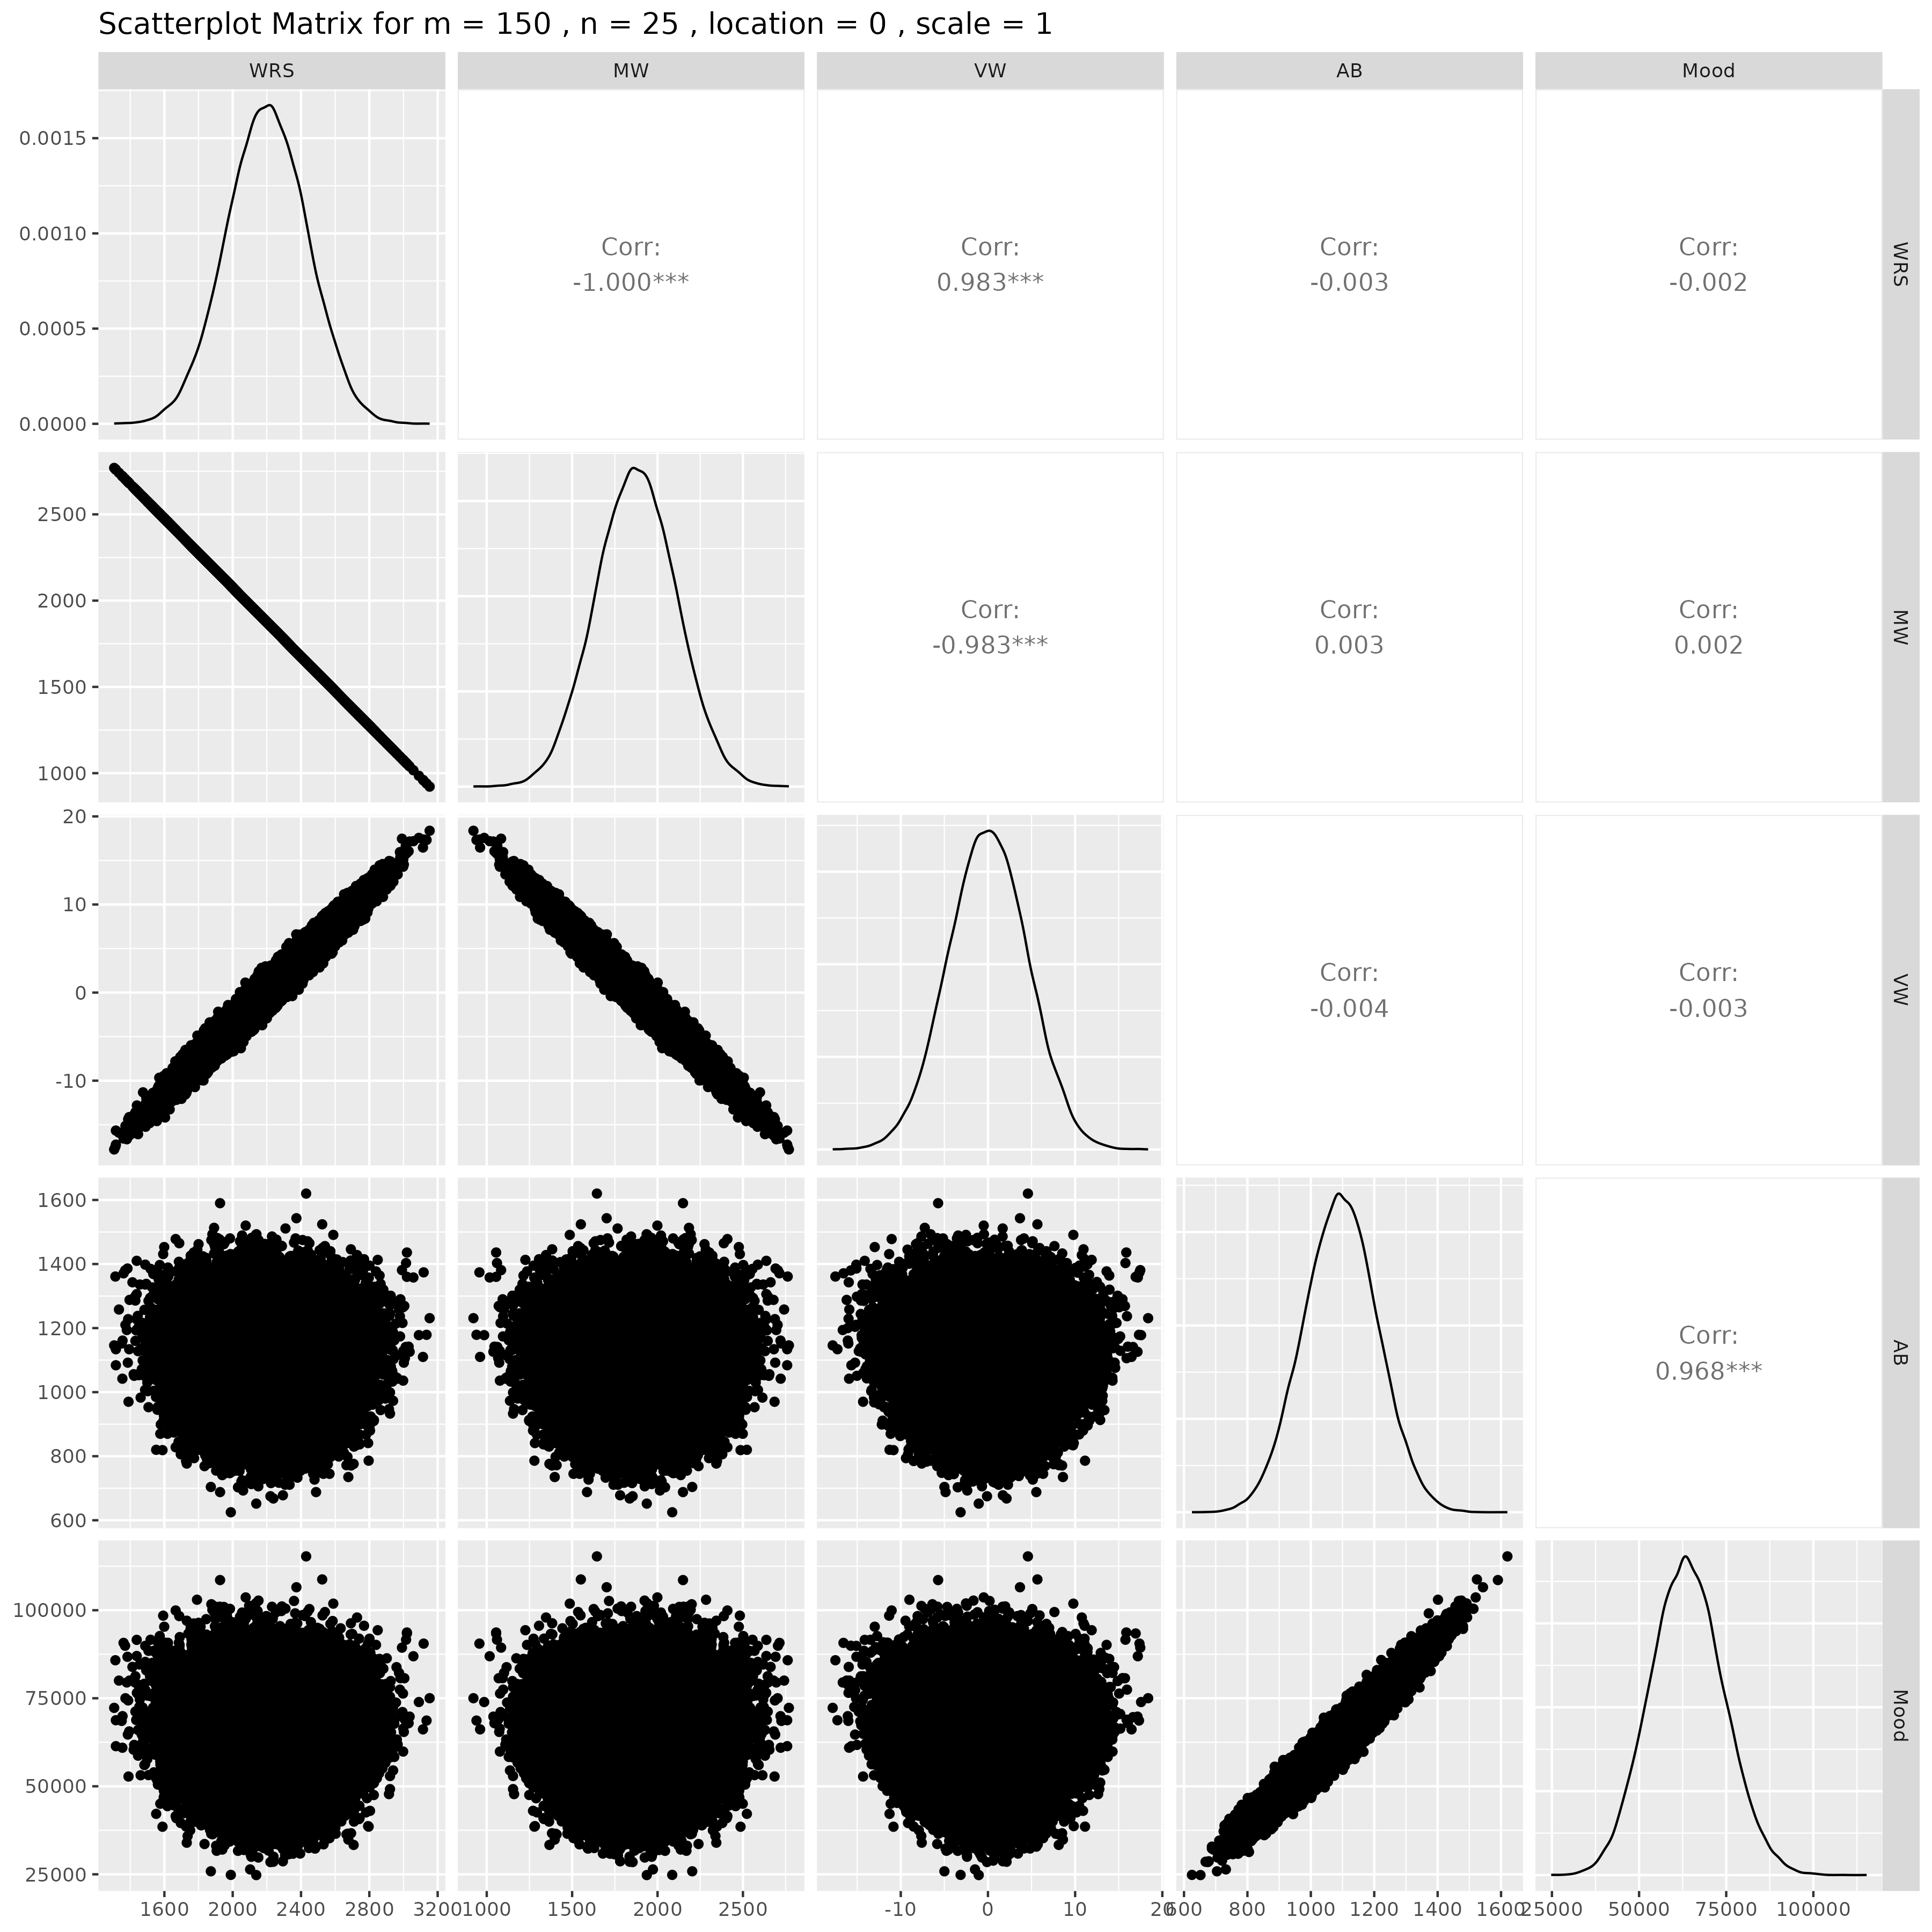

## Results for m = 150 , n = 30 , location = 0 , scale = 1

### Correlation Matrix

| Statistic | WRS | MW | VW | AB | Mood |
| --- | --- | --- | --- | --- | --- |
| character | numeric | numeric | numeric | numeric | numeric |
| WRS | 1.0000 | -1.0000 | 0.9823 | -0.0005 | 0.0004 |
| MW | -1.0000 | 1.0000 | -0.9823 | 0.0005 | -0.0004 |
| VW | 0.9823 | -0.9823 | 1.0000 | -0.0005 | 0.0004 |
| AB | -0.0005 | 0.0005 | -0.0005 | 1.0000 | 0.9680 |
| Mood | 0.0004 | -0.0004 | 0.0004 | 0.9680 | 1.0000 |
| n: 5 | | | | | |

### P-Value Matrix

| Statistic | WRS | MW | VW | AB | Mood |
| --- | --- | --- | --- | --- | --- |
| character | numeric | numeric | numeric | numeric | numeric |
| WRS |  | 0.0000 | 0.0000 | 0.9099 | 0.9250 |
| MW | 0.0000 |  | 0.0000 | 0.9099 | 0.9250 |
| VW | 0.0000 | 0.0000 |  | 0.9048 | 0.9263 |
| AB | 0.9099 | 0.9099 | 0.9048 |  | 0.0000 |
| Mood | 0.9250 | 0.9250 | 0.9263 | 0.0000 |  |
| n: 5 | | | | | |

### Scatter Plot Matrix:

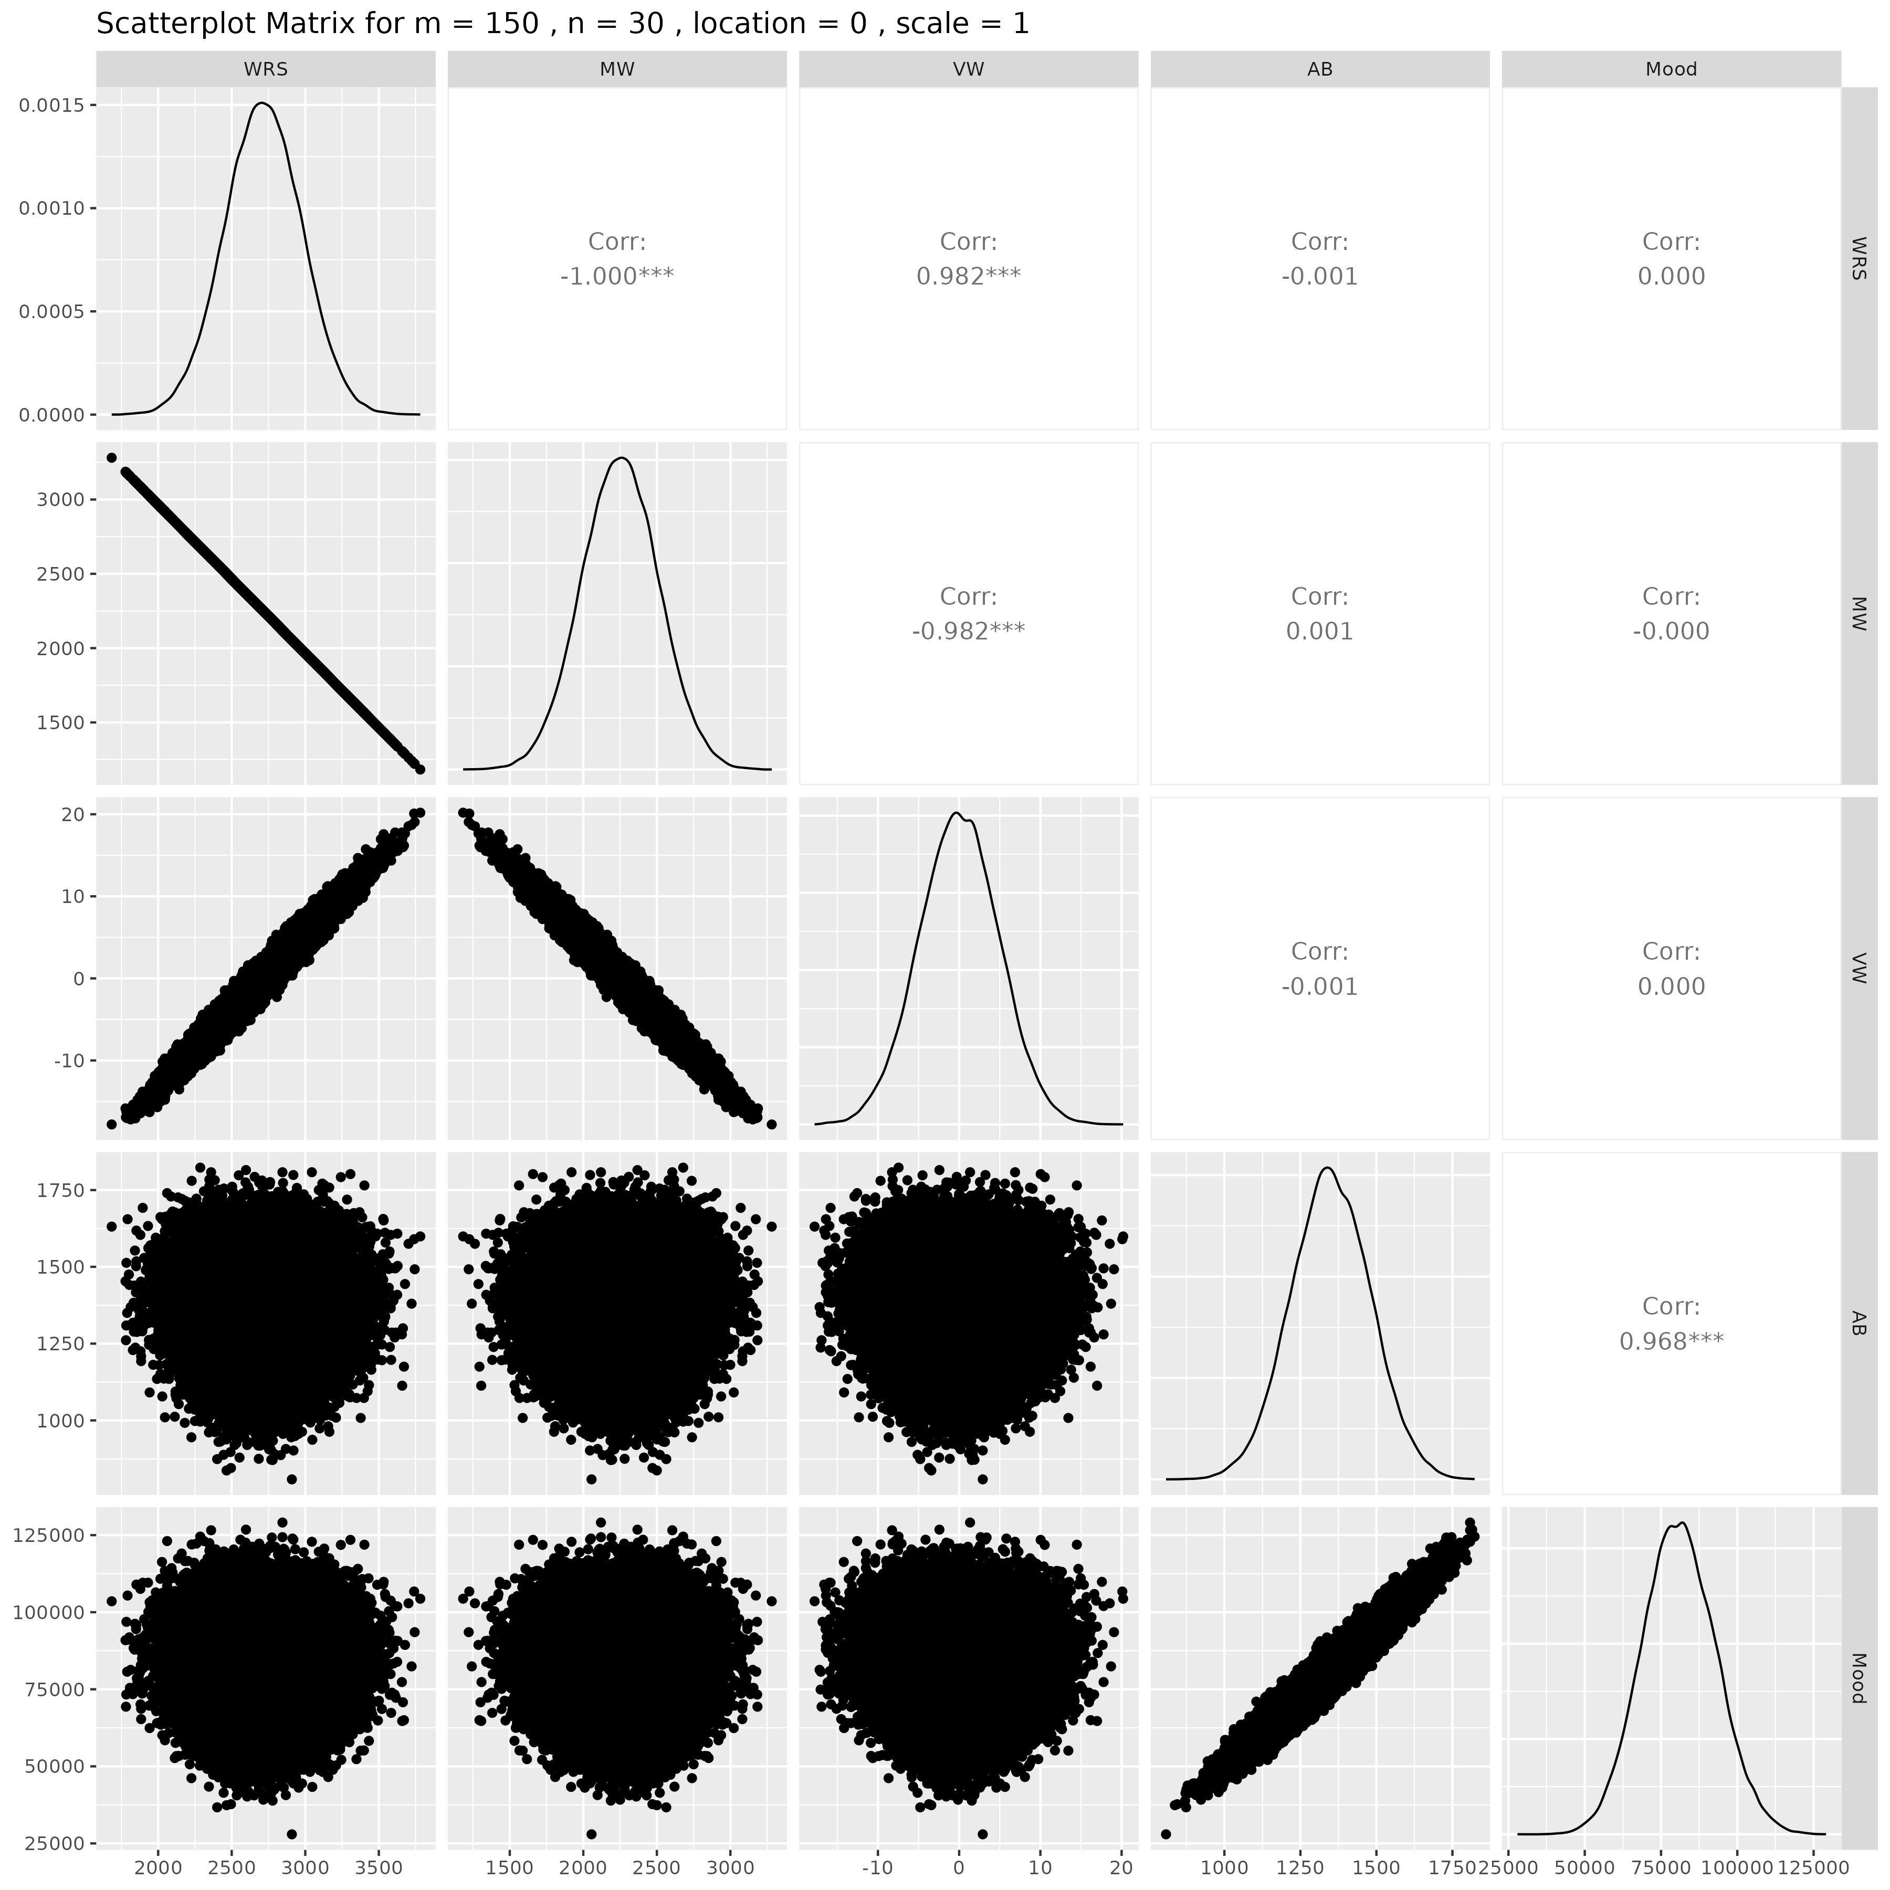

## Results for m = 150 , n = 50 , location = 0 , scale = 1

### Correlation Matrix

| Statistic | WRS | MW | VW | AB | Mood |
| --- | --- | --- | --- | --- | --- |
| character | numeric | numeric | numeric | numeric | numeric |
| WRS | 1.0000 | -1.0000 | 0.9817 | -0.0058 | -0.0064 |
| MW | -1.0000 | 1.0000 | -0.9817 | 0.0058 | 0.0064 |
| VW | 0.9817 | -0.9817 | 1.0000 | -0.0055 | -0.0061 |
| AB | -0.0058 | 0.0058 | -0.0055 | 1.0000 | 0.9681 |
| Mood | -0.0064 | 0.0064 | -0.0061 | 0.9681 | 1.0000 |
| n: 5 | | | | | |

### P-Value Matrix

| Statistic | WRS | MW | VW | AB | Mood |
| --- | --- | --- | --- | --- | --- |
| character | numeric | numeric | numeric | numeric | numeric |
| WRS |  | 0.0000 | 0.0000 | 0.1946 | 0.1528 |
| MW | 0.0000 |  | 0.0000 | 0.1946 | 0.1528 |
| VW | 0.0000 | 0.0000 |  | 0.2164 | 0.1703 |
| AB | 0.1946 | 0.1946 | 0.2164 |  | 0.0000 |
| Mood | 0.1528 | 0.1528 | 0.1703 | 0.0000 |  |
| n: 5 | | | | | |

### Scatter Plot Matrix:

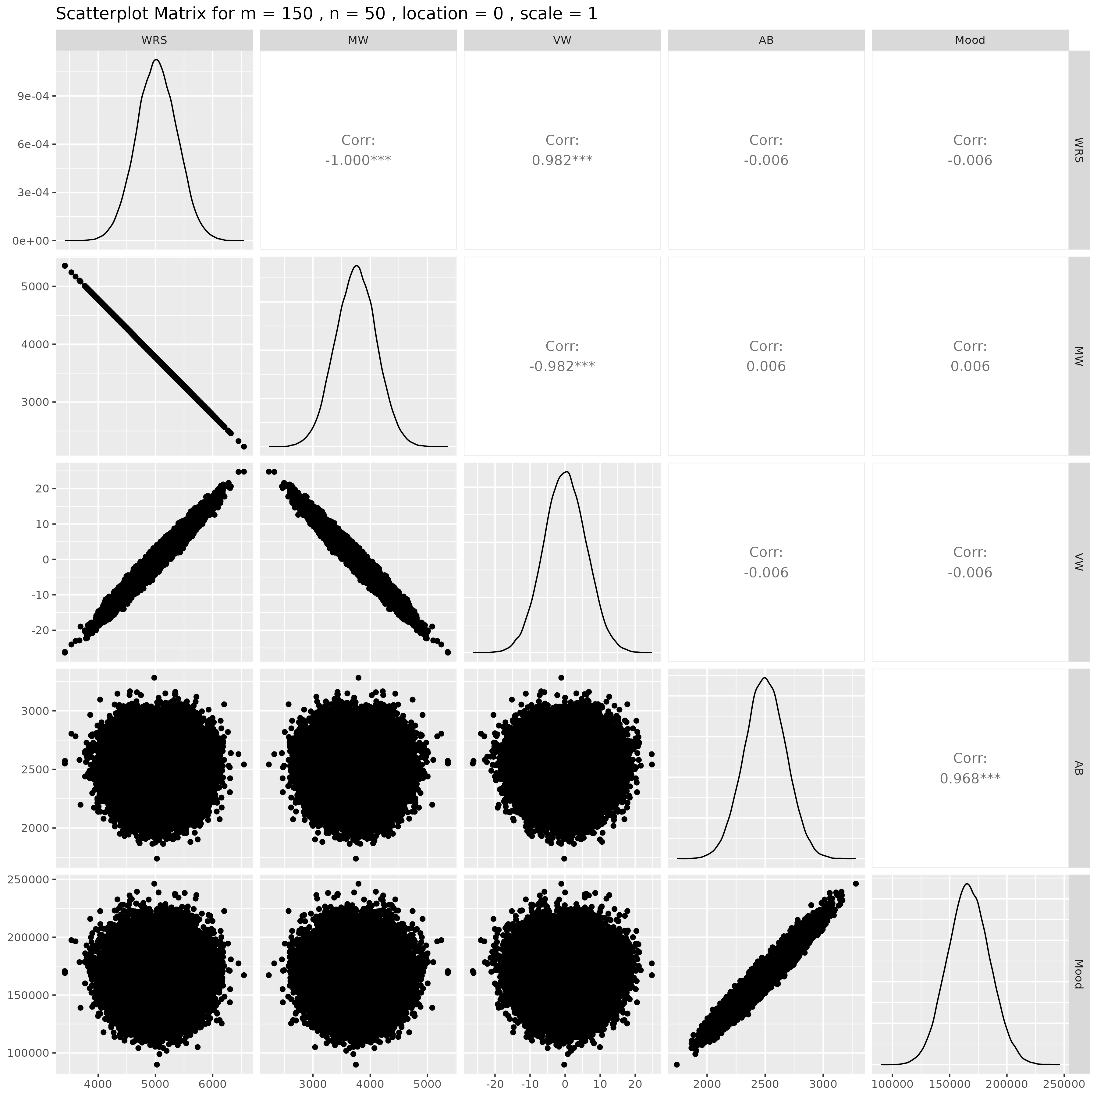

## Results for m = 175 , n = 5 , location = 0 , scale = 1

### Correlation Matrix

| Statistic | WRS | MW | VW | AB | Mood |
| --- | --- | --- | --- | --- | --- |
| character | numeric | numeric | numeric | numeric | numeric |
| WRS | 1.0000 | -1.0000 | 0.9823 | -0.0037 | -0.0033 |
| MW | -1.0000 | 1.0000 | -0.9823 | 0.0037 | 0.0033 |
| VW | 0.9823 | -0.9823 | 1.0000 | -0.0030 | -0.0027 |
| AB | -0.0037 | 0.0037 | -0.0030 | 1.0000 | 0.9684 |
| Mood | -0.0033 | 0.0033 | -0.0027 | 0.9684 | 1.0000 |
| n: 5 | | | | | |

### P-Value Matrix

| Statistic | WRS | MW | VW | AB | Mood |
| --- | --- | --- | --- | --- | --- |
| character | numeric | numeric | numeric | numeric | numeric |
| WRS |  | 0.0000 | 0.0000 | 0.4053 | 0.4633 |
| MW | 0.0000 |  | 0.0000 | 0.4053 | 0.4633 |
| VW | 0.0000 | 0.0000 |  | 0.4979 | 0.5455 |
| AB | 0.4053 | 0.4053 | 0.4979 |  | 0.0000 |
| Mood | 0.4633 | 0.4633 | 0.5455 | 0.0000 |  |
| n: 5 | | | | | |

### Scatter Plot Matrix:

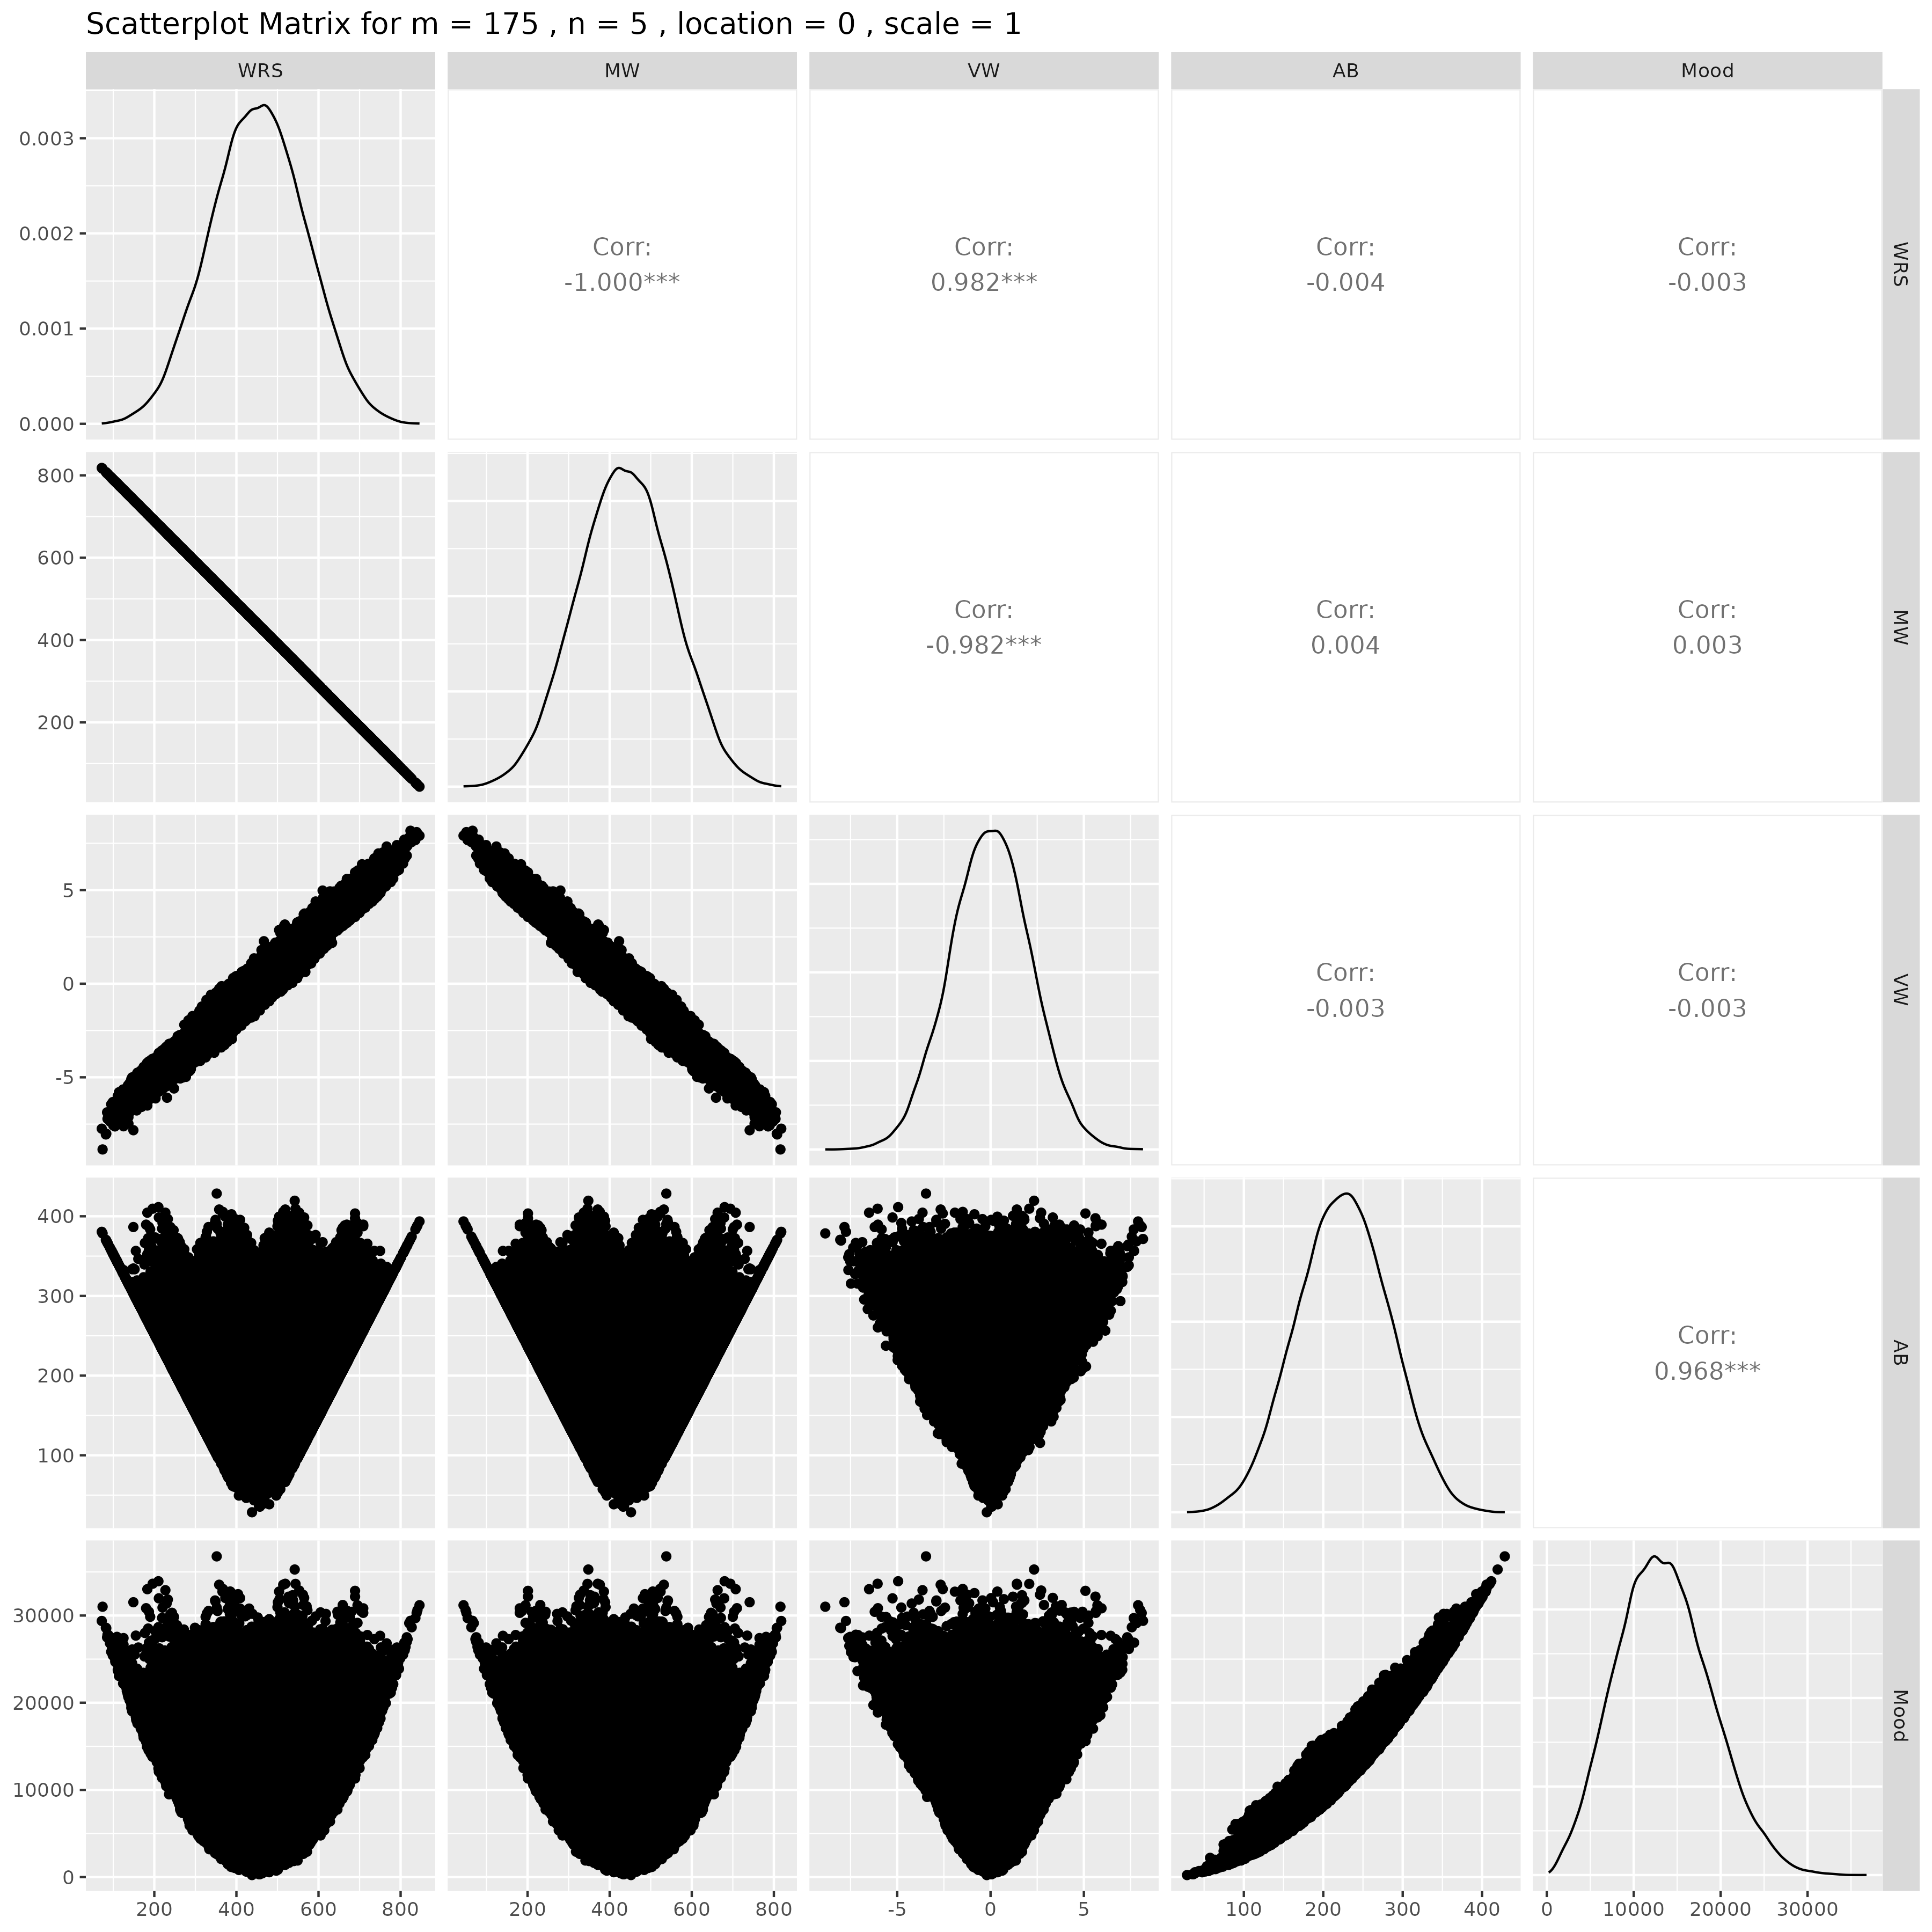

## Results for m = 175 , n = 10 , location = 0 , scale = 1

### Correlation Matrix

| Statistic | WRS | MW | VW | AB | Mood |
| --- | --- | --- | --- | --- | --- |
| character | numeric | numeric | numeric | numeric | numeric |
| WRS | 1.0000 | -1.0000 | 0.9821 | -0.0058 | -0.0070 |
| MW | -1.0000 | 1.0000 | -0.9821 | 0.0058 | 0.0070 |
| VW | 0.9821 | -0.9821 | 1.0000 | -0.0057 | -0.0074 |
| AB | -0.0058 | 0.0058 | -0.0057 | 1.0000 | 0.9686 |
| Mood | -0.0070 | 0.0070 | -0.0074 | 0.9686 | 1.0000 |
| n: 5 | | | | | |

### P-Value Matrix

| Statistic | WRS | MW | VW | AB | Mood |
| --- | --- | --- | --- | --- | --- |
| character | numeric | numeric | numeric | numeric | numeric |
| WRS |  | 0.0000 | 0.0000 | 0.1940 | 0.1172 |
| MW | 0.0000 |  | 0.0000 | 0.1940 | 0.1172 |
| VW | 0.0000 | 0.0000 |  | 0.2003 | 0.0970 |
| AB | 0.1940 | 0.1940 | 0.2003 |  | 0.0000 |
| Mood | 0.1172 | 0.1172 | 0.0970 | 0.0000 |  |
| n: 5 | | | | | |

### Scatter Plot Matrix:

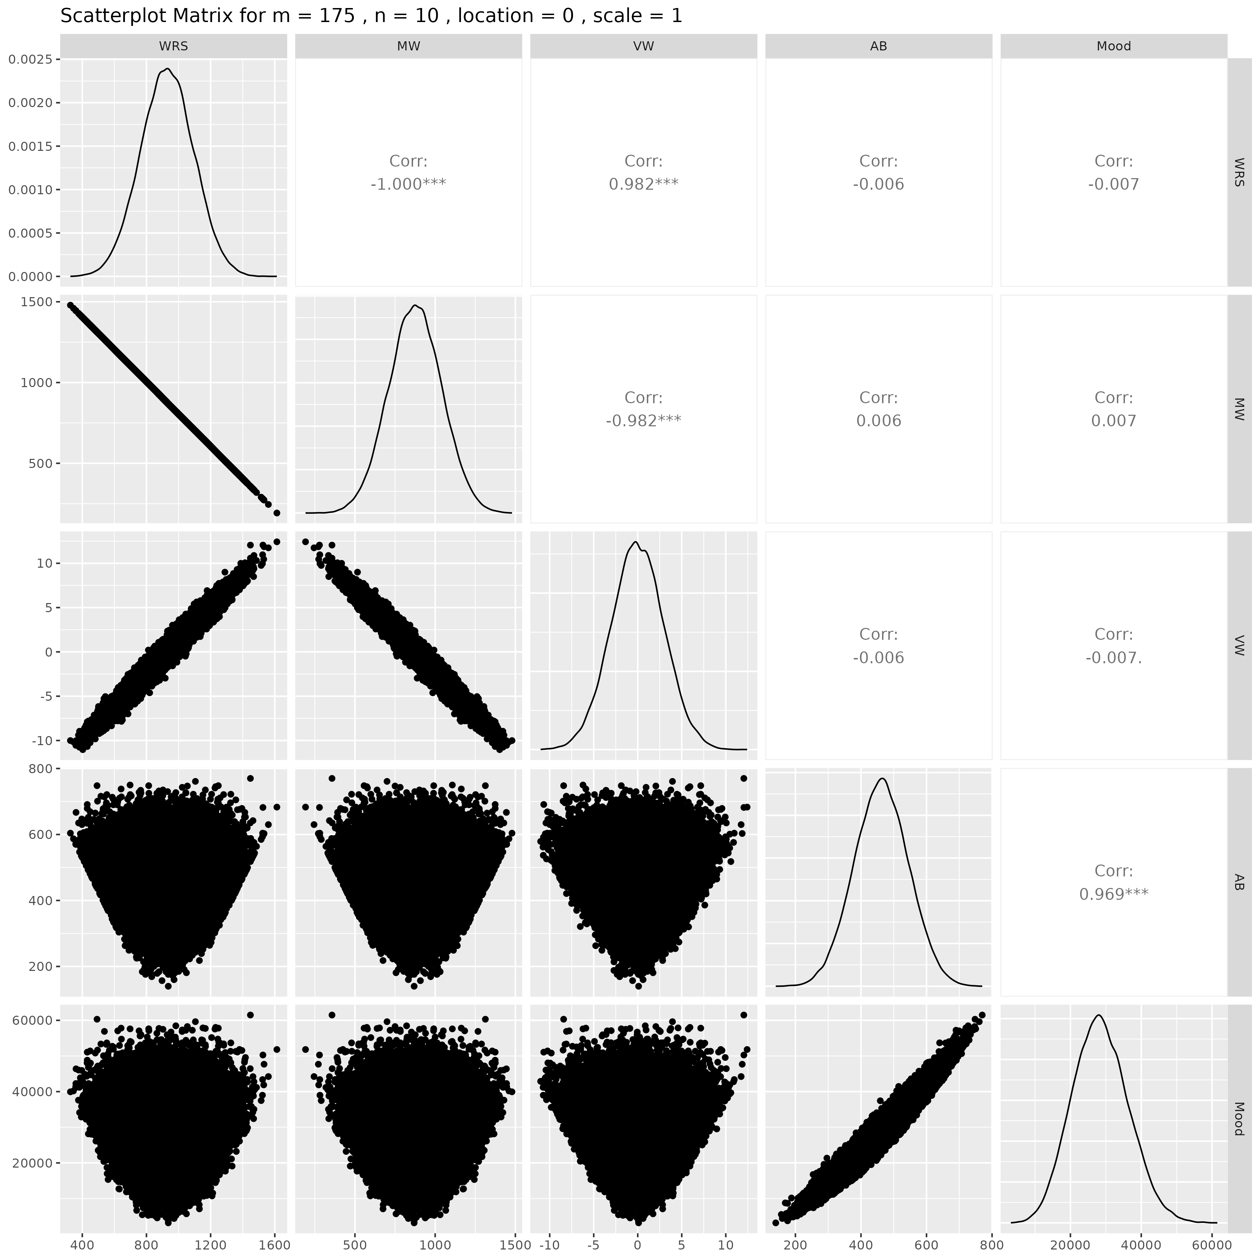

## Results for m = 175 , n = 15 , location = 0 , scale = 1

### Correlation Matrix

| Statistic | WRS | MW | VW | AB | Mood |
| --- | --- | --- | --- | --- | --- |
| character | numeric | numeric | numeric | numeric | numeric |
| WRS | 1.0000 | -1.0000 | 0.9819 | 0.0029 | 0.0035 |
| MW | -1.0000 | 1.0000 | -0.9819 | -0.0029 | -0.0035 |
| VW | 0.9819 | -0.9819 | 1.0000 | 0.0045 | 0.0049 |
| AB | 0.0029 | -0.0029 | 0.0045 | 1.0000 | 0.9681 |
| Mood | 0.0035 | -0.0035 | 0.0049 | 0.9681 | 1.0000 |
| n: 5 | | | | | |

### P-Value Matrix

| Statistic | WRS | MW | VW | AB | Mood |
| --- | --- | --- | --- | --- | --- |
| character | numeric | numeric | numeric | numeric | numeric |
| WRS |  | 0.0000 | 0.0000 | 0.5170 | 0.4334 |
| MW | 0.0000 |  | 0.0000 | 0.5170 | 0.4334 |
| VW | 0.0000 | 0.0000 |  | 0.3136 | 0.2770 |
| AB | 0.5170 | 0.5170 | 0.3136 |  | 0.0000 |
| Mood | 0.4334 | 0.4334 | 0.2770 | 0.0000 |  |
| n: 5 | | | | | |

### Scatter Plot Matrix:

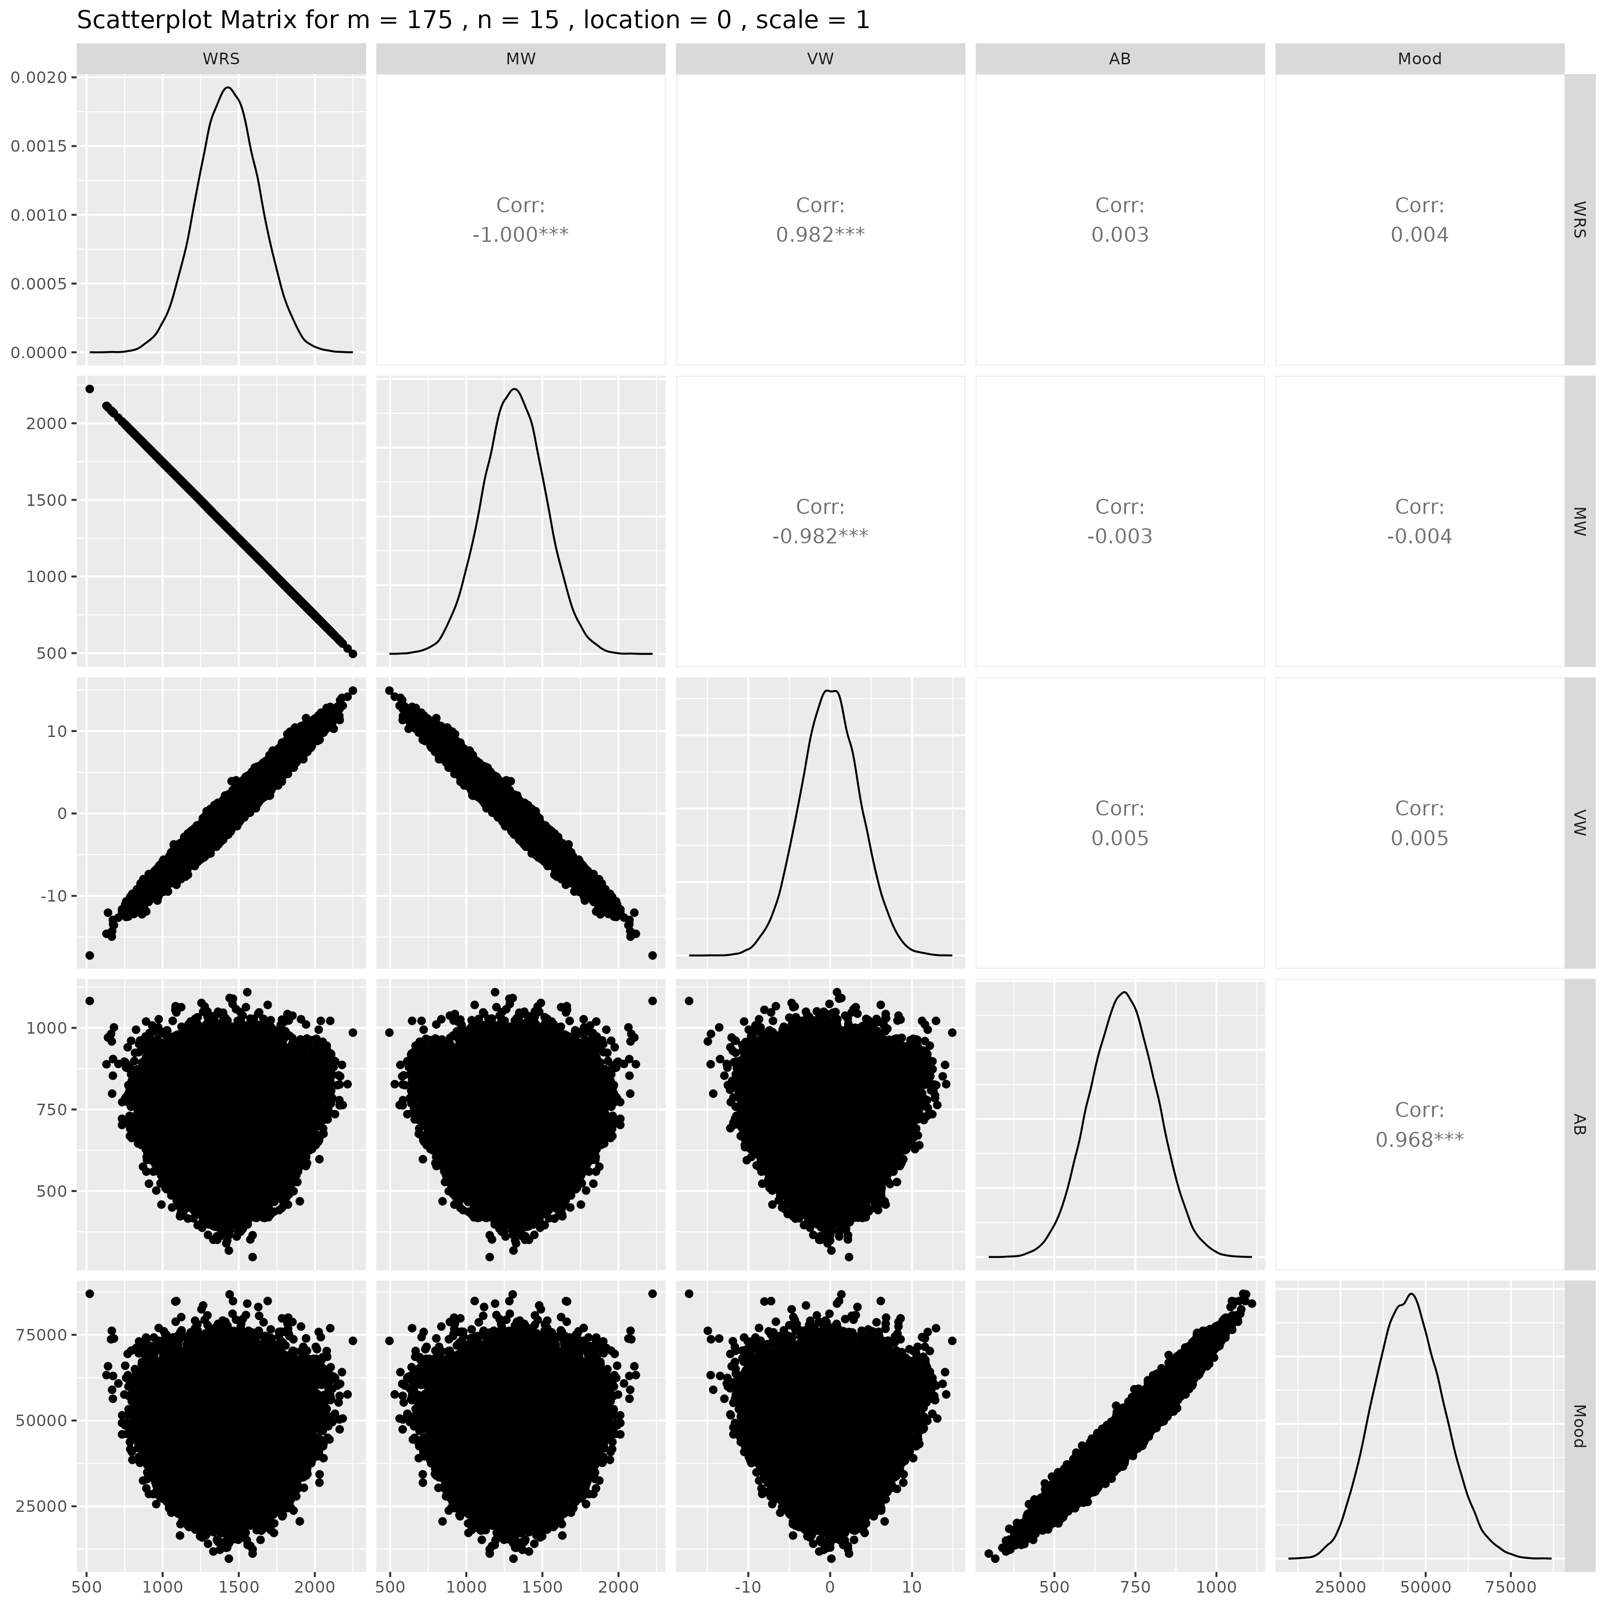

## Results for m = 175 , n = 20 , location = 0 , scale = 1

### Correlation Matrix

| Statistic | WRS | MW | VW | AB | Mood |
| --- | --- | --- | --- | --- | --- |
| character | numeric | numeric | numeric | numeric | numeric |
| WRS | 1.0000 | -1.0000 | 0.9821 | 0.0009 | 0.0027 |
| MW | -1.0000 | 1.0000 | -0.9821 | -0.0009 | -0.0027 |
| VW | 0.9821 | -0.9821 | 1.0000 | 0.0007 | 0.0025 |
| AB | 0.0009 | -0.0009 | 0.0007 | 1.0000 | 0.9678 |
| Mood | 0.0027 | -0.0027 | 0.0025 | 0.9678 | 1.0000 |
| n: 5 | | | | | |

### P-Value Matrix

| Statistic | WRS | MW | VW | AB | Mood |
| --- | --- | --- | --- | --- | --- |
| character | numeric | numeric | numeric | numeric | numeric |
| WRS |  | 0.0000 | 0.0000 | 0.8410 | 0.5505 |
| MW | 0.0000 |  | 0.0000 | 0.8410 | 0.5505 |
| VW | 0.0000 | 0.0000 |  | 0.8835 | 0.5740 |
| AB | 0.8410 | 0.8410 | 0.8835 |  | 0.0000 |
| Mood | 0.5505 | 0.5505 | 0.5740 | 0.0000 |  |
| n: 5 | | | | | |

### Scatter Plot Matrix:

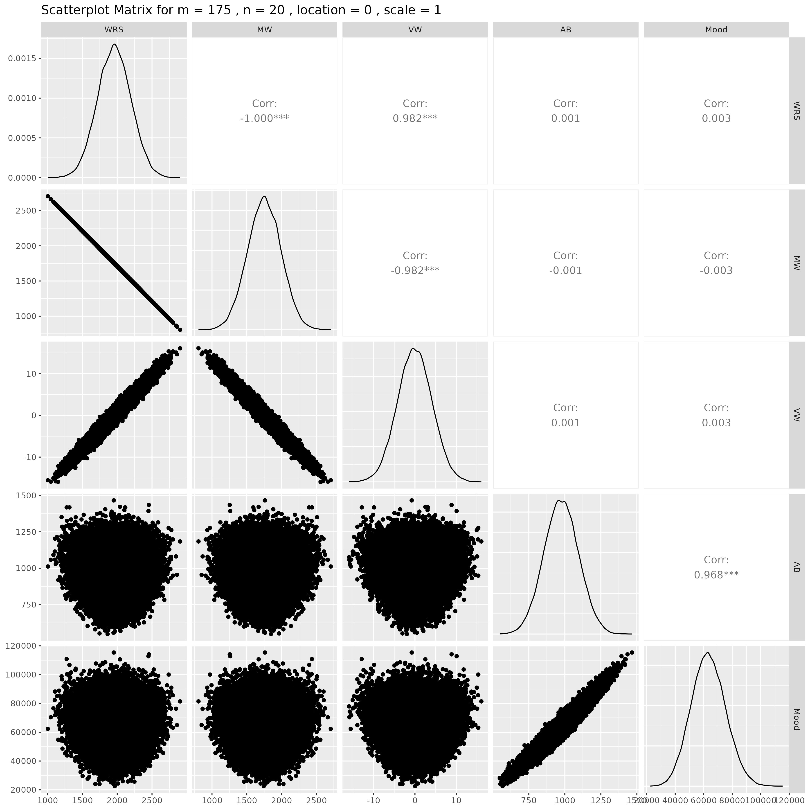

## Results for m = 175 , n = 25 , location = 0 , scale = 1

### Correlation Matrix

| Statistic | WRS | MW | VW | AB | Mood |
| --- | --- | --- | --- | --- | --- |
| character | numeric | numeric | numeric | numeric | numeric |
| WRS | 1.0000 | -1.0000 | 0.9819 | -0.0025 | -0.0030 |
| MW | -1.0000 | 1.0000 | -0.9819 | 0.0025 | 0.0030 |
| VW | 0.9819 | -0.9819 | 1.0000 | -0.0033 | -0.0037 |
| AB | -0.0025 | 0.0025 | -0.0033 | 1.0000 | 0.9681 |
| Mood | -0.0030 | 0.0030 | -0.0037 | 0.9681 | 1.0000 |
| n: 5 | | | | | |

### P-Value Matrix

| Statistic | WRS | MW | VW | AB | Mood |
| --- | --- | --- | --- | --- | --- |
| character | numeric | numeric | numeric | numeric | numeric |
| WRS |  | 0.0000 | 0.0000 | 0.5761 | 0.5090 |
| MW | 0.0000 |  | 0.0000 | 0.5761 | 0.5090 |
| VW | 0.0000 | 0.0000 |  | 0.4540 | 0.4080 |
| AB | 0.5761 | 0.5761 | 0.4540 |  | 0.0000 |
| Mood | 0.5090 | 0.5090 | 0.4080 | 0.0000 |  |
| n: 5 | | | | | |

### Scatter Plot Matrix:

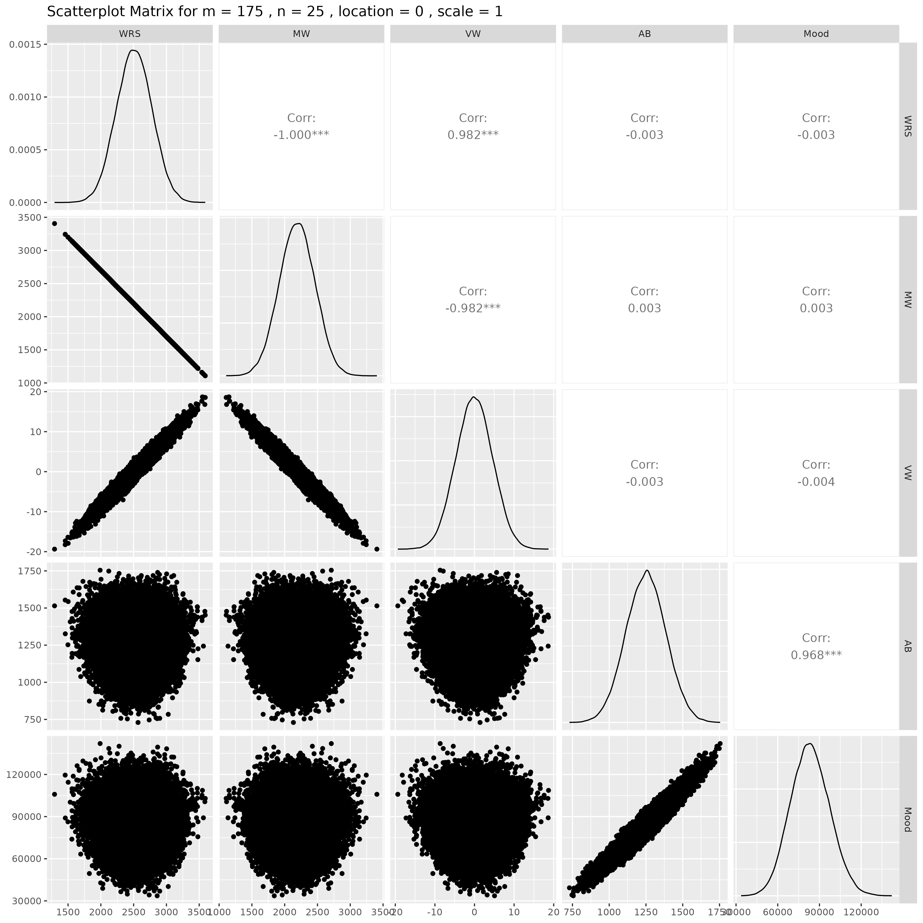

## Results for m = 175 , n = 30 , location = 0 , scale = 1

### Correlation Matrix

| Statistic | WRS | MW | VW | AB | Mood |
| --- | --- | --- | --- | --- | --- |
| character | numeric | numeric | numeric | numeric | numeric |
| WRS | 1.0000 | -1.0000 | 0.9819 | 0.0038 | 0.0024 |
| MW | -1.0000 | 1.0000 | -0.9819 | -0.0038 | -0.0024 |
| VW | 0.9819 | -0.9819 | 1.0000 | 0.0037 | 0.0023 |
| AB | 0.0038 | -0.0038 | 0.0037 | 1.0000 | 0.9682 |
| Mood | 0.0024 | -0.0024 | 0.0023 | 0.9682 | 1.0000 |
| n: 5 | | | | | |

### P-Value Matrix

| Statistic | WRS | MW | VW | AB | Mood |
| --- | --- | --- | --- | --- | --- |
| character | numeric | numeric | numeric | numeric | numeric |
| WRS |  | 0.0000 | 0.0000 | 0.3943 | 0.5863 |
| MW | 0.0000 |  | 0.0000 | 0.3943 | 0.5863 |
| VW | 0.0000 | 0.0000 |  | 0.4113 | 0.6115 |
| AB | 0.3943 | 0.3943 | 0.4113 |  | 0.0000 |
| Mood | 0.5863 | 0.5863 | 0.6115 | 0.0000 |  |
| n: 5 | | | | | |

### Scatter Plot Matrix:

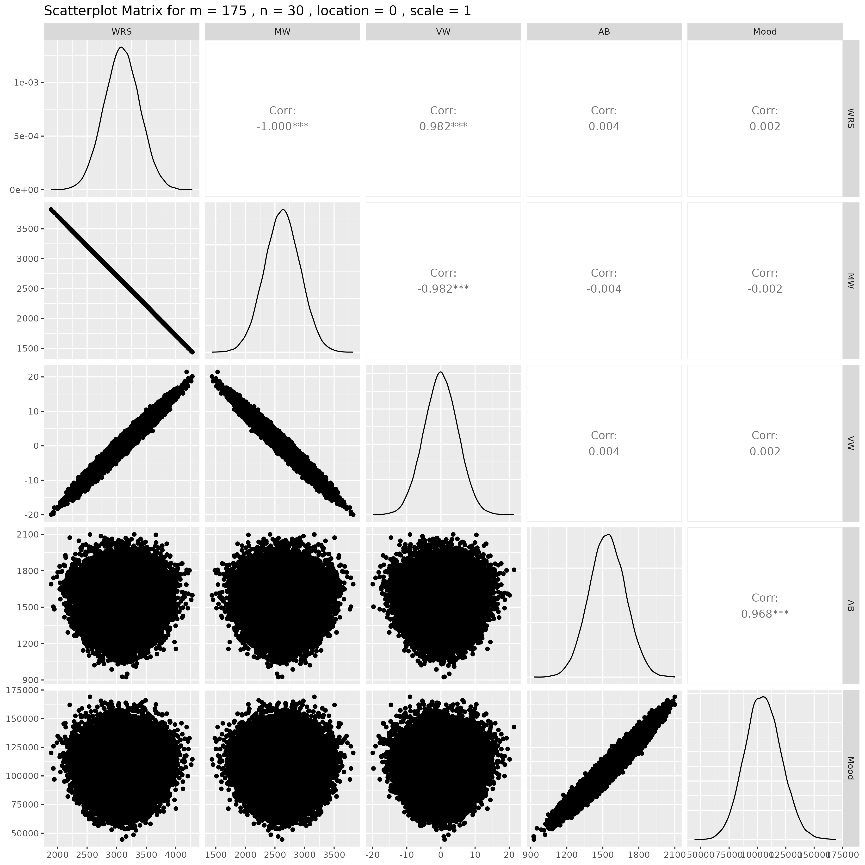

## Results for m = 175 , n = 50 , location = 0 , scale = 1

### Correlation Matrix

| Statistic | WRS | MW | VW | AB | Mood |
| --- | --- | --- | --- | --- | --- |
| character | numeric | numeric | numeric | numeric | numeric |
| WRS | 1.0000 | -1.0000 | 0.9817 | -0.0015 | -0.0033 |
| MW | -1.0000 | 1.0000 | -0.9817 | 0.0015 | 0.0033 |
| VW | 0.9817 | -0.9817 | 1.0000 | -0.0015 | -0.0031 |
| AB | -0.0015 | 0.0015 | -0.0015 | 1.0000 | 0.9682 |
| Mood | -0.0033 | 0.0033 | -0.0031 | 0.9682 | 1.0000 |
| n: 5 | | | | | |

### P-Value Matrix

| Statistic | WRS | MW | VW | AB | Mood |
| --- | --- | --- | --- | --- | --- |
| character | numeric | numeric | numeric | numeric | numeric |
| WRS |  | 0.0000 | 0.0000 | 0.7376 | 0.4640 |
| MW | 0.0000 |  | 0.0000 | 0.7376 | 0.4640 |
| VW | 0.0000 | 0.0000 |  | 0.7405 | 0.4897 |
| AB | 0.7376 | 0.7376 | 0.7405 |  | 0.0000 |
| Mood | 0.4640 | 0.4640 | 0.4897 | 0.0000 |  |
| n: 5 | | | | | |

### Scatter Plot Matrix:

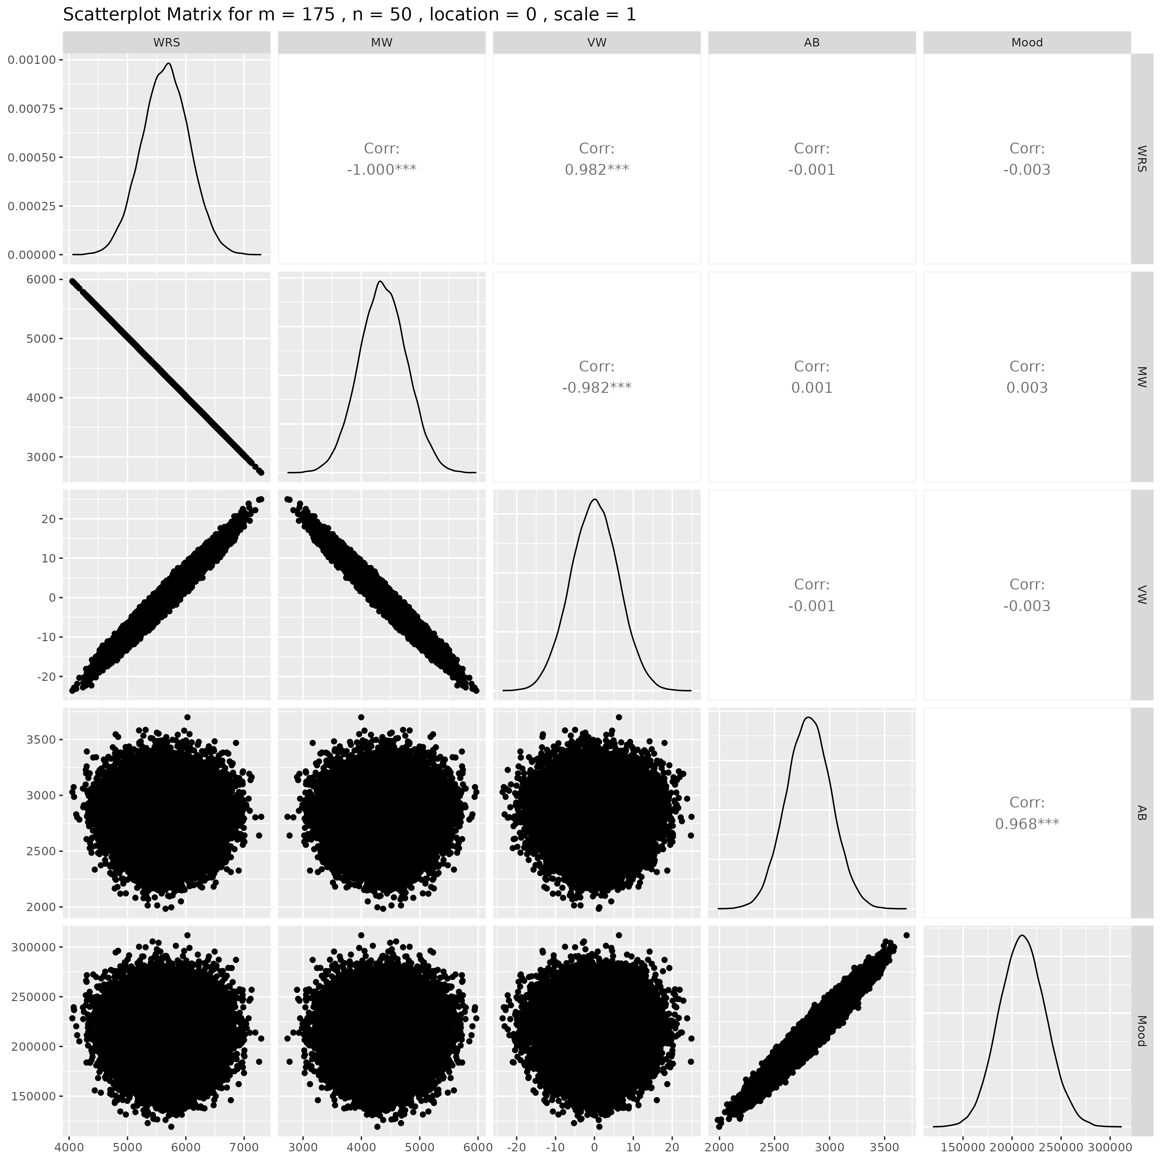

## Results for m = 200 , n = 5 , location = 0 , scale = 1

### Correlation Matrix

| Statistic | WRS | MW | VW | AB | Mood |
| --- | --- | --- | --- | --- | --- |
| character | numeric | numeric | numeric | numeric | numeric |
| WRS | 1.0000 | -1.0000 | 0.9821 | -0.0068 | -0.0070 |
| MW | -1.0000 | 1.0000 | -0.9821 | 0.0068 | 0.0070 |
| VW | 0.9821 | -0.9821 | 1.0000 | -0.0062 | -0.0065 |
| AB | -0.0068 | 0.0068 | -0.0062 | 1.0000 | 0.9685 |
| Mood | -0.0070 | 0.0070 | -0.0065 | 0.9685 | 1.0000 |
| n: 5 | | | | | |

### P-Value Matrix

| Statistic | WRS | MW | VW | AB | Mood |
| --- | --- | --- | --- | --- | --- |
| character | numeric | numeric | numeric | numeric | numeric |
| WRS |  | 0.0000 | 0.0000 | 0.1260 | 0.1199 |
| MW | 0.0000 |  | 0.0000 | 0.1260 | 0.1199 |
| VW | 0.0000 | 0.0000 |  | 0.1641 | 0.1450 |
| AB | 0.1260 | 0.1260 | 0.1641 |  | 0.0000 |
| Mood | 0.1199 | 0.1199 | 0.1450 | 0.0000 |  |
| n: 5 | | | | | |

### Scatter Plot Matrix:

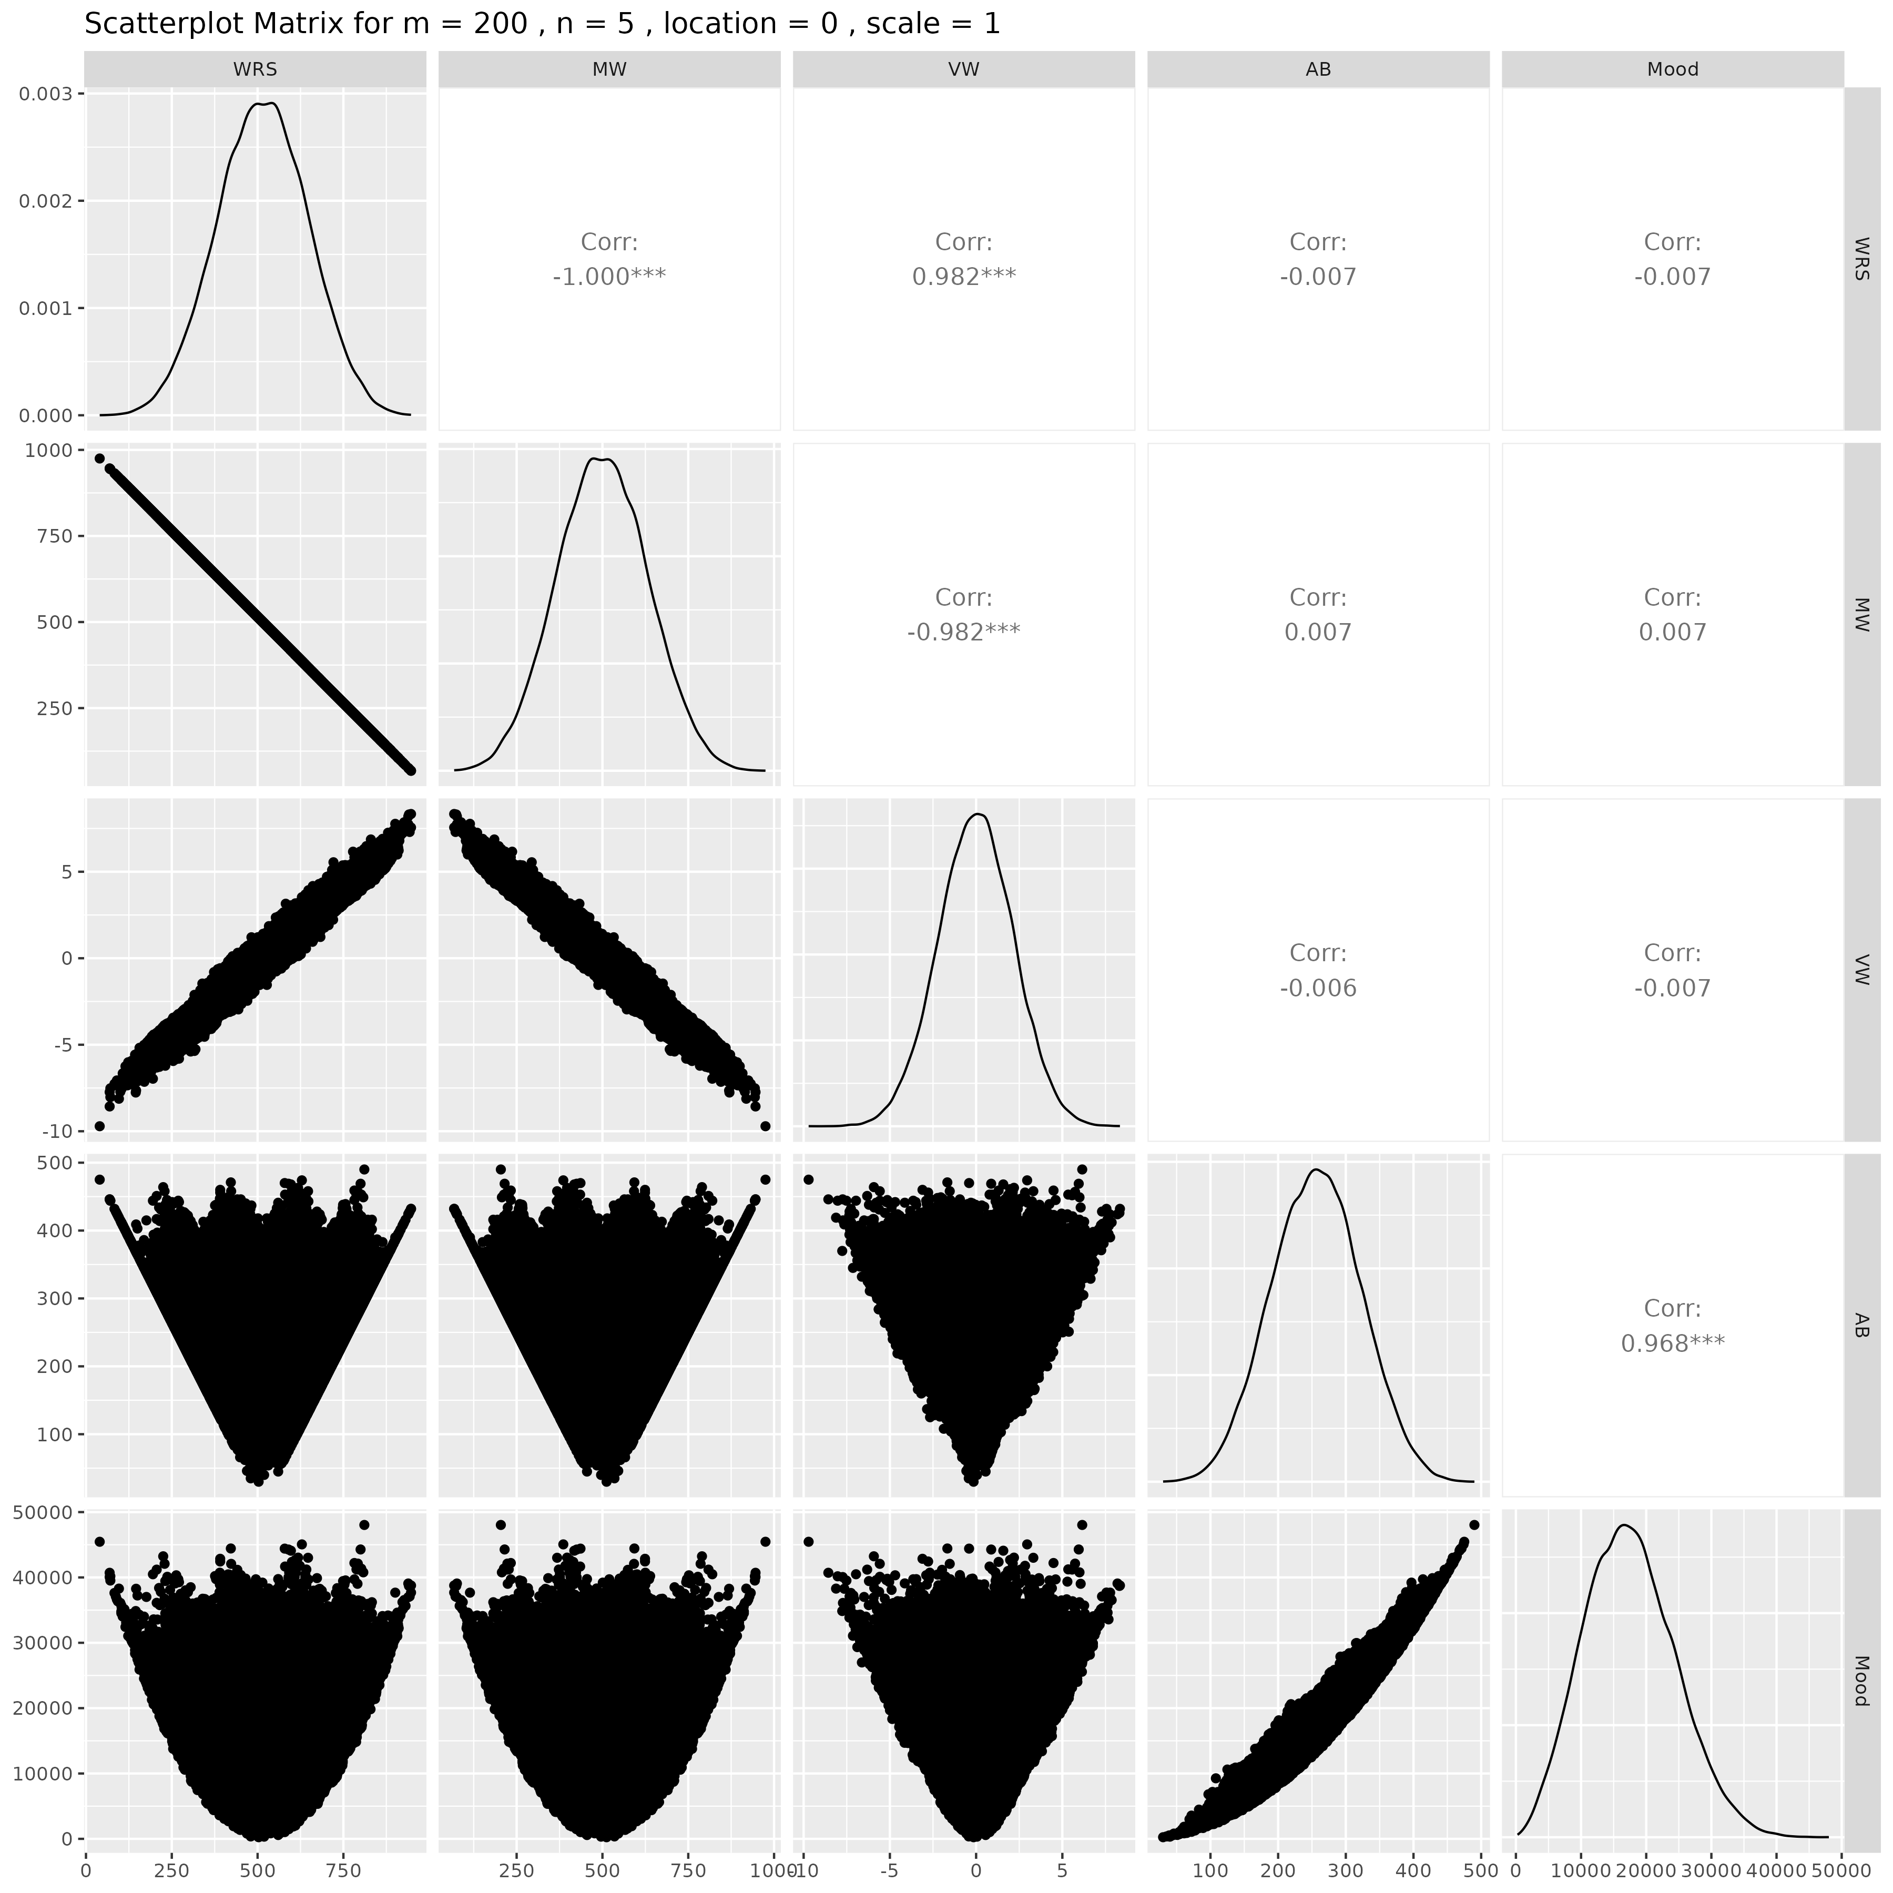

## Results for m = 200 , n = 10 , location = 0 , scale = 1

### Correlation Matrix

| Statistic | WRS | MW | VW | AB | Mood |
| --- | --- | --- | --- | --- | --- |
| character | numeric | numeric | numeric | numeric | numeric |
| WRS | 1.0000 | -1.0000 | 0.9816 | -0.0064 | -0.0056 |
| MW | -1.0000 | 1.0000 | -0.9816 | 0.0064 | 0.0056 |
| VW | 0.9816 | -0.9816 | 1.0000 | -0.0065 | -0.0060 |
| AB | -0.0064 | 0.0064 | -0.0065 | 1.0000 | 0.9675 |
| Mood | -0.0056 | 0.0056 | -0.0060 | 0.9675 | 1.0000 |
| n: 5 | | | | | |

### P-Value Matrix

| Statistic | WRS | MW | VW | AB | Mood |
| --- | --- | --- | --- | --- | --- |
| character | numeric | numeric | numeric | numeric | numeric |
| WRS |  | 0.0000 | 0.0000 | 0.1532 | 0.2094 |
| MW | 0.0000 |  | 0.0000 | 0.1532 | 0.2094 |
| VW | 0.0000 | 0.0000 |  | 0.1446 | 0.1828 |
| AB | 0.1532 | 0.1532 | 0.1446 |  | 0.0000 |
| Mood | 0.2094 | 0.2094 | 0.1828 | 0.0000 |  |
| n: 5 | | | | | |

### Scatter Plot Matrix:

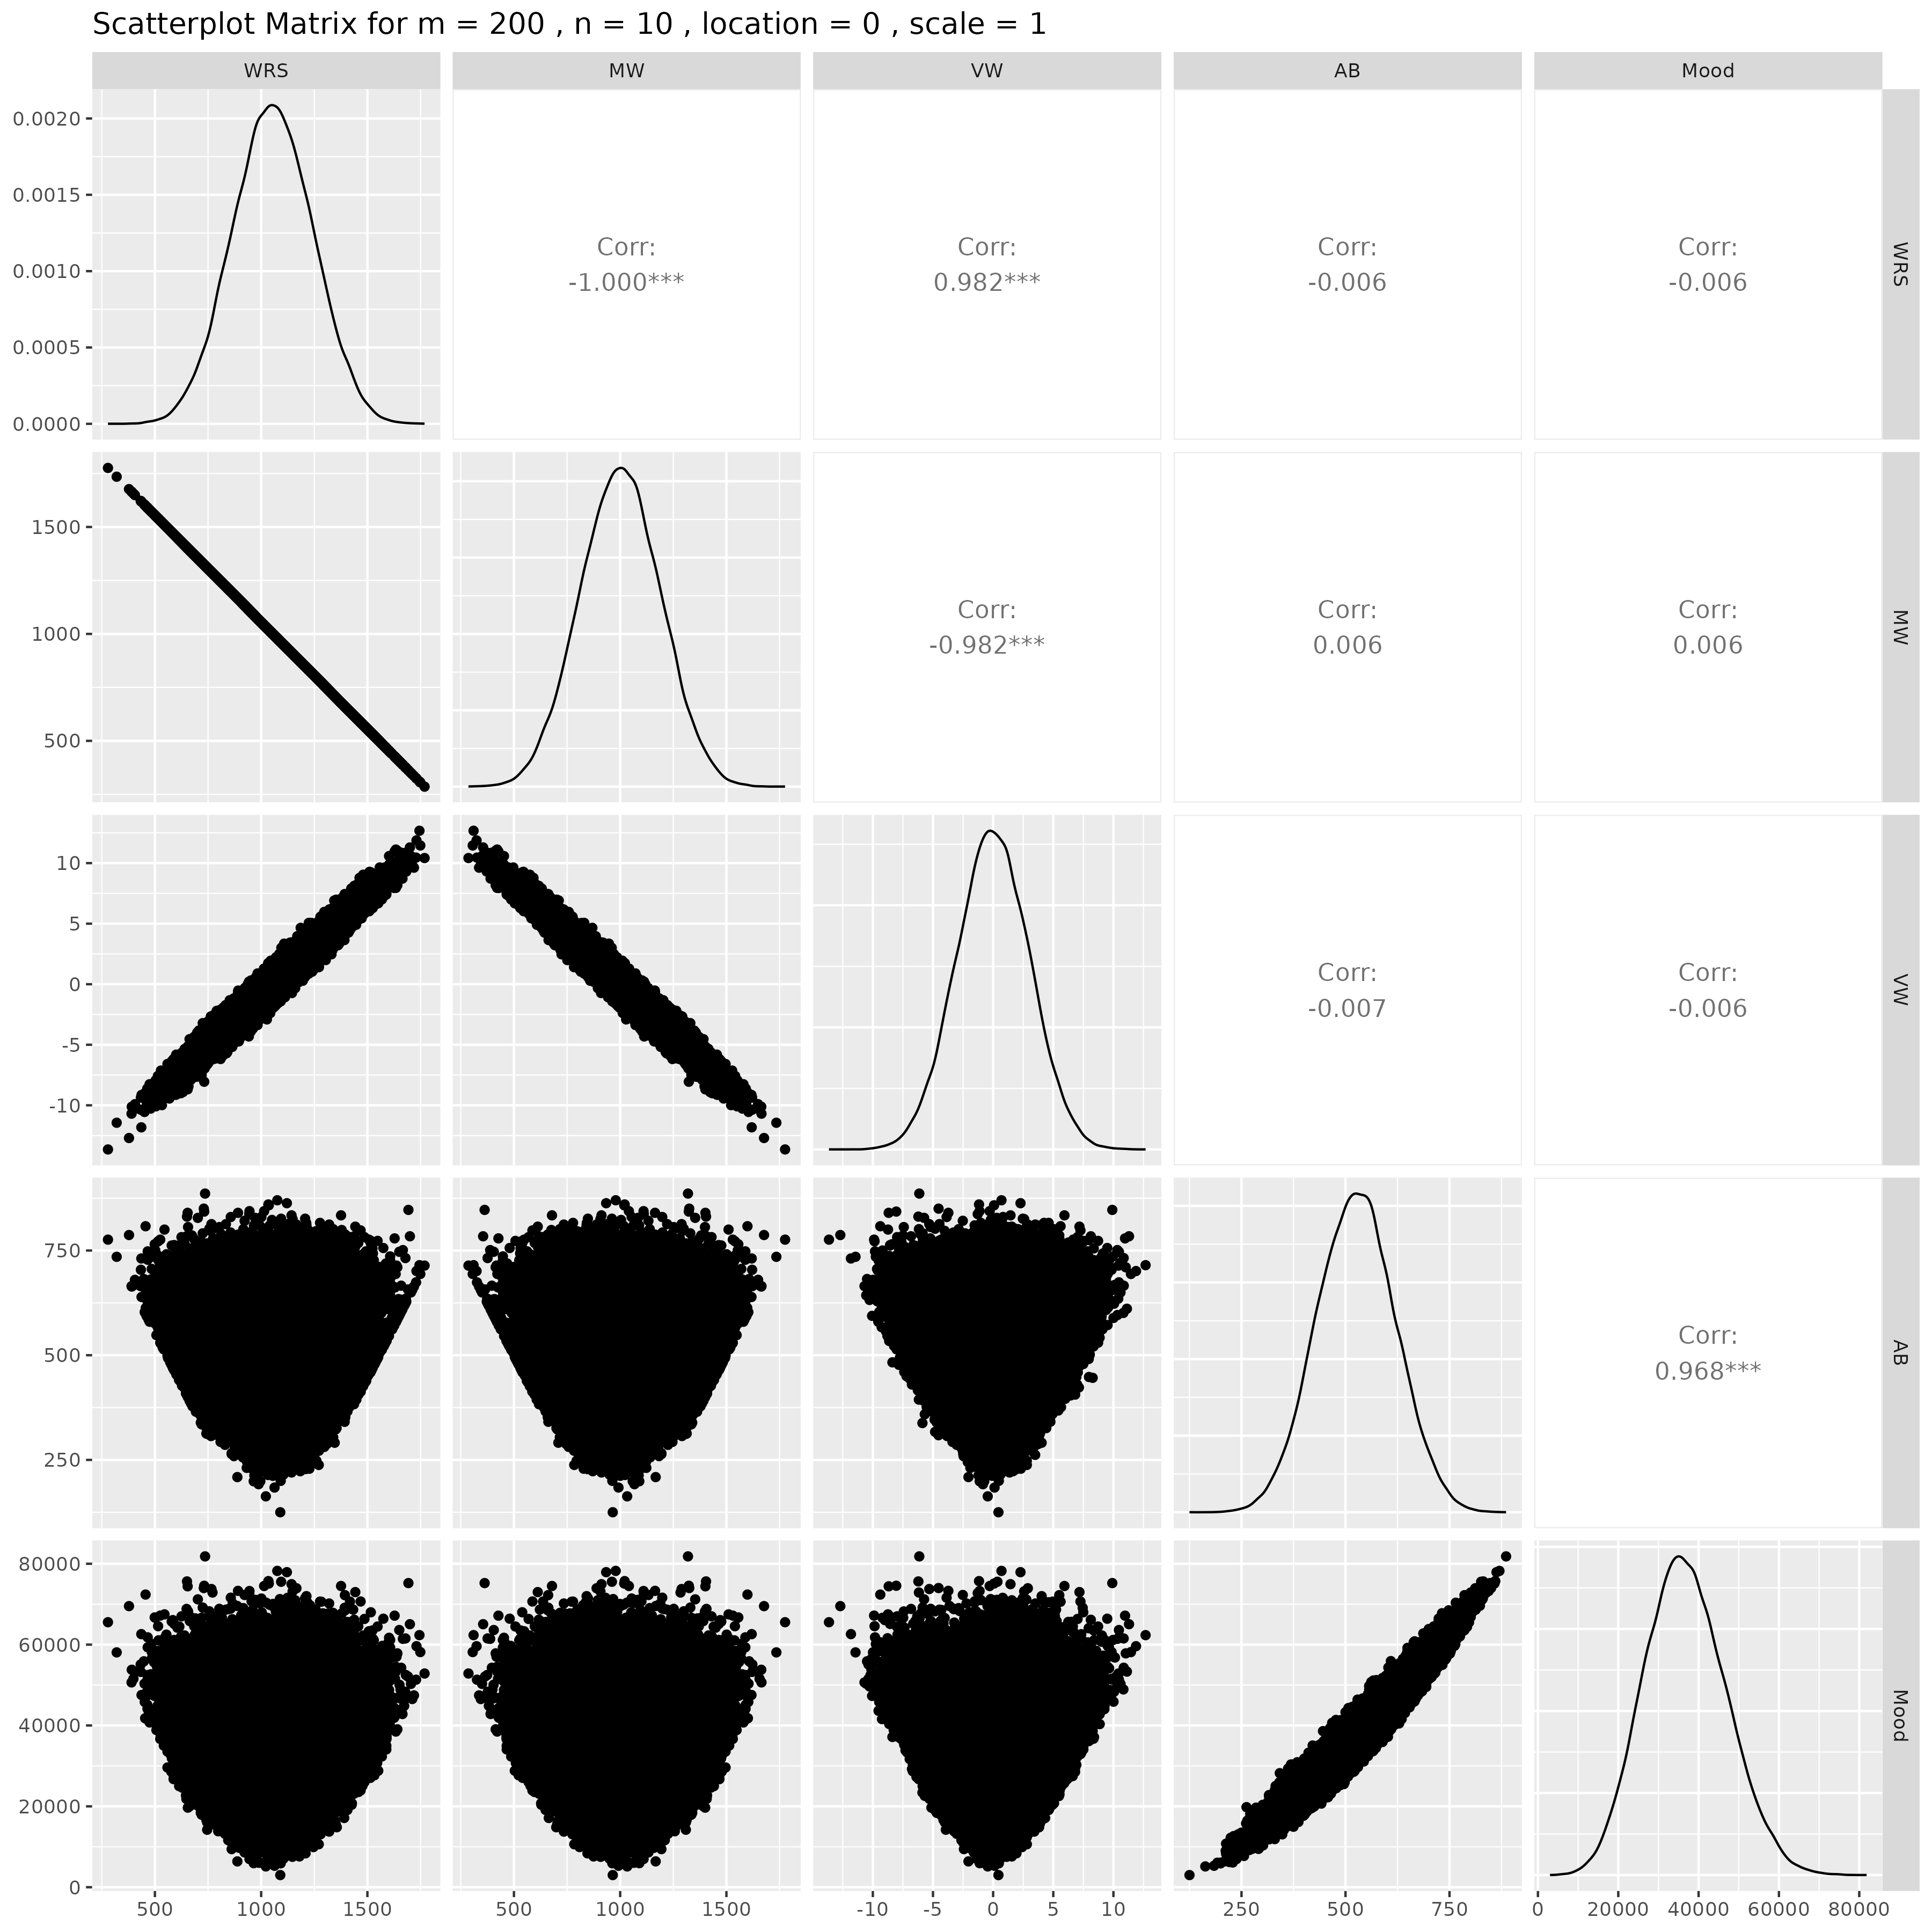

## Results for m = 200 , n = 15 , location = 0 , scale = 1

### Correlation Matrix

| Statistic | WRS | MW | VW | AB | Mood |
| --- | --- | --- | --- | --- | --- |
| character | numeric | numeric | numeric | numeric | numeric |
| WRS | 1.0000 | -1.0000 | 0.9817 | -0.0070 | -0.0046 |
| MW | -1.0000 | 1.0000 | -0.9817 | 0.0070 | 0.0046 |
| VW | 0.9817 | -0.9817 | 1.0000 | -0.0067 | -0.0043 |
| AB | -0.0070 | 0.0070 | -0.0067 | 1.0000 | 0.9682 |
| Mood | -0.0046 | 0.0046 | -0.0043 | 0.9682 | 1.0000 |
| n: 5 | | | | | |

### P-Value Matrix

| Statistic | WRS | MW | VW | AB | Mood |
| --- | --- | --- | --- | --- | --- |
| character | numeric | numeric | numeric | numeric | numeric |
| WRS |  | 0.0000 | 0.0000 | 0.1198 | 0.3033 |
| MW | 0.0000 |  | 0.0000 | 0.1198 | 0.3033 |
| VW | 0.0000 | 0.0000 |  | 0.1343 | 0.3393 |
| AB | 0.1198 | 0.1198 | 0.1343 |  | 0.0000 |
| Mood | 0.3033 | 0.3033 | 0.3393 | 0.0000 |  |
| n: 5 | | | | | |

### Scatter Plot Matrix:

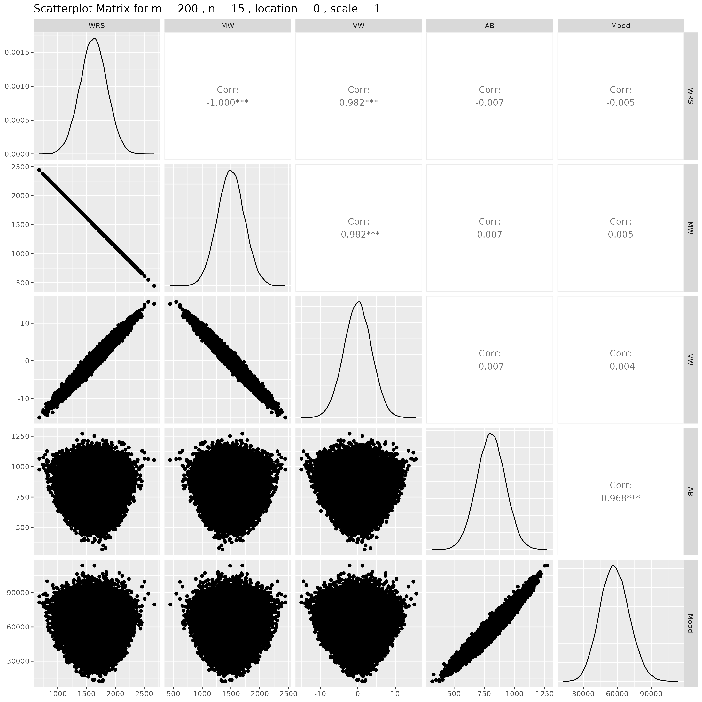

## Results for m = 200 , n = 20 , location = 0 , scale = 1

### Correlation Matrix

| Statistic | WRS | MW | VW | AB | Mood |
| --- | --- | --- | --- | --- | --- |
| character | numeric | numeric | numeric | numeric | numeric |
| WRS | 1.0000 | -1.0000 | 0.9816 | 0.0004 | 0.0008 |
| MW | -1.0000 | 1.0000 | -0.9816 | -0.0004 | -0.0008 |
| VW | 0.9816 | -0.9816 | 1.0000 | 0.0003 | 0.0009 |
| AB | 0.0004 | -0.0004 | 0.0003 | 1.0000 | 0.9677 |
| Mood | 0.0008 | -0.0008 | 0.0009 | 0.9677 | 1.0000 |
| n: 5 | | | | | |

### P-Value Matrix

| Statistic | WRS | MW | VW | AB | Mood |
| --- | --- | --- | --- | --- | --- |
| character | numeric | numeric | numeric | numeric | numeric |
| WRS |  | 0.0000 | 0.0000 | 0.9342 | 0.8524 |
| MW | 0.0000 |  | 0.0000 | 0.9342 | 0.8524 |
| VW | 0.0000 | 0.0000 |  | 0.9455 | 0.8331 |
| AB | 0.9342 | 0.9342 | 0.9455 |  | 0.0000 |
| Mood | 0.8524 | 0.8524 | 0.8331 | 0.0000 |  |
| n: 5 | | | | | |

### Scatter Plot Matrix:

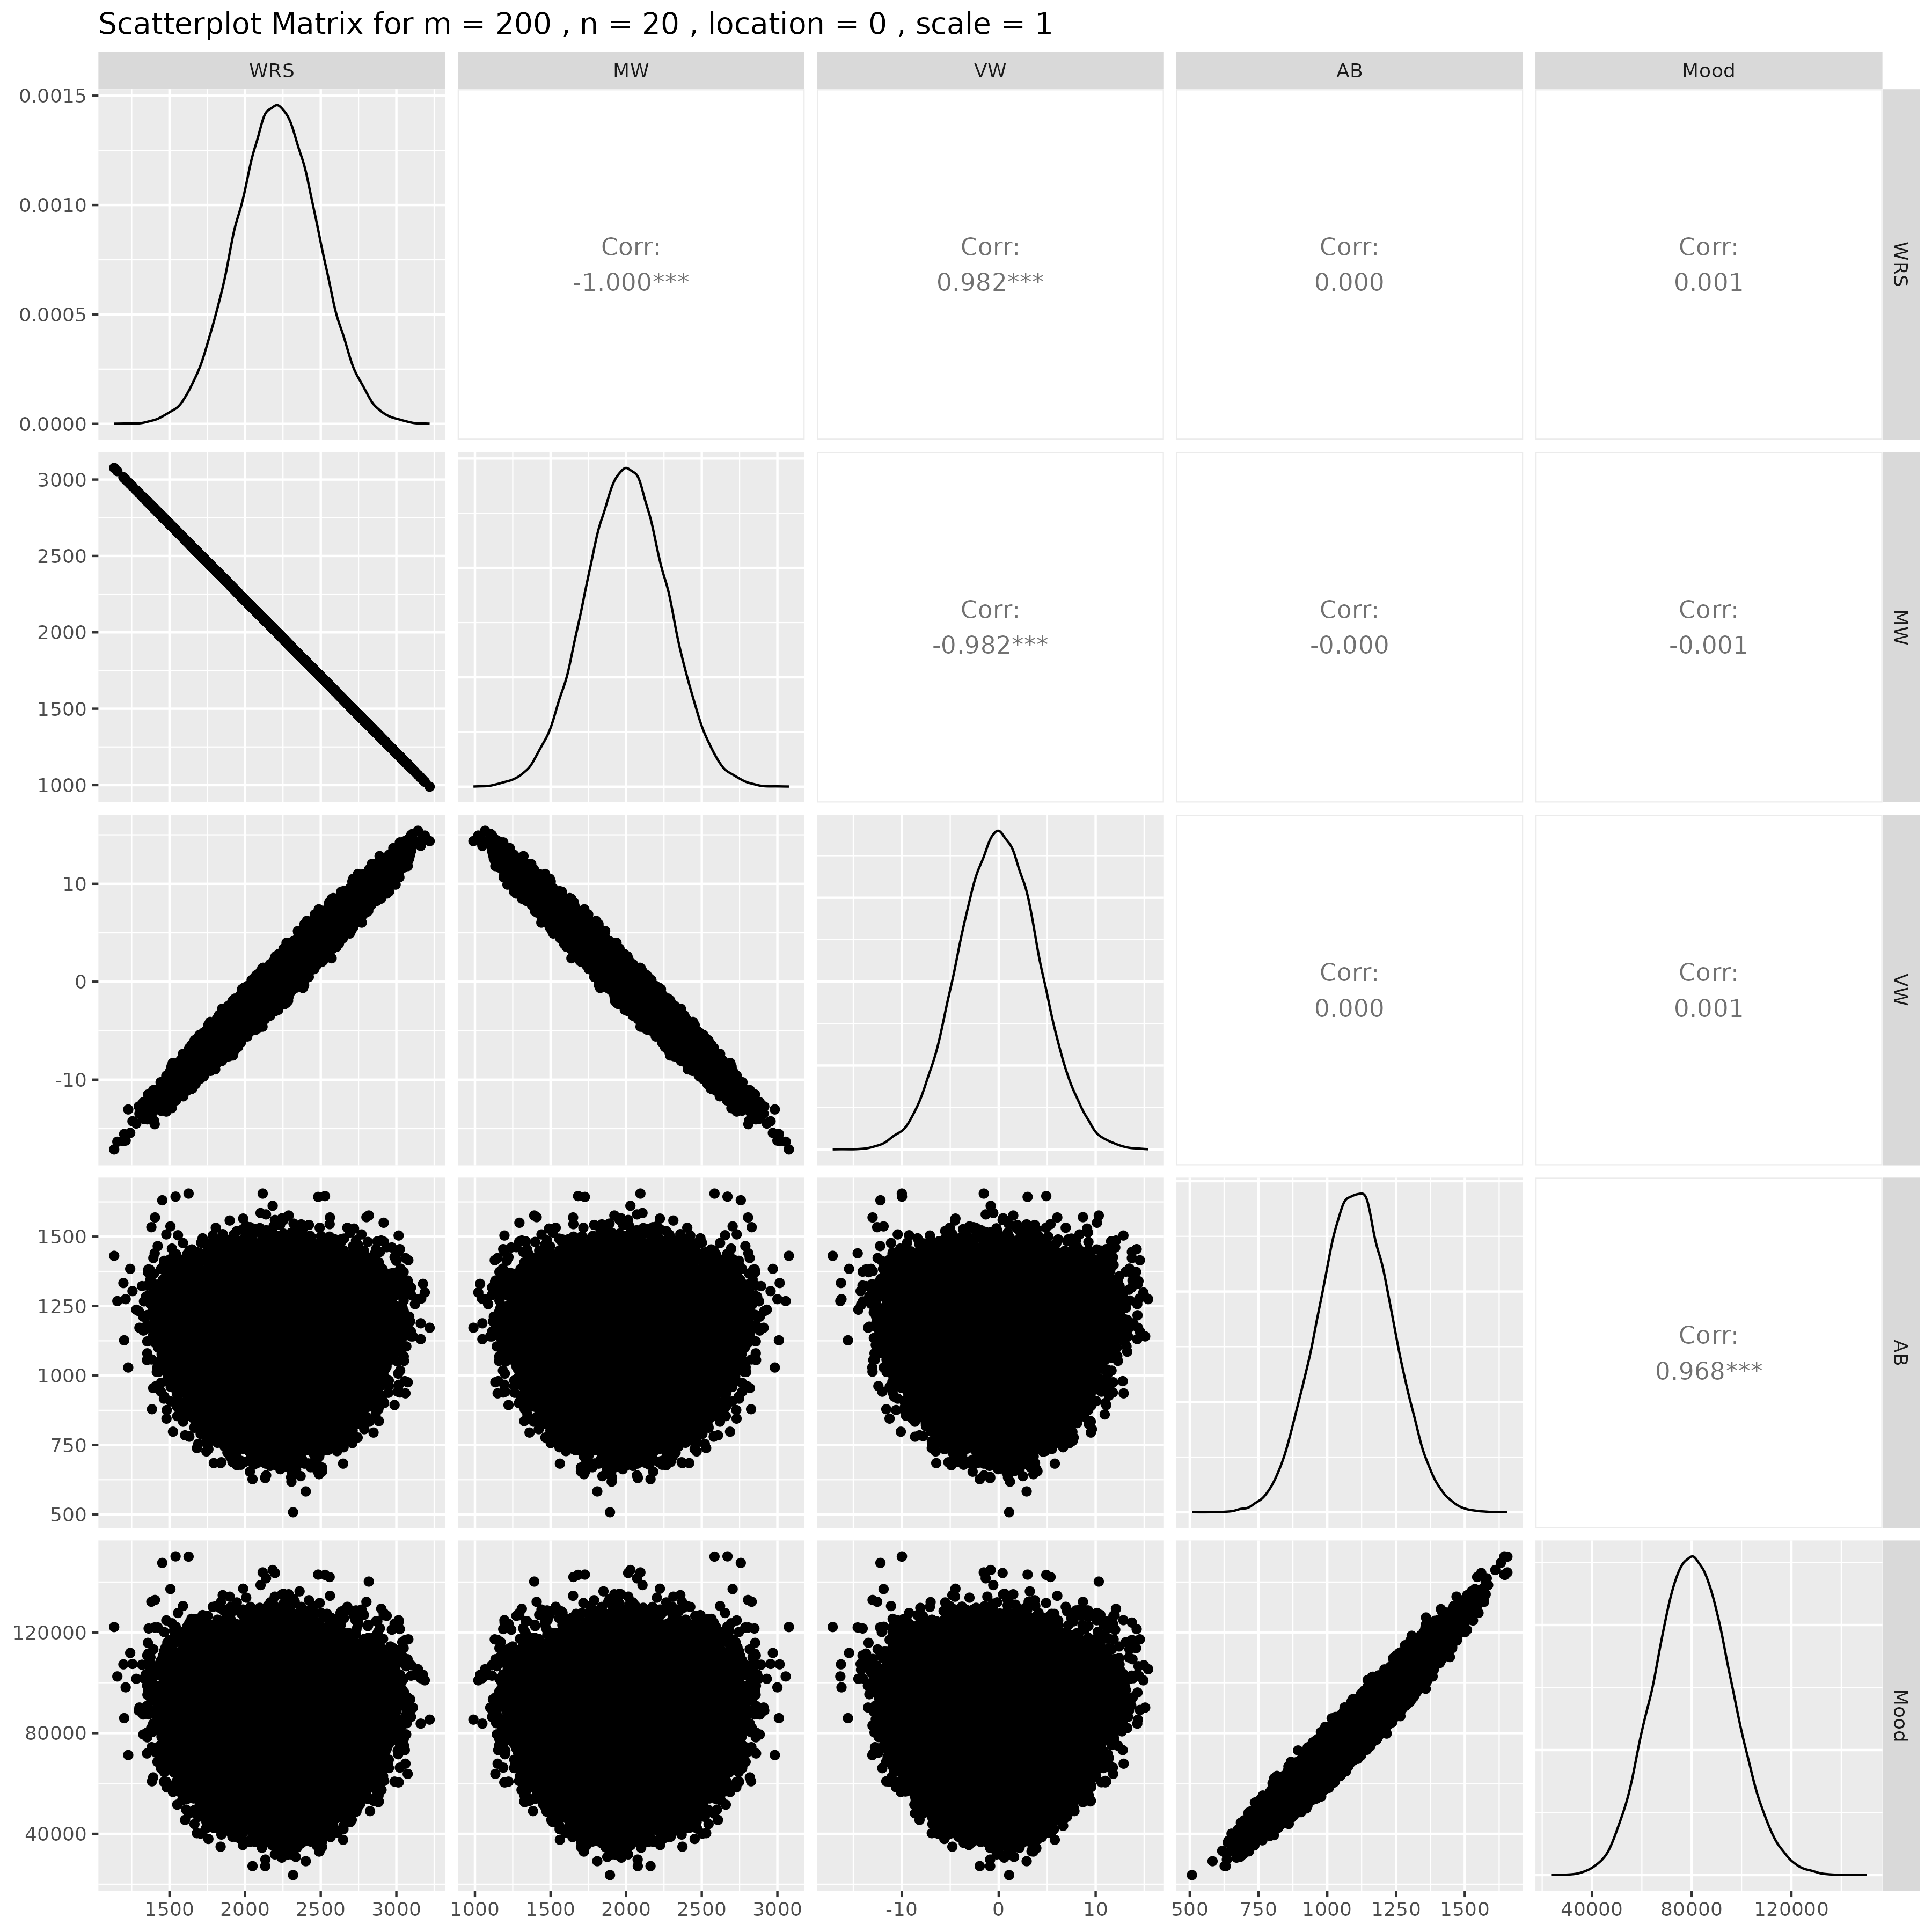

## Results for m = 200 , n = 25 , location = 0 , scale = 1

### Correlation Matrix

| Statistic | WRS | MW | VW | AB | Mood |
| --- | --- | --- | --- | --- | --- |
| character | numeric | numeric | numeric | numeric | numeric |
| WRS | 1.0000 | -1.0000 | 0.9818 | -0.0022 | -0.0018 |
| MW | -1.0000 | 1.0000 | -0.9818 | 0.0022 | 0.0018 |
| VW | 0.9818 | -0.9818 | 1.0000 | -0.0026 | -0.0024 |
| AB | -0.0022 | 0.0022 | -0.0026 | 1.0000 | 0.9688 |
| Mood | -0.0018 | 0.0018 | -0.0024 | 0.9688 | 1.0000 |
| n: 5 | | | | | |

### P-Value Matrix

| Statistic | WRS | MW | VW | AB | Mood |
| --- | --- | --- | --- | --- | --- |
| character | numeric | numeric | numeric | numeric | numeric |
| WRS |  | 0.0000 | 0.0000 | 0.6267 | 0.6794 |
| MW | 0.0000 |  | 0.0000 | 0.6267 | 0.6794 |
| VW | 0.0000 | 0.0000 |  | 0.5548 | 0.5967 |
| AB | 0.6267 | 0.6267 | 0.5548 |  | 0.0000 |
| Mood | 0.6794 | 0.6794 | 0.5967 | 0.0000 |  |
| n: 5 | | | | | |

### Scatter Plot Matrix:

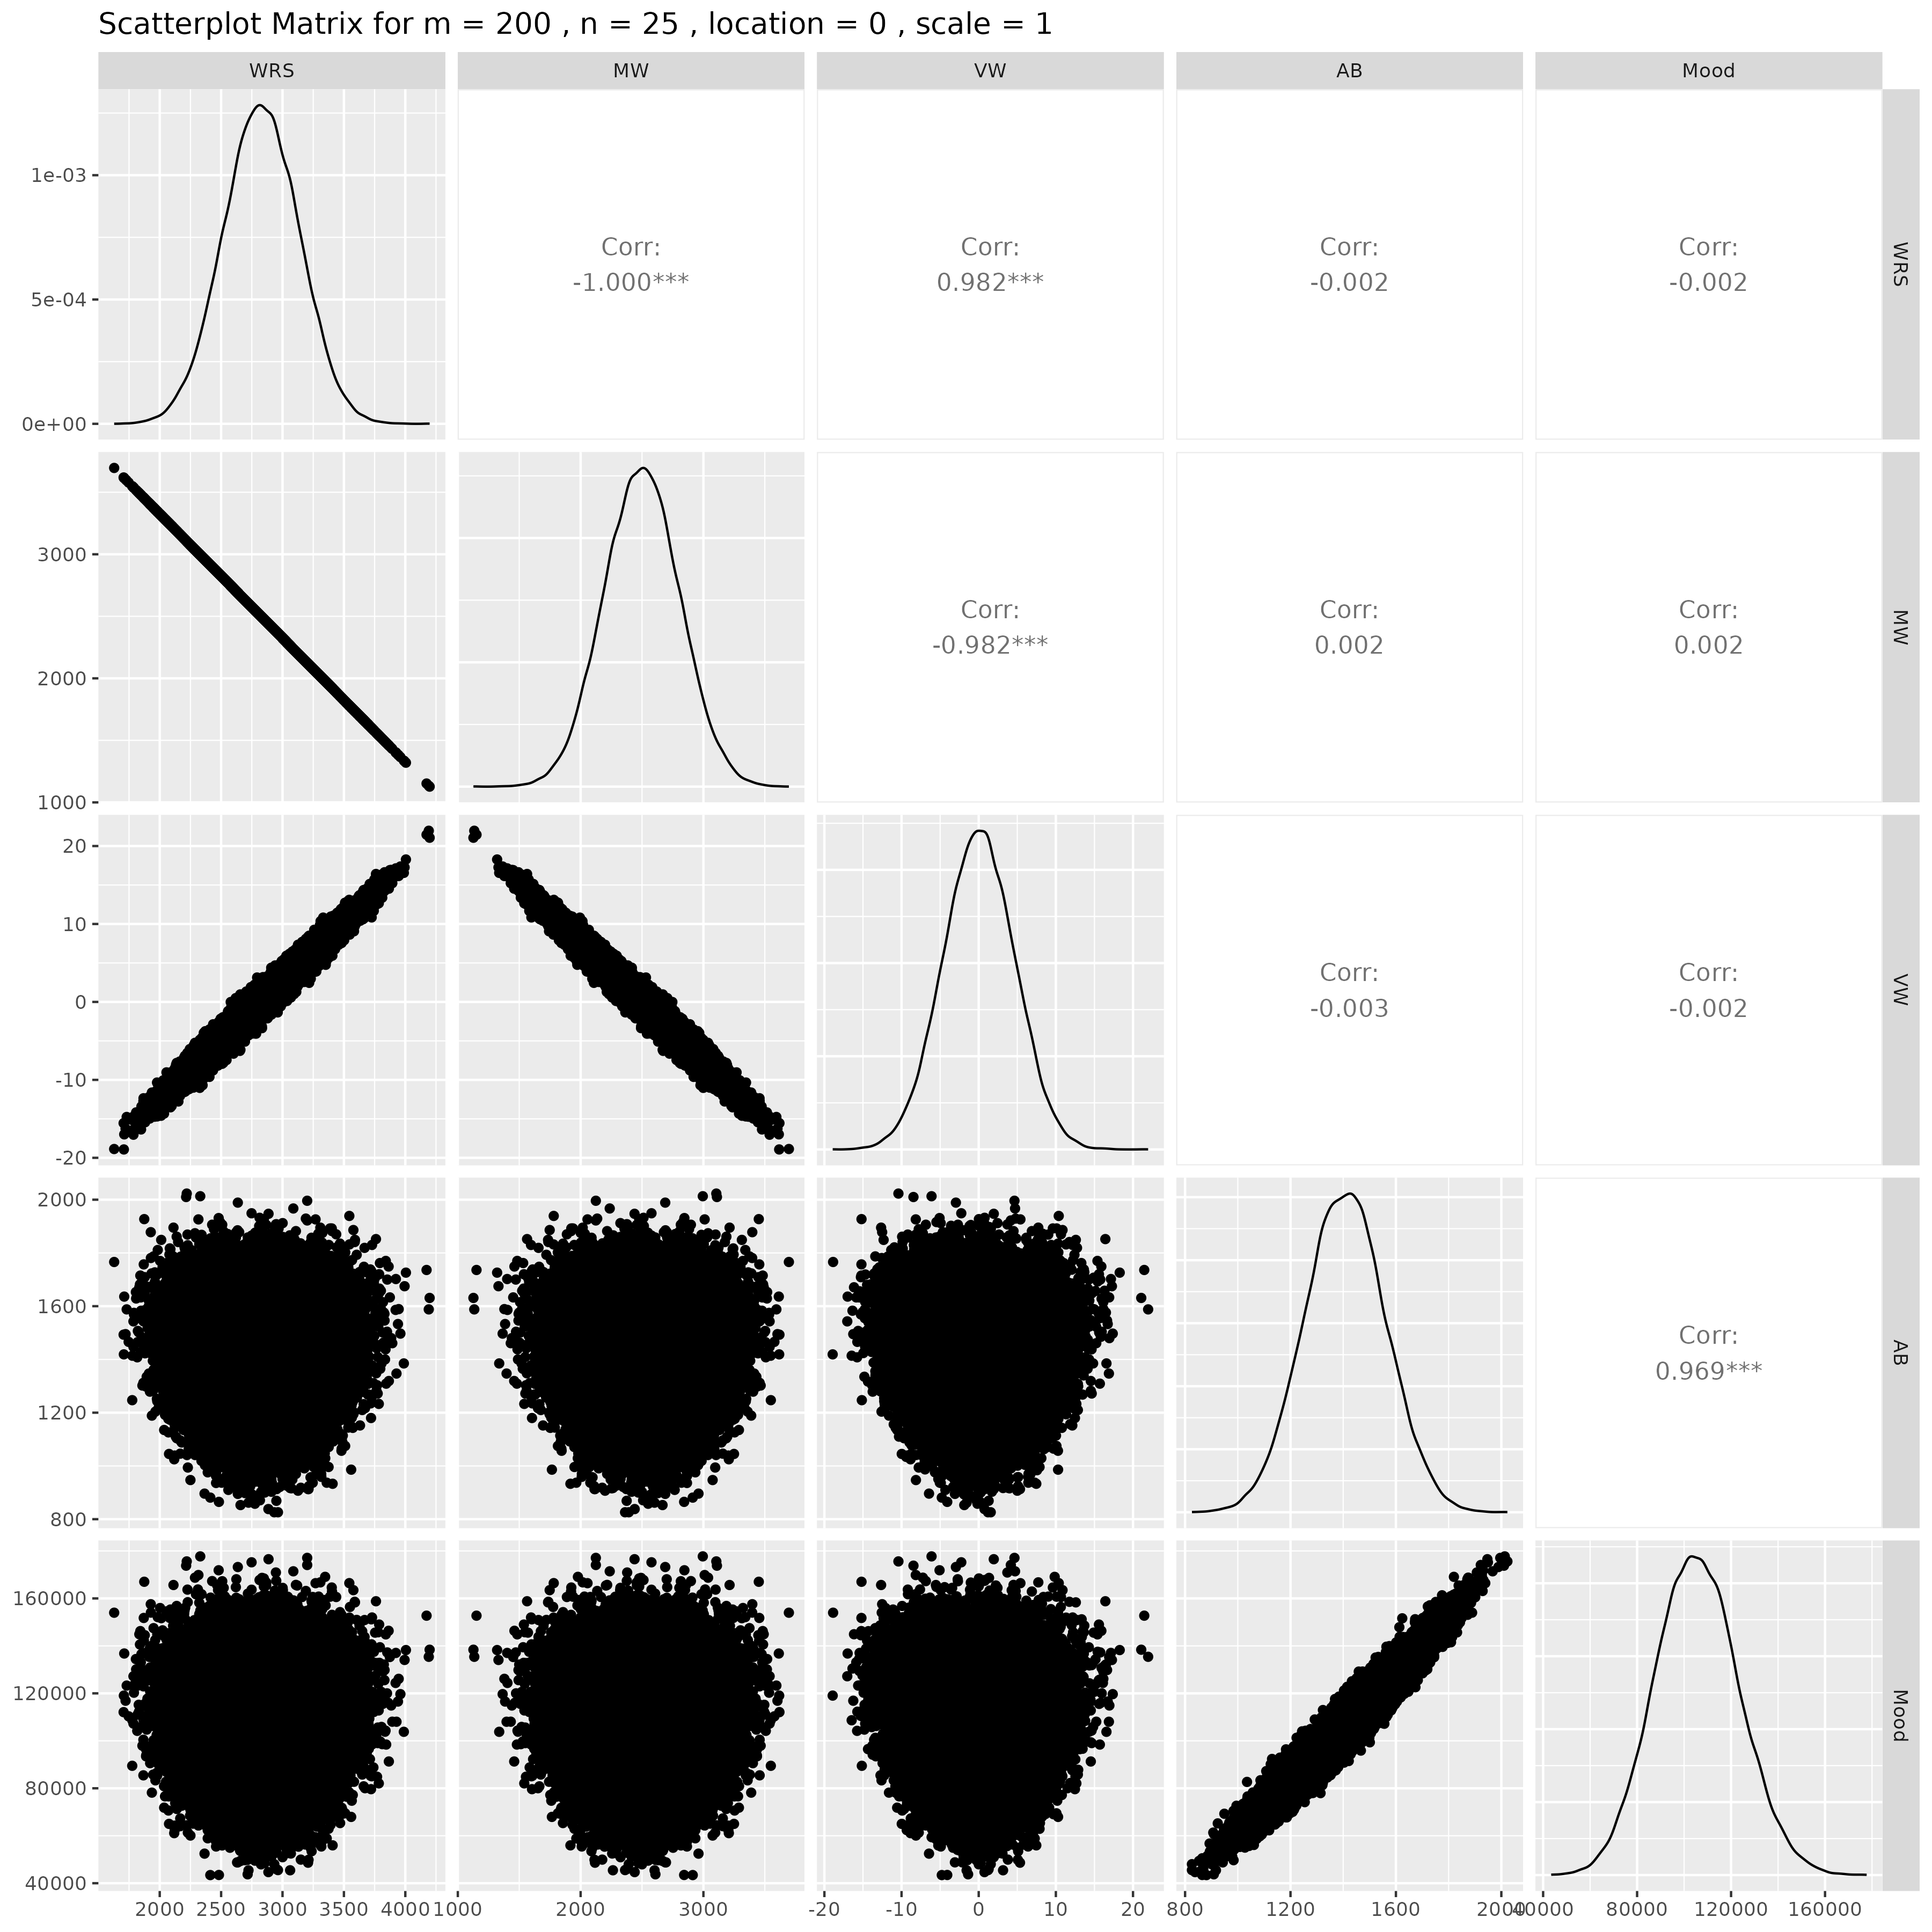

## Results for m = 200 , n = 30 , location = 0 , scale = 1

### Correlation Matrix

| Statistic | WRS | MW | VW | AB | Mood |
| --- | --- | --- | --- | --- | --- |
| character | numeric | numeric | numeric | numeric | numeric |
| WRS | 1.0000 | -1.0000 | 0.9816 | -0.0052 | -0.0042 |
| MW | -1.0000 | 1.0000 | -0.9816 | 0.0052 | 0.0042 |
| VW | 0.9816 | -0.9816 | 1.0000 | -0.0040 | -0.0026 |
| AB | -0.0052 | 0.0052 | -0.0040 | 1.0000 | 0.9680 |
| Mood | -0.0042 | 0.0042 | -0.0026 | 0.9680 | 1.0000 |
| n: 5 | | | | | |

### P-Value Matrix

| Statistic | WRS | MW | VW | AB | Mood |
| --- | --- | --- | --- | --- | --- |
| character | numeric | numeric | numeric | numeric | numeric |
| WRS |  | 0.0000 | 0.0000 | 0.2458 | 0.3471 |
| MW | 0.0000 |  | 0.0000 | 0.2458 | 0.3471 |
| VW | 0.0000 | 0.0000 |  | 0.3652 | 0.5629 |
| AB | 0.2458 | 0.2458 | 0.3652 |  | 0.0000 |
| Mood | 0.3471 | 0.3471 | 0.5629 | 0.0000 |  |
| n: 5 | | | | | |

### Scatter Plot Matrix:

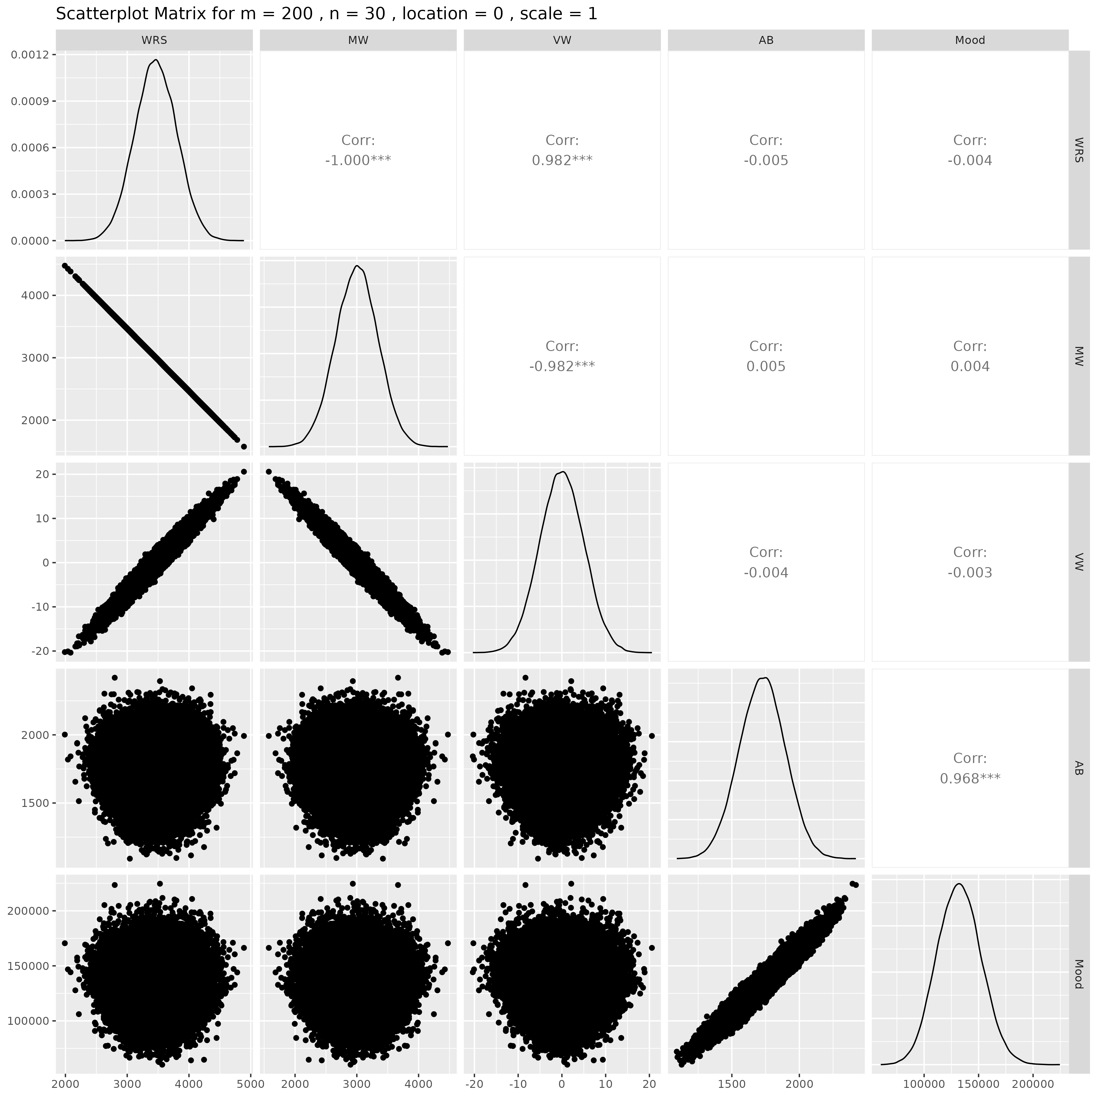

## Results for m = 200 , n = 50 , location = 0 , scale = 1

### Correlation Matrix

| Statistic | WRS | MW | VW | AB | Mood |
| --- | --- | --- | --- | --- | --- |
| character | numeric | numeric | numeric | numeric | numeric |
| WRS | 1.0000 | -1.0000 | 0.9815 | -0.0020 | -0.0017 |
| MW | -1.0000 | 1.0000 | -0.9815 | 0.0020 | 0.0017 |
| VW | 0.9815 | -0.9815 | 1.0000 | -0.0003 | -0.0004 |
| AB | -0.0020 | 0.0020 | -0.0003 | 1.0000 | 0.9679 |
| Mood | -0.0017 | 0.0017 | -0.0004 | 0.9679 | 1.0000 |
| n: 5 | | | | | |

### P-Value Matrix

| Statistic | WRS | MW | VW | AB | Mood |
| --- | --- | --- | --- | --- | --- |
| character | numeric | numeric | numeric | numeric | numeric |
| WRS |  | 0.0000 | 0.0000 | 0.6614 | 0.7026 |
| MW | 0.0000 |  | 0.0000 | 0.6614 | 0.7026 |
| VW | 0.0000 | 0.0000 |  | 0.9477 | 0.9204 |
| AB | 0.6614 | 0.6614 | 0.9477 |  | 0.0000 |
| Mood | 0.7026 | 0.7026 | 0.9204 | 0.0000 |  |
| n: 5 | | | | | |

### Scatter Plot Matrix:

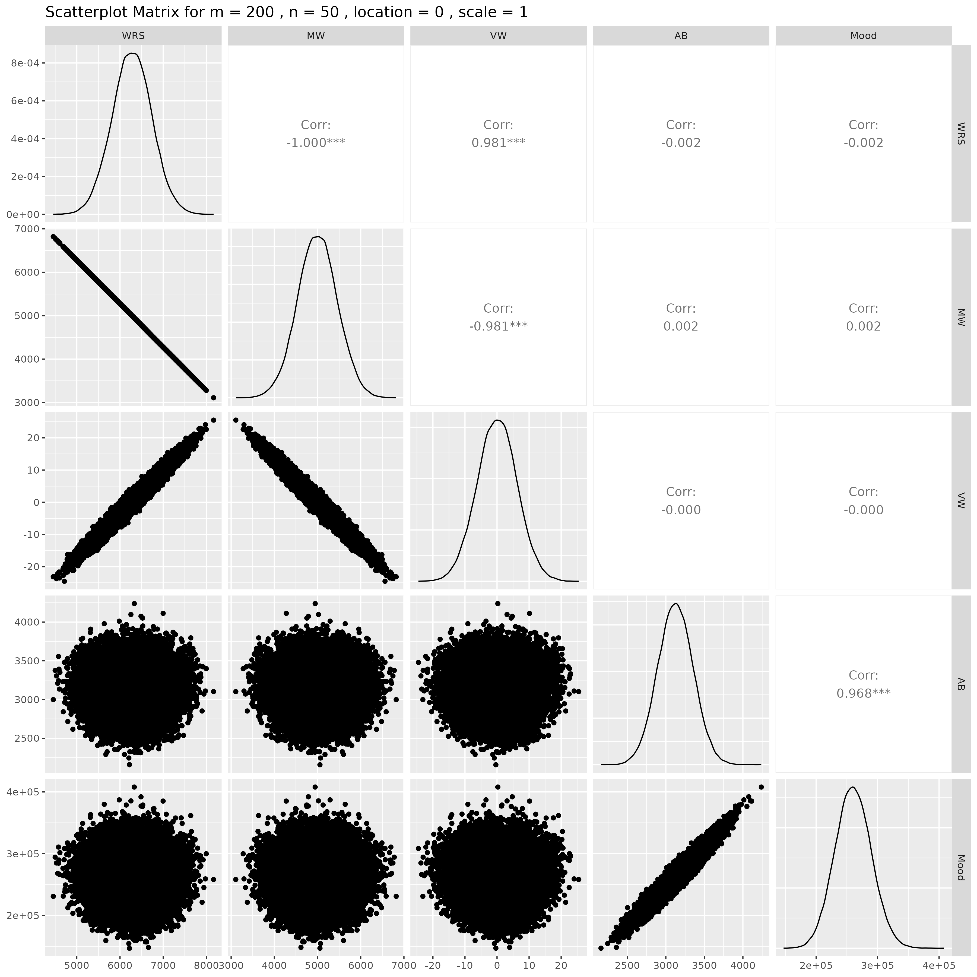

## Results for m = 300 , n = 5 , location = 0 , scale = 1

### Correlation Matrix

| Statistic | WRS | MW | VW | AB | Mood |
| --- | --- | --- | --- | --- | --- |
| character | numeric | numeric | numeric | numeric | numeric |
| WRS | 1.0000 | -1.0000 | 0.9806 | -0.0000 | 0.0003 |
| MW | -1.0000 | 1.0000 | -0.9806 | 0.0000 | -0.0003 |
| VW | 0.9806 | -0.9806 | 1.0000 | 0.0001 | 0.0004 |
| AB | -0.0000 | 0.0000 | 0.0001 | 1.0000 | 0.9686 |
| Mood | 0.0003 | -0.0003 | 0.0004 | 0.9686 | 1.0000 |
| n: 5 | | | | | |

### P-Value Matrix

| Statistic | WRS | MW | VW | AB | Mood |
| --- | --- | --- | --- | --- | --- |
| character | numeric | numeric | numeric | numeric | numeric |
| WRS |  | 0.0000 | 0.0000 | 0.9932 | 0.9473 |
| MW | 0.0000 |  | 0.0000 | 0.9932 | 0.9473 |
| VW | 0.0000 | 0.0000 |  | 0.9886 | 0.9294 |
| AB | 0.9932 | 0.9932 | 0.9886 |  | 0.0000 |
| Mood | 0.9473 | 0.9473 | 0.9294 | 0.0000 |  |
| n: 5 | | | | | |

### Scatter Plot Matrix:

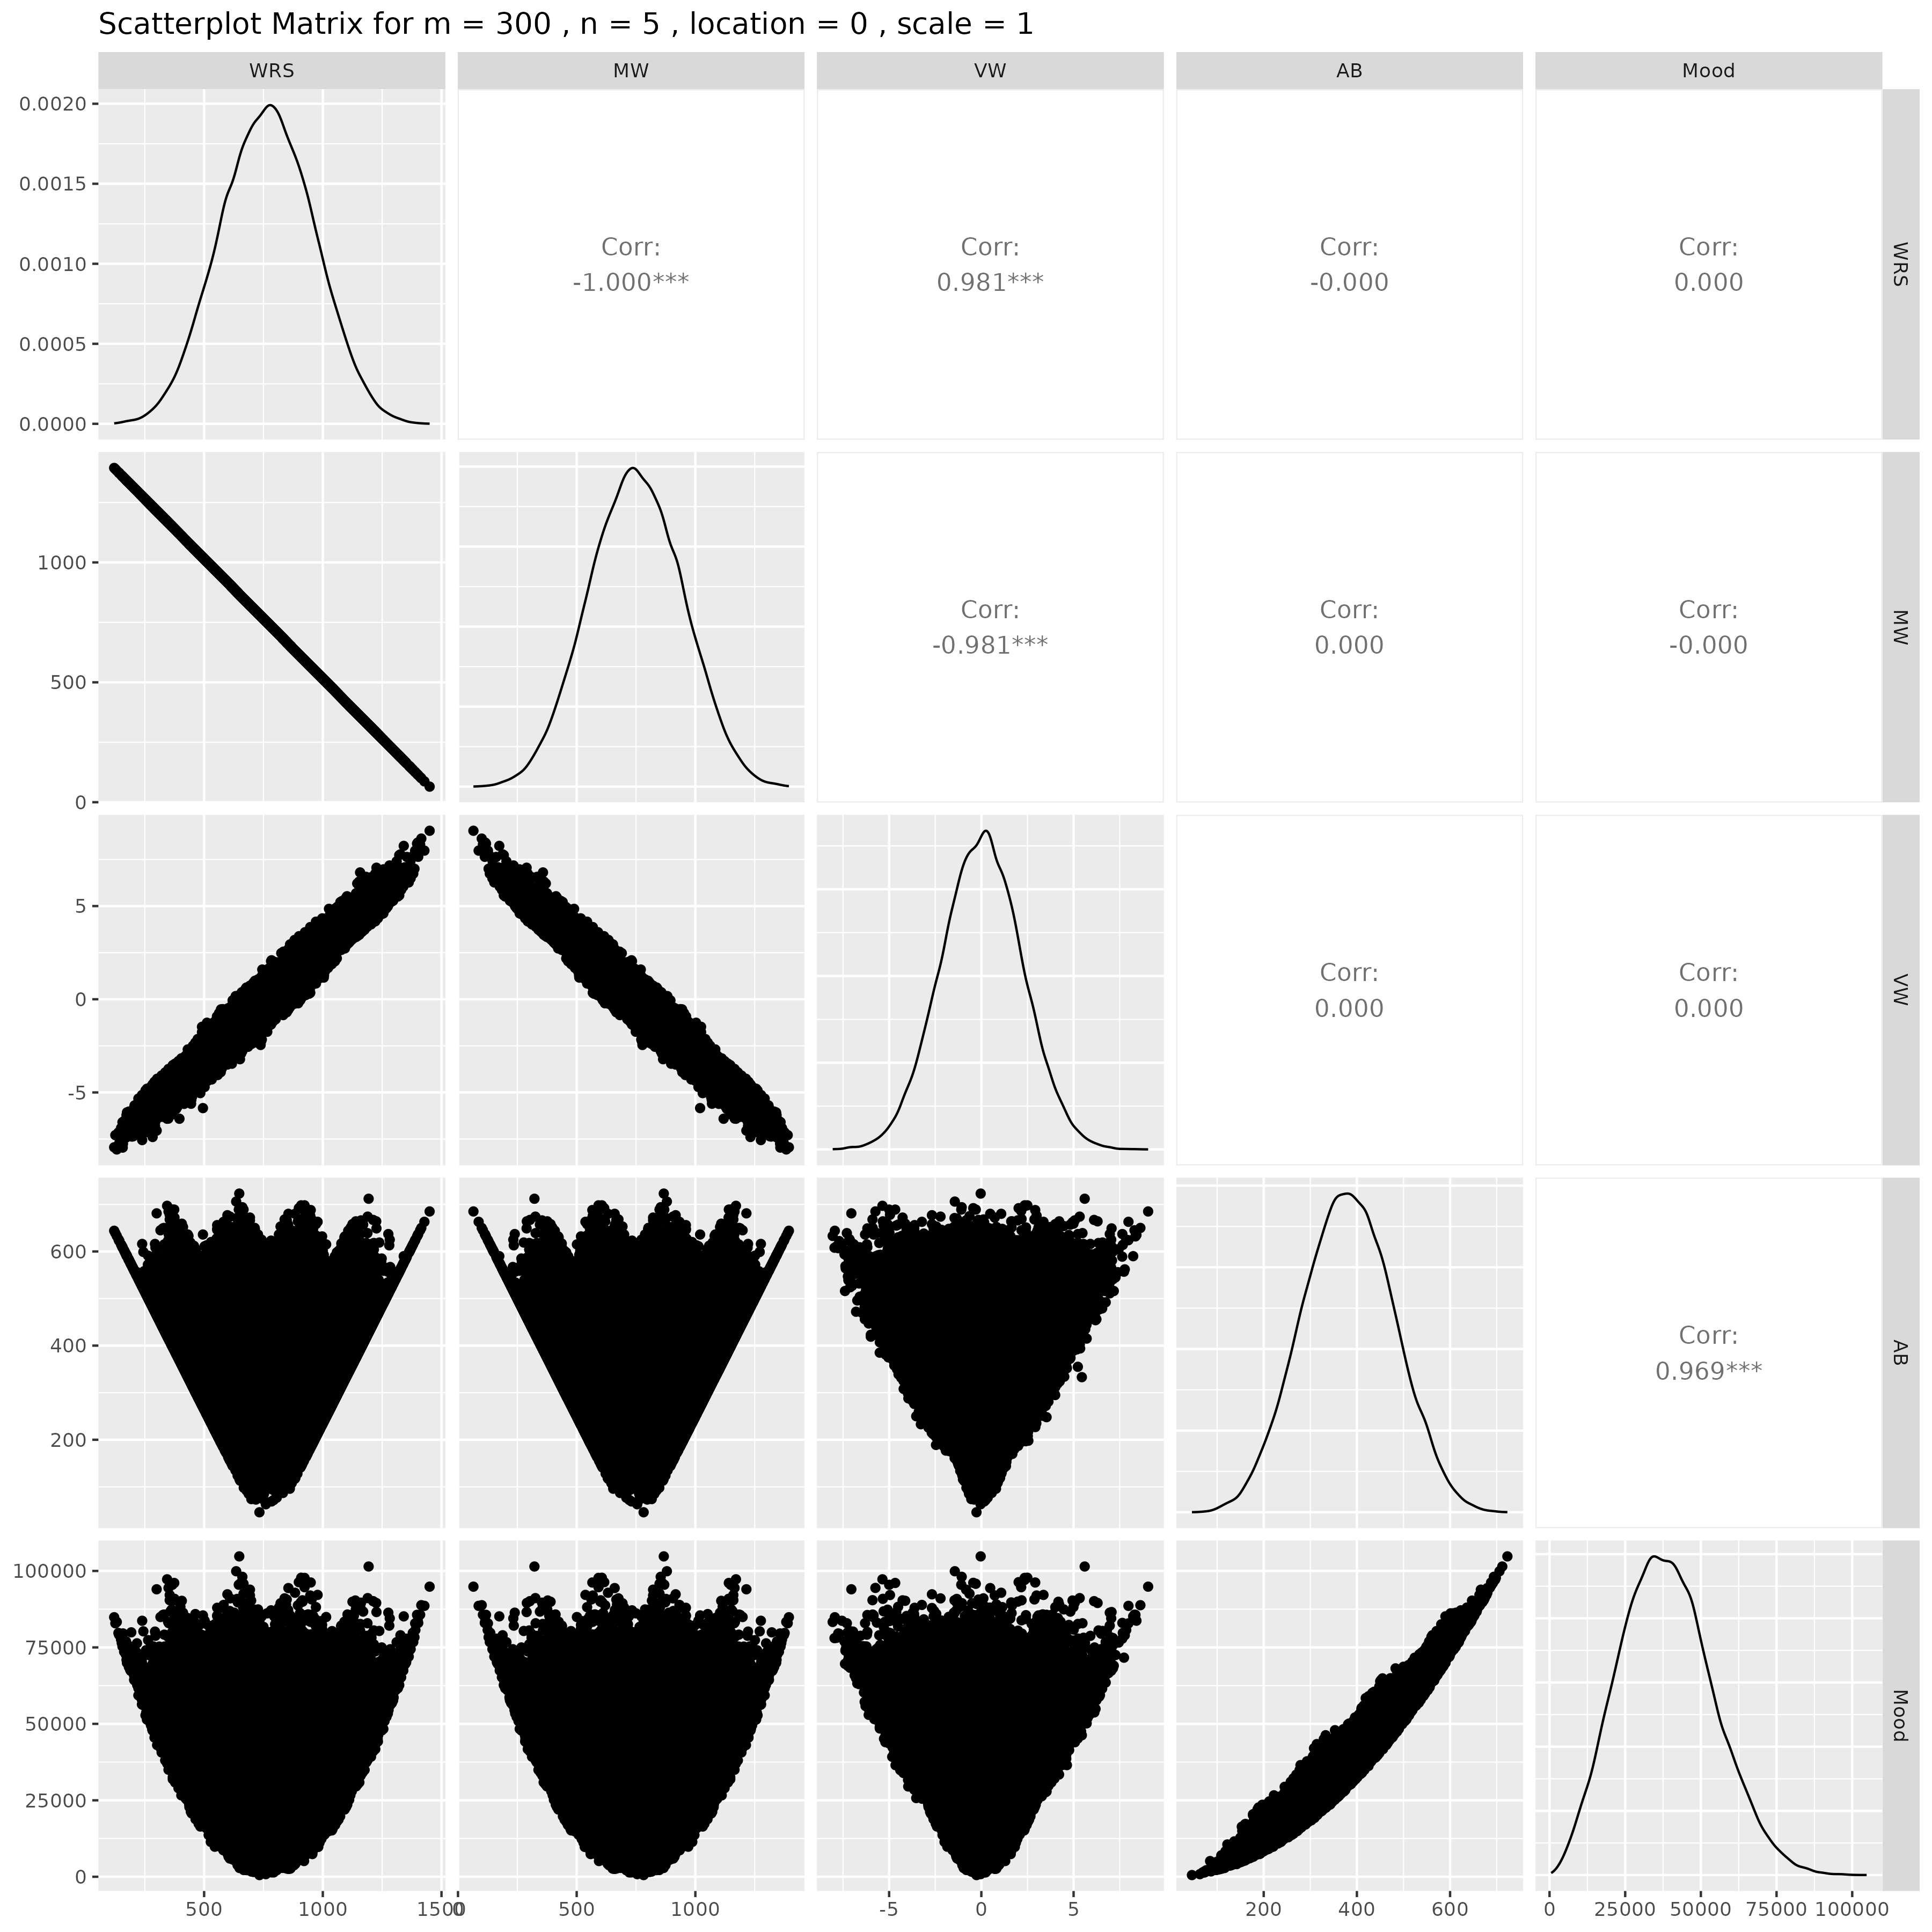

## Results for m = 300 , n = 10 , location = 0 , scale = 1

### Correlation Matrix

| Statistic | WRS | MW | VW | AB | Mood |
| --- | --- | --- | --- | --- | --- |
| character | numeric | numeric | numeric | numeric | numeric |
| WRS | 1.0000 | -1.0000 | 0.9808 | 0.0005 | 0.0012 |
| MW | -1.0000 | 1.0000 | -0.9808 | -0.0005 | -0.0012 |
| VW | 0.9808 | -0.9808 | 1.0000 | -0.0006 | 0.0002 |
| AB | 0.0005 | -0.0005 | -0.0006 | 1.0000 | 0.9681 |
| Mood | 0.0012 | -0.0012 | 0.0002 | 0.9681 | 1.0000 |
| n: 5 | | | | | |

### P-Value Matrix

| Statistic | WRS | MW | VW | AB | Mood |
| --- | --- | --- | --- | --- | --- |
| character | numeric | numeric | numeric | numeric | numeric |
| WRS |  | 0.0000 | 0.0000 | 0.9135 | 0.7969 |
| MW | 0.0000 |  | 0.0000 | 0.9135 | 0.7969 |
| VW | 0.0000 | 0.0000 |  | 0.8892 | 0.9696 |
| AB | 0.9135 | 0.9135 | 0.8892 |  | 0.0000 |
| Mood | 0.7969 | 0.7969 | 0.9696 | 0.0000 |  |
| n: 5 | | | | | |

### Scatter Plot Matrix:

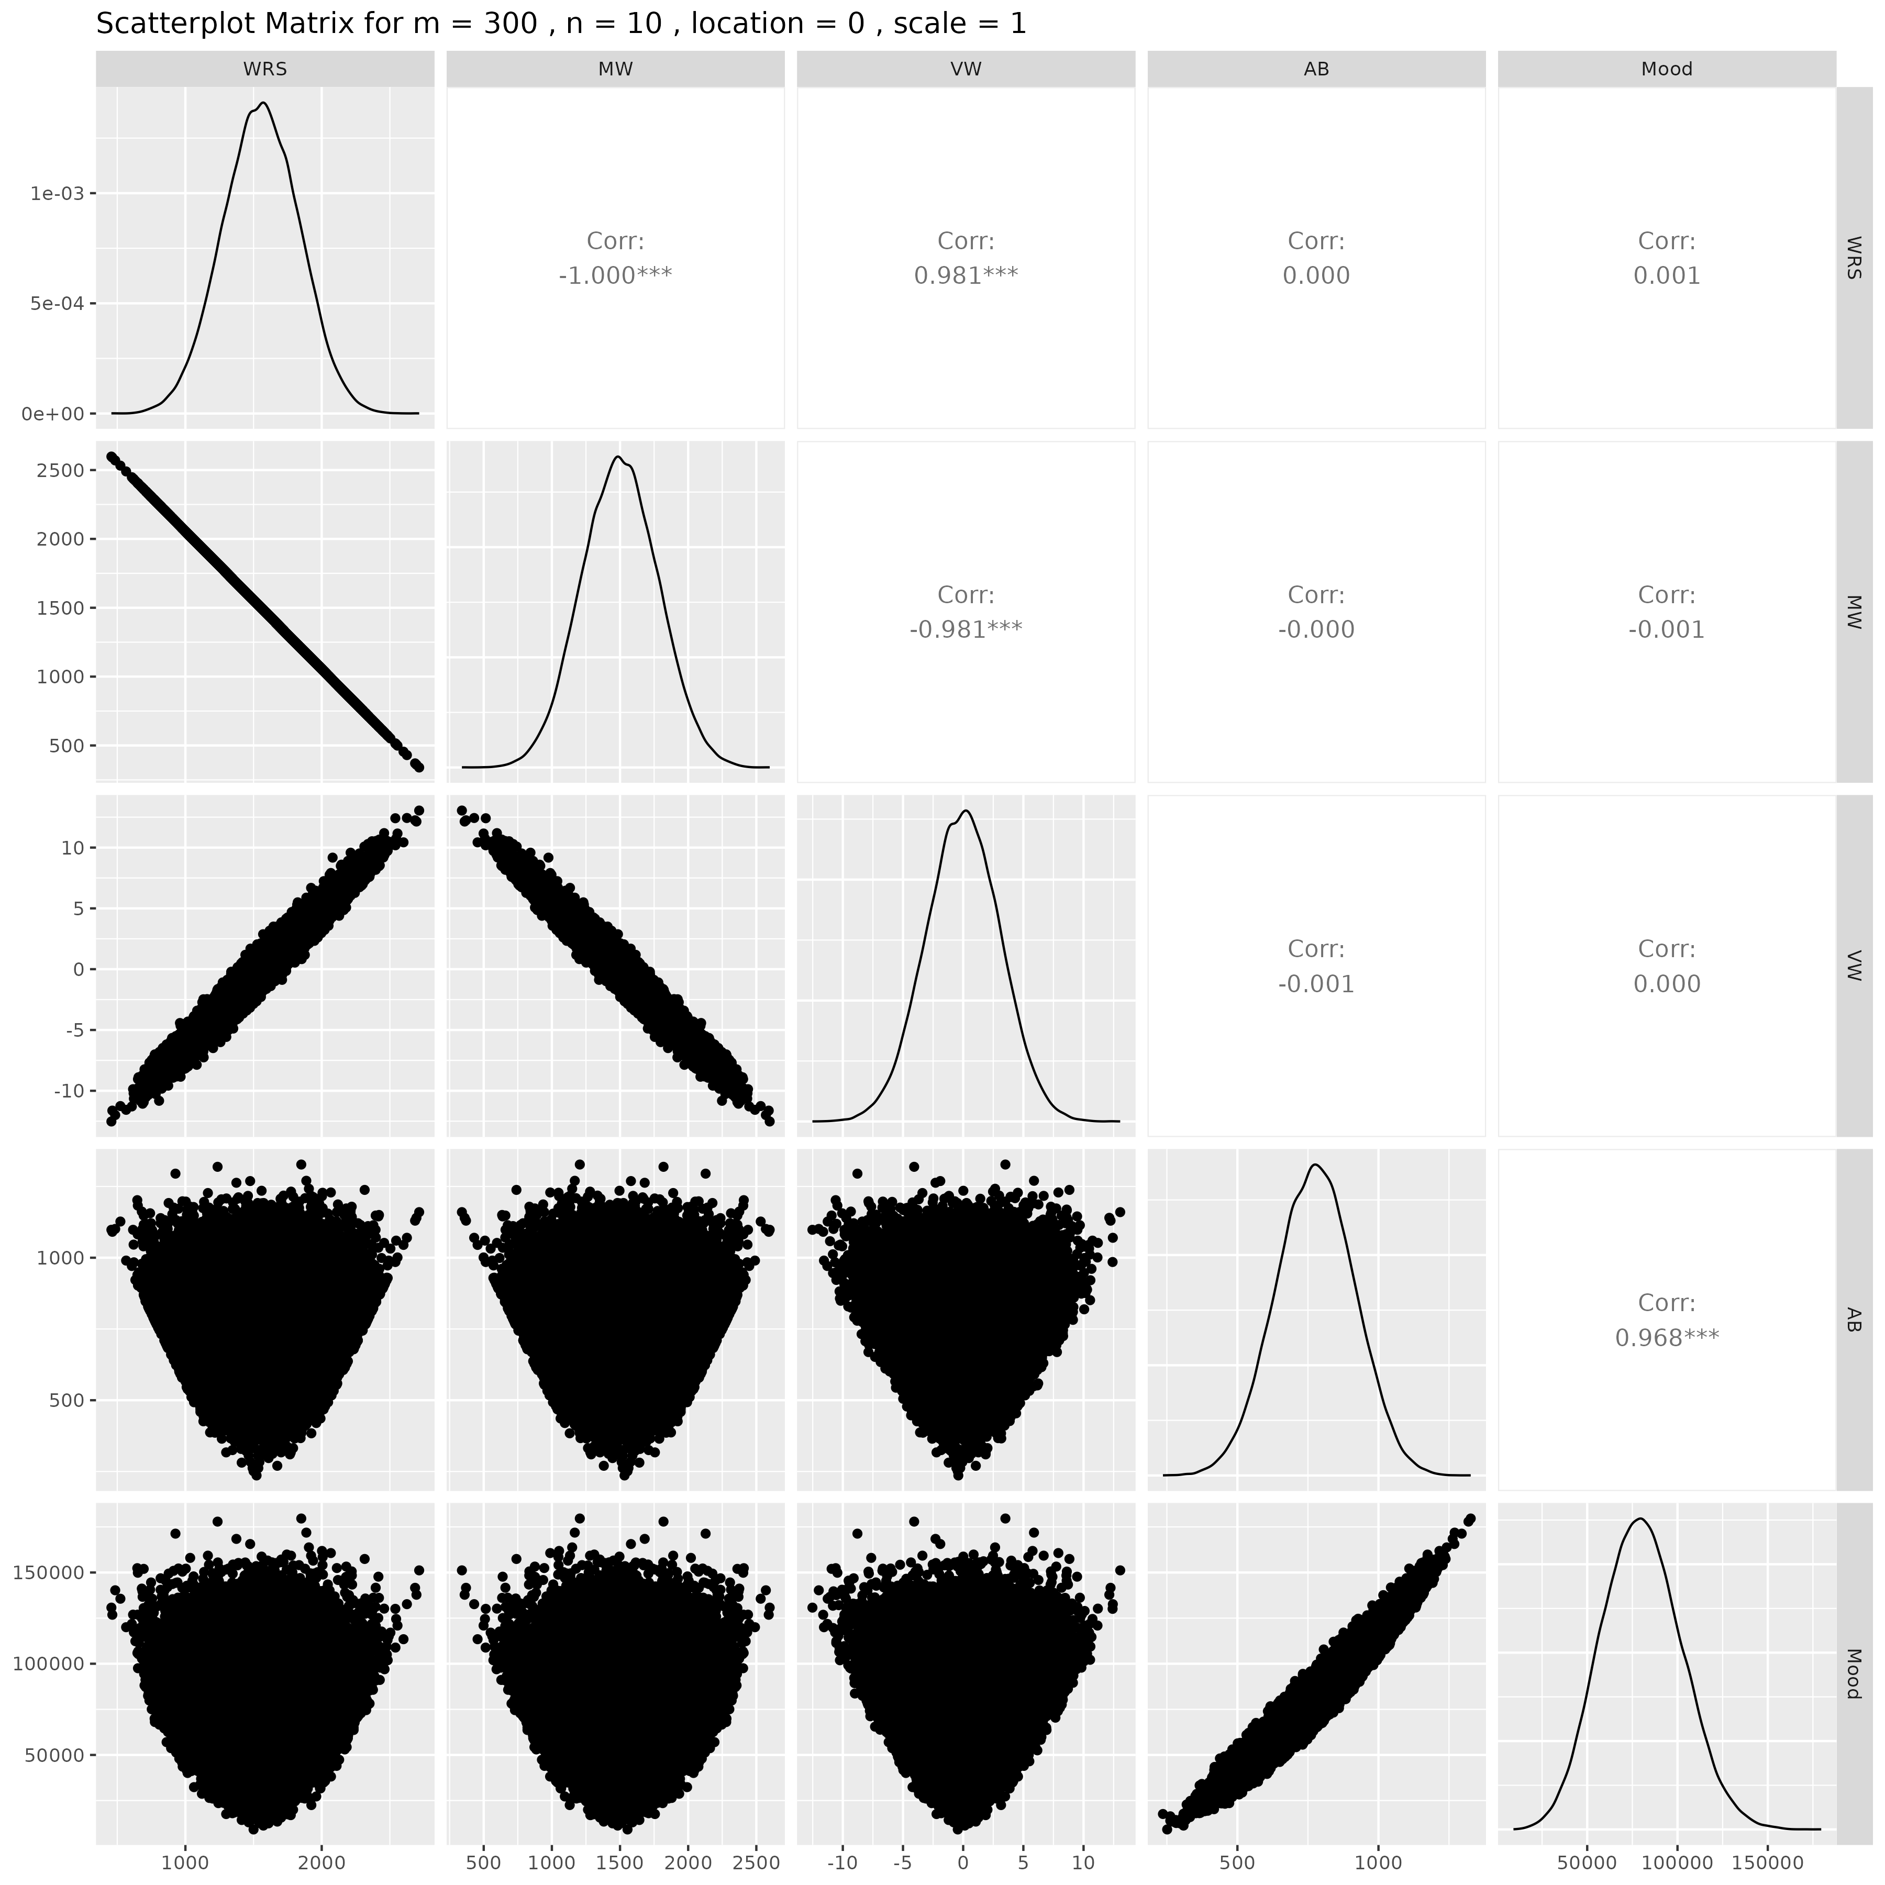

## Results for m = 300 , n = 15 , location = 0 , scale = 1

### Correlation Matrix

| Statistic | WRS | MW | VW | AB | Mood |
| --- | --- | --- | --- | --- | --- |
| character | numeric | numeric | numeric | numeric | numeric |
| WRS | 1.0000 | -1.0000 | 0.9806 | -0.0089 | -0.0094 |
| MW | -1.0000 | 1.0000 | -0.9806 | 0.0089 | 0.0094 |
| VW | 0.9806 | -0.9806 | 1.0000 | -0.0090 | -0.0093 |
| AB | -0.0089 | 0.0089 | -0.0090 | 1.0000 | 0.9681 |
| Mood | -0.0094 | 0.0094 | -0.0093 | 0.9681 | 1.0000 |
| n: 5 | | | | | |

### P-Value Matrix

| Statistic | WRS | MW | VW | AB | Mood |
| --- | --- | --- | --- | --- | --- |
| character | numeric | numeric | numeric | numeric | numeric |
| WRS |  | 0.0000 | 0.0000 | 0.0456 | 0.0359 |
| MW | 0.0000 |  | 0.0000 | 0.0456 | 0.0359 |
| VW | 0.0000 | 0.0000 |  | 0.0454 | 0.0377 |
| AB | 0.0456 | 0.0456 | 0.0454 |  | 0.0000 |
| Mood | 0.0359 | 0.0359 | 0.0377 | 0.0000 |  |
| n: 5 | | | | | |

### Scatter Plot Matrix:

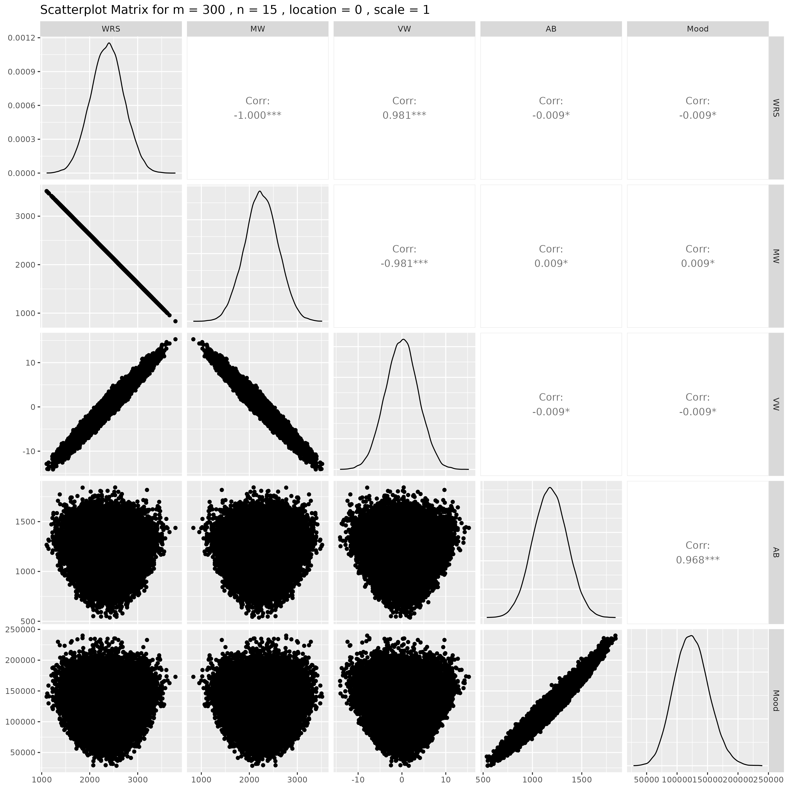

## Results for m = 300 , n = 20 , location = 0 , scale = 1

### Correlation Matrix

| Statistic | WRS | MW | VW | AB | Mood |
| --- | --- | --- | --- | --- | --- |
| character | numeric | numeric | numeric | numeric | numeric |
| WRS | 1.0000 | -1.0000 | 0.9806 | 0.0054 | 0.0057 |
| MW | -1.0000 | 1.0000 | -0.9806 | -0.0054 | -0.0057 |
| VW | 0.9806 | -0.9806 | 1.0000 | 0.0046 | 0.0047 |
| AB | 0.0054 | -0.0054 | 0.0046 | 1.0000 | 0.9685 |
| Mood | 0.0057 | -0.0057 | 0.0047 | 0.9685 | 1.0000 |
| n: 5 | | | | | |

### P-Value Matrix

| Statistic | WRS | MW | VW | AB | Mood |
| --- | --- | --- | --- | --- | --- |
| character | numeric | numeric | numeric | numeric | numeric |
| WRS |  | 0.0000 | 0.0000 | 0.2293 | 0.2021 |
| MW | 0.0000 |  | 0.0000 | 0.2293 | 0.2021 |
| VW | 0.0000 | 0.0000 |  | 0.3050 | 0.2933 |
| AB | 0.2293 | 0.2293 | 0.3050 |  | 0.0000 |
| Mood | 0.2021 | 0.2021 | 0.2933 | 0.0000 |  |
| n: 5 | | | | | |

### Scatter Plot Matrix:

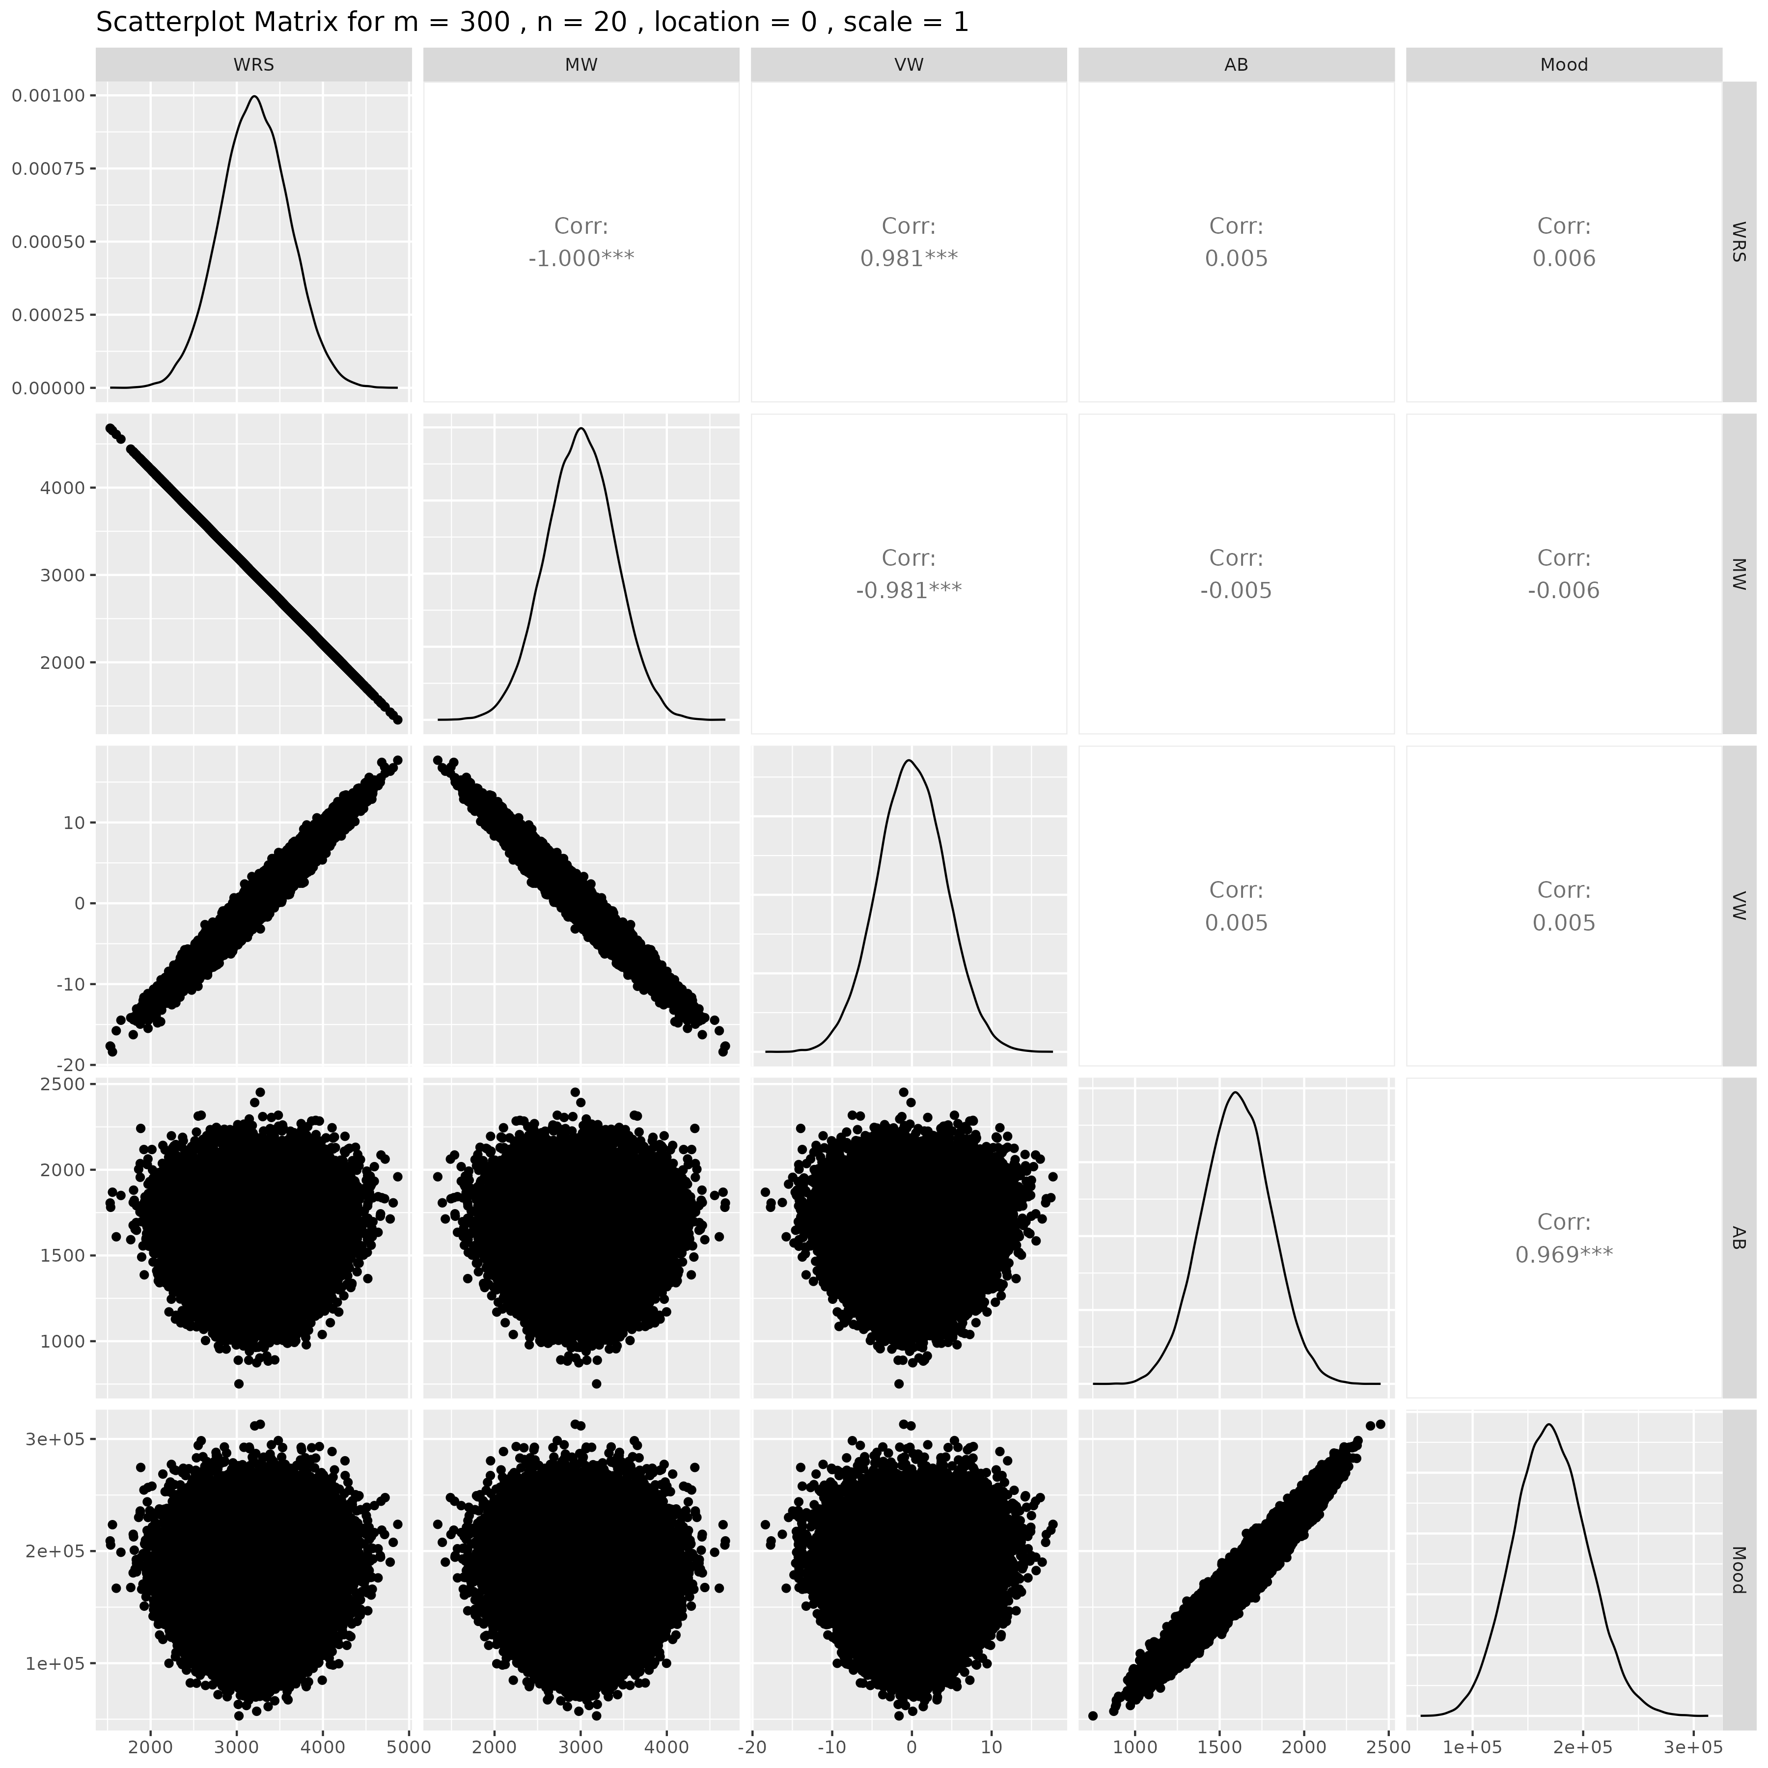

## Results for m = 300 , n = 25 , location = 0 , scale = 1

### Correlation Matrix

| Statistic | WRS | MW | VW | AB | Mood |
| --- | --- | --- | --- | --- | --- |
| character | numeric | numeric | numeric | numeric | numeric |
| WRS | 1.0000 | -1.0000 | 0.9806 | -0.0031 | -0.0048 |
| MW | -1.0000 | 1.0000 | -0.9806 | 0.0031 | 0.0048 |
| VW | 0.9806 | -0.9806 | 1.0000 | -0.0026 | -0.0046 |
| AB | -0.0031 | 0.0031 | -0.0026 | 1.0000 | 0.9682 |
| Mood | -0.0048 | 0.0048 | -0.0046 | 0.9682 | 1.0000 |
| n: 5 | | | | | |

### P-Value Matrix

| Statistic | WRS | MW | VW | AB | Mood |
| --- | --- | --- | --- | --- | --- |
| character | numeric | numeric | numeric | numeric | numeric |
| WRS |  | 0.0000 | 0.0000 | 0.4919 | 0.2788 |
| MW | 0.0000 |  | 0.0000 | 0.4919 | 0.2788 |
| VW | 0.0000 | 0.0000 |  | 0.5579 | 0.3029 |
| AB | 0.4919 | 0.4919 | 0.5579 |  | 0.0000 |
| Mood | 0.2788 | 0.2788 | 0.3029 | 0.0000 |  |
| n: 5 | | | | | |

### Scatter Plot Matrix:

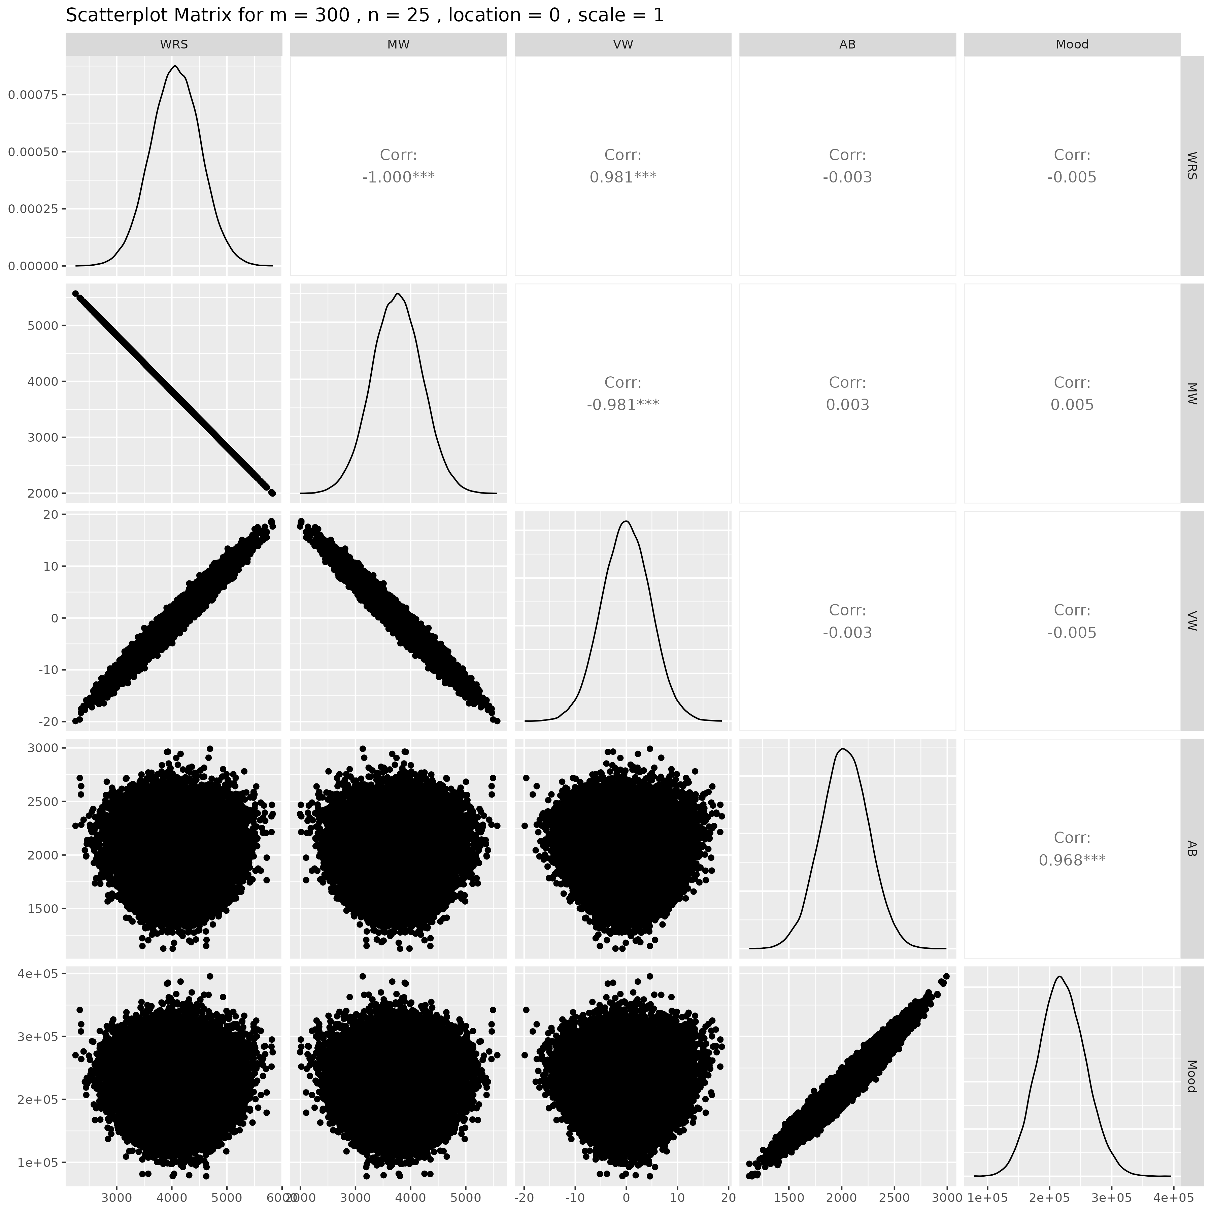

## Results for m = 300 , n = 30 , location = 0 , scale = 1

### Correlation Matrix

| Statistic | WRS | MW | VW | AB | Mood |
| --- | --- | --- | --- | --- | --- |
| character | numeric | numeric | numeric | numeric | numeric |
| WRS | 1.0000 | -1.0000 | 0.9806 | -0.0064 | -0.0061 |
| MW | -1.0000 | 1.0000 | -0.9806 | 0.0064 | 0.0061 |
| VW | 0.9806 | -0.9806 | 1.0000 | -0.0081 | -0.0078 |
| AB | -0.0064 | 0.0064 | -0.0081 | 1.0000 | 0.9682 |
| Mood | -0.0061 | 0.0061 | -0.0078 | 0.9682 | 1.0000 |
| n: 5 | | | | | |

### P-Value Matrix

| Statistic | WRS | MW | VW | AB | Mood |
| --- | --- | --- | --- | --- | --- |
| character | numeric | numeric | numeric | numeric | numeric |
| WRS |  | 0.0000 | 0.0000 | 0.1495 | 0.1702 |
| MW | 0.0000 |  | 0.0000 | 0.1495 | 0.1702 |
| VW | 0.0000 | 0.0000 |  | 0.0685 | 0.0822 |
| AB | 0.1495 | 0.1495 | 0.0685 |  | 0.0000 |
| Mood | 0.1702 | 0.1702 | 0.0822 | 0.0000 |  |
| n: 5 | | | | | |

### Scatter Plot Matrix:

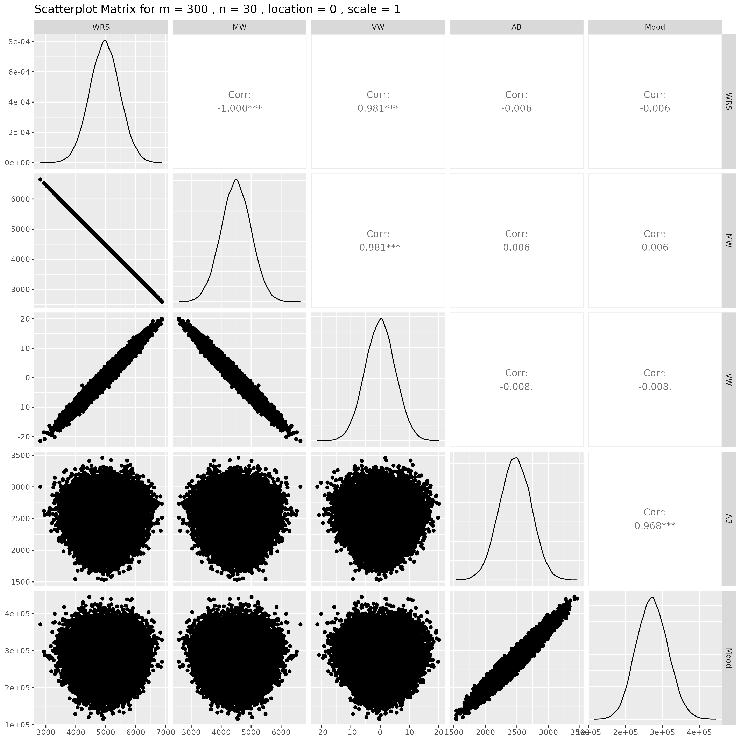

## Results for m = 300 , n = 50 , location = 0 , scale = 1

### Correlation Matrix

| Statistic | WRS | MW | VW | AB | Mood |
| --- | --- | --- | --- | --- | --- |
| character | numeric | numeric | numeric | numeric | numeric |
| WRS | 1.0000 | -1.0000 | 0.9808 | -0.0040 | -0.0040 |
| MW | -1.0000 | 1.0000 | -0.9808 | 0.0040 | 0.0040 |
| VW | 0.9808 | -0.9808 | 1.0000 | -0.0028 | -0.0028 |
| AB | -0.0040 | 0.0040 | -0.0028 | 1.0000 | 0.9683 |
| Mood | -0.0040 | 0.0040 | -0.0028 | 0.9683 | 1.0000 |
| n: 5 | | | | | |

### P-Value Matrix

| Statistic | WRS | MW | VW | AB | Mood |
| --- | --- | --- | --- | --- | --- |
| character | numeric | numeric | numeric | numeric | numeric |
| WRS |  | 0.0000 | 0.0000 | 0.3764 | 0.3760 |
| MW | 0.0000 |  | 0.0000 | 0.3764 | 0.3760 |
| VW | 0.0000 | 0.0000 |  | 0.5312 | 0.5337 |
| AB | 0.3764 | 0.3764 | 0.5312 |  | 0.0000 |
| Mood | 0.3760 | 0.3760 | 0.5337 | 0.0000 |  |
| n: 5 | | | | | |

### Scatter Plot Matrix:

